Thank you for your commitment to green initiatives at the University of Illinois. One of the final steps in completing the terms of the funding agreement for your project is the submission of a Final Report with key information about your project. You will also need to submit a detailed report of expenses (if you don't list it within this document) as well as supporting photos to showcase your project.

Please be as accurate as possible in describing the project (including possible setbacks or challenges in meeting the initial goals of the project). Not fully meeting your project's goals will not disqualify you from making future funding requests as long as your reports are as complete and accurate as possible. If you have any questions, please contact the Student Sustainability Committee, at sustainability-committee@illinois.edu.
Project Name: Sustainability and Science Policy Workshop

Date of Report Submission: 1/31/2018

Project Purpose:
1. Inform a general campus and community audience about science policy, specifically in regard to how sustainability policy is developed, implemented and advanced.
2. Train STEM students (undergraduate and graduate) how to effectively participate in science policy and equip them with the tools to do so.
3. Use the skills and knowledge acquired to impact policy and contribute to active advocacy work.

Project Summary:
Our event, which took place on Thursday, September 21st, 2017, was broken down into three main segments: a morning lecture serving as an introduction to science policy, a dual-activity/discussion workshop in the afternoon, and a concluding afternoon lecture on how science policy and sustainability interact. We invited Dr. Melanie Roberts, a policy advisor and founding director of Emerging Leaders in Science and Society (ELISS), to speak at the morning lecture. She also agreed to be an advisor for development of the workshop program throughout the months planning the project. Dr. Roberts attended meals with graduate students to discuss her career and give advice on how to build successful programs at the university level. This included insight about how to enable students and build skills to be marketable in a science policy career. Her opening lecture was titled, “Introducing Scientists to Science Policy” and served to inform a general campus community on what science policy is and where scientists fit into the policy-making process. The opening lecture was followed by a break for lunch and then the interactive dual-workshop sessions on “Effective Lobbying Strategies” and “Economic Tradeoffs of Creating New Policies.” These interactive sessions ran concurrently and then the participants switched rooms such that everyone could participate in both workshops. Participants were encouraged to pre-register for these interactive sessions in order to access a pre-workshop survey containing questions relevant to the workshop topics to be discussed. Later, a post-workshop survey containing the same questions was given to the participants in an effort to gauge how effective the workshops were at teaching the material. The Effective Lobbying Strategies workshop was facilitated by Melissa Haas, Associate Director of Federal Relations at the Office of Government Relations for UIUC, and Marissa Brewer, the Assistant Vice President of Alumni Advocacy and Director of Illinois Connection. Together, they led a training session on effective lobbying methods and subsequently, provided an opportunity for participants to take action and write postcards to their legislators urging them to support scientific research funding in the federal budget. In the Economic Tradeoffs session, Professor Don Fullerton, Gutgsell Endowed Professor in the Finance department at UIUC, led students in a discussion to analyze the economic and logistical challenges of implementing sustainability policy. Participants debated the effectiveness of utilizing incentives vs. mandates in climate policy, and patent policies vs. government funded research in technological advancement. Following the interactive sessions, Dr. Ashlynn Stillwell, from the Civil and Environmental Engineering department, gave the closing lecture on “Sustainability in Research and Policy” where she discussed her experience at the Congressional Research Service and current research in urban water and energy sustainability. Our original proposal included taking the skills learned during the workshop and applying them in an advocating setting. We intended to do this in conjunction with Prairie Rivers Network, a local environmental advocacy group. While we have not set up an actual advocacy event, we invited Prairie Rivers Network Executive Director Dr. Carol Hays to give a seminar on campus. Also, to further develop our advocacy skills, Science Policy Group took a trip to Springfield to meet with state legislators, graciously funded by the Student Organization resource Fund (SORF). This trip required applying some of the information gathered during the workshop, but also served as a foundation-laying trip to develop relationships with local law-makers. There were only ten available spots for this trip, and priority given to workshop attendees. While we deviated from our original plan, we were able to implement the workshop experience into different advocacy based events. We will continue to develop a relationship with Prairie Rivers Network in order to eventually engage in actual advocacy work with them.

Summary of Project Expenditures:
We came in under our $2,500 budget for this workshop project, having spent a total of $1,288.93 (leaving $1,211.07 unspent and to be returned). Our largest expenses were travel costs associated with getting Dr. Roberts to and from campus, as she was traveling from Seattle, Washington. Besides that, there were minimal, expected costs of putting on the event including refreshments and equipment rental from the Union, as well as other meals for workshop facilitators. A complete expense report can be found at the end of this report in Table 1.

Problems/Challenges Encountered (leading up to event)
Overall, the planning portion of this event was rather successful. We were able to hold the event early in the fall semester of 2017 and make all the arrangements in a timely manner. Dr. Roberts travel arrangements were completed by August. One challenge here was working with all the facilitators’ schedule to find a day that worked for everyone, as some were on campus, some from other parts of the state and even as far away as Seattle (Dr. Roberts). Our biggest challenge, however, was determining comprehensive, yet engaging workshop material and appropriate people to facilitate. We invited a few different professionals who we thought had strong resumes for conducting the workshop events, before we got someone to agree to conduct any portion of the event. Dr. Roberts agreed first, but only to give a lecture and not a workshop, as she did not have any prepared workshop material. We overestimated the number of people who had already prepared and tested workshop material. We eventually turned to our local options for filling in the rest of the facilitators in order to adhere to our travel budget. This speaks to abilities of our student members to continue to push our project forward despite these challenges, as well as to the importance of sharing an event and experience like this workshop. Hopefully, it has inspired students and others to develop engaging material on the topic of science policy and sustainability in order to fill the rising demand of this type of knowledge.

Problems/Challenges Encountered (during and after the event/reflection)
Another challenge encountered was the attendance of all of the portions of the event. We had encouraging pre-registration of the workshop (about 30 people), but only 19 people actually attended. The morning lecture had 18 people sign the attendance sheet and maybe a few more that were there, but did not sign in. Also, 15 people attended the afternoon lecture. What was encouraging, however, was the diversity represented in the attendance. There were a number of different departments represented including chemistry, physics, biological sciences, various engineering majors, as well as anthropology, among others. This is inspiring because science policy and sustainability are broad-reaching enough to encompass all these fields of study. We originally planned to measure the effectiveness of the program by comparing the pre-survey and post-survey for the interactive sessions. These surveys had content specific questions designed to test if the participants advanced their understanding and consideration of the concepts discussed in each session. The pre-survey responses were thoughtful, but there was very little participation in the post-event survey for the interactive sessions. We did get a fair number of responses on our overall event feedback survey which included ranked questions on the sessions, the workshop as a whole and included space for free response comments/suggestions. Because we implemented multiple, separate surveys, we were able to use the feedback on this more comprehensive event survey to supplement the lack of responses for the content specific post-interactive session survey. In general, attendees who answered the post-event survey seemed to appreciate the content of the workshop and lectures. Many seemed to be unfamiliar with science policy and sustainability’s role within it, thus the event hit its target of engaging new-comers to this field. Attendees were also impressed, not just with the content, but with the people delivering it. The lectures were highly regarded as being informative, as well as well presented by experts on those areas. There was also feedback on how the event could improve in a future attempt. This criticism mostly focused on advertising and organization. Some of the audience was not informed of the event until the week or day before it was held. If more widespread advertising is executed next time, we can potentially improve our attendance numbers. Also, the overall organization of the event was questioned, as some people commented that there seemed to be oddly long gaps between portions, making it difficult to attend all of them. For a future event, it may be better to make it one single afternoon or break it up into a few afternoons in the week. Additionally, the workshops lacked structure and devolved into more discussion-type activities, opposed to hands-on. This relates to the previously stated challenge above of finding expert facilitators with experienced workshop material built for a clear goal or outcome. Overall, the event was successful for informing inexperienced students about science policy and sustainability.

Student Involvement and Outreach to Date:
This project was entirely developed and implemented by graduate students in a variety of STEM fields and open to the general campus community including undergraduate and graduate students. Students organized the speakers and facilitators, as well as designed advertising and executed day-of coordinating. Students also attended meals with Dr. Roberts (breakfast, lunch and dinner) and Prof. Fullerton (dinner), engaging in helpful discussions about extending our audience, exploring career opportunities, and persevering with our goals and organization.

Marketing and Promotion Efforts to Date:
The event was advertised by electronic distribution of flyers through GradLinks, department specific e-mail listservs, the Science Policy Group listserv, and social media including Facebook, Twitter.

Additional Comments:
Please find attached the letter of support from our invited speaker, Dr. Melanie Roberts (separate document attached in submission email).

In addition to the above fields, please provide a detailed accounting of how the funding was spent as well as pictures of the final project in an email to sustainability-committee@illinois.edu. Thank you again for your commitment to sustainability.

Table 1. Financial summary for Sustainability and Science Policy Workshop event
Transaction Category | Debit | Credit | Expense detail
Initial Grant/Award | 2500.00 |  | Initial grant given to Science Policy Group by SSC
Dr. Roberts' arrangements |  | 600.01 | Flight for Dr. Roberts, with fee for travel agent used to book arrangements
 |  | 29.00 | Train ticket from Champaign to Chicago for Dr. Roberts
 |  | 359.34 | Hotel for Dr. Roberts, 2 nights
 |  | 74.55 | Dr. Roberts reimbursement for ground travel and travel meals along her trip
Workshop expenses |  | 27.60 | Audio and visual equipment rental for conference room in Student Union
 |  | 138.98 | Coffee and refreshments for workshop attendees and facilitators
Miscellaneous expenses |  | 33.90 | Dinner costs for invited facilitators (Dr. Roberts and Dr. Fullerton)
 |  | 25.55 | Food and parking costs for Libby Haywood (SPG member and workshop organizer) accompanying Dr. Roberts on the day of the event
Totals | 2500.00 | 1288.93
Net | 1211.07

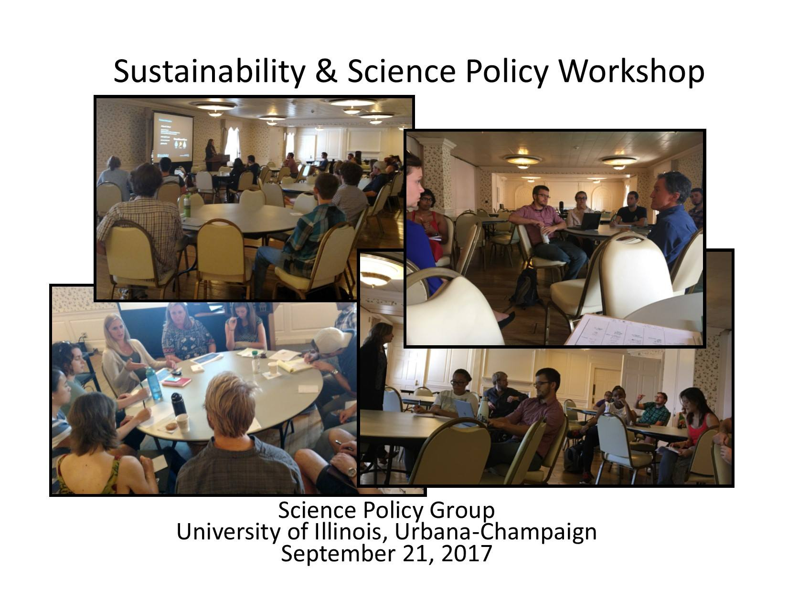
Figure 1. Photo summary of the Sustainability and Science Policy Workshop event.
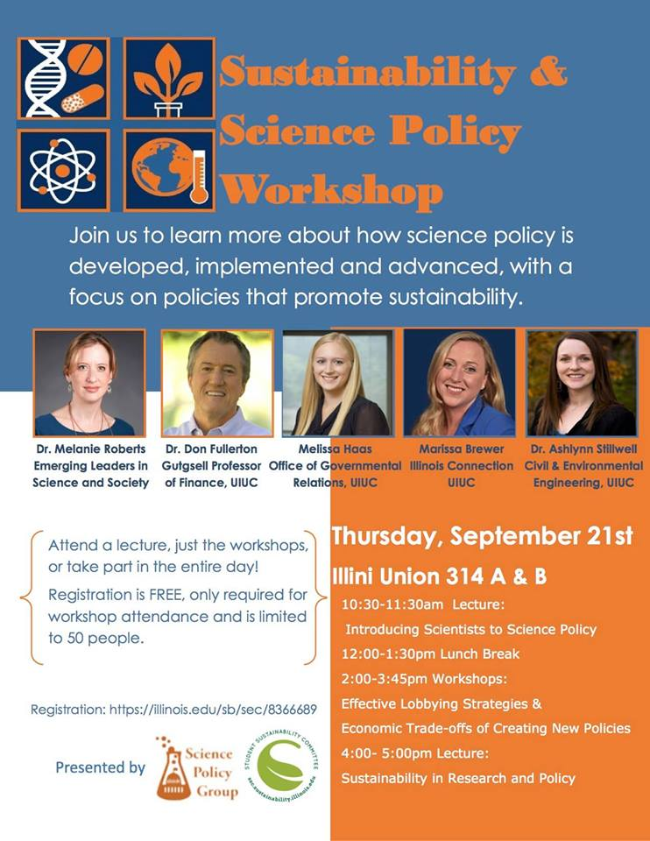
Figure 2. Advertising flyer for the workshop event featuring all of the facilitators and speakers.

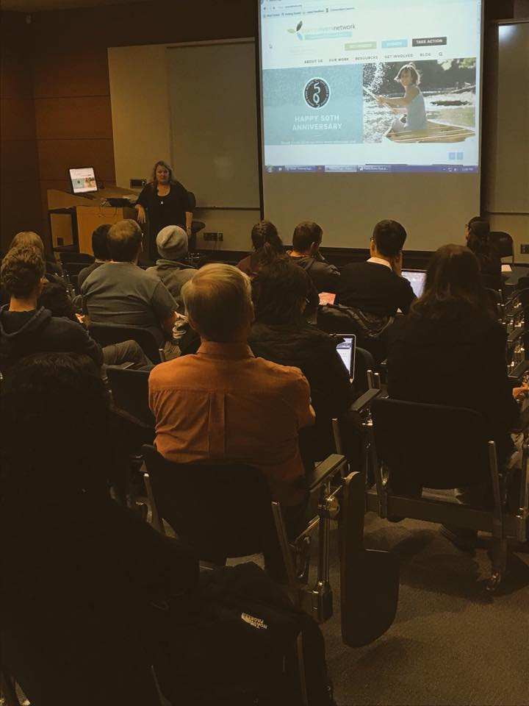
Figure 3. Photo from the Prairie Rivers Network seminar.

