Woodland Wildflowers At Chi Omega Planting, April 9, 2018.
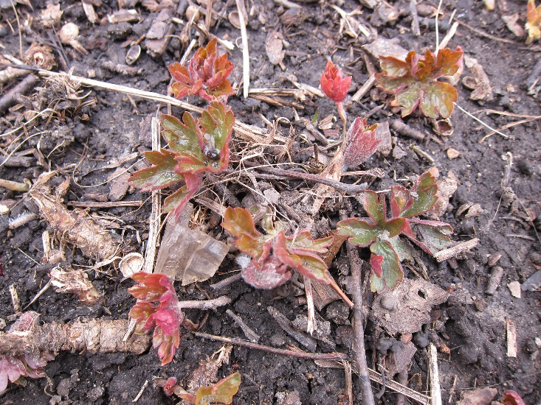 | 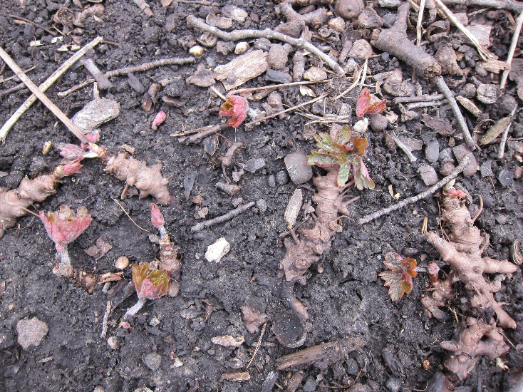
2018-04-09 FLR ChiO 07 geranium.JPG | 2018-04-09 FLR ChiO 04 geranium .JPG
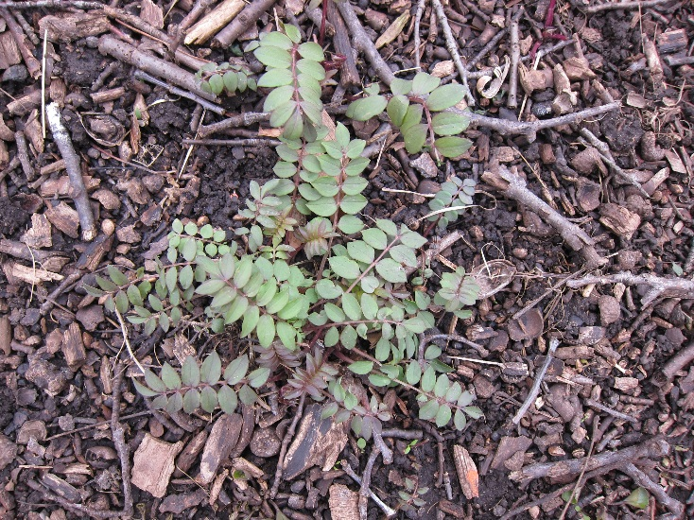 | 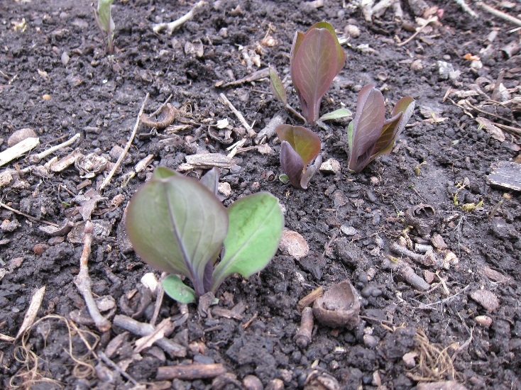
2018-04-09 FLR ChiO 01 Jacob's ladder.JPG | 2018-04-09 FLR ChiO 03 Bluebell.JPG
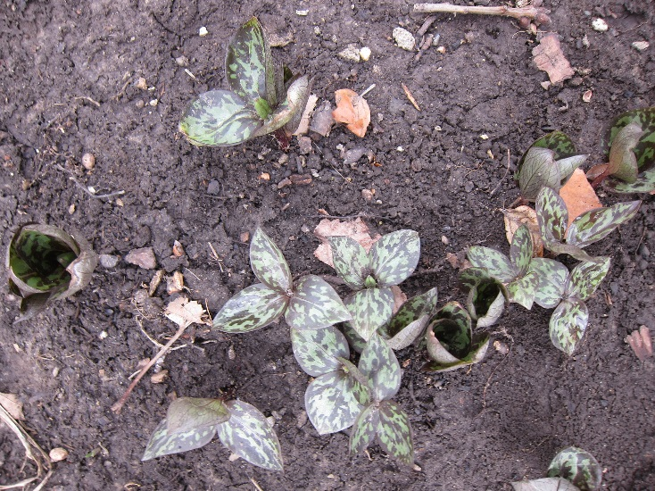 | 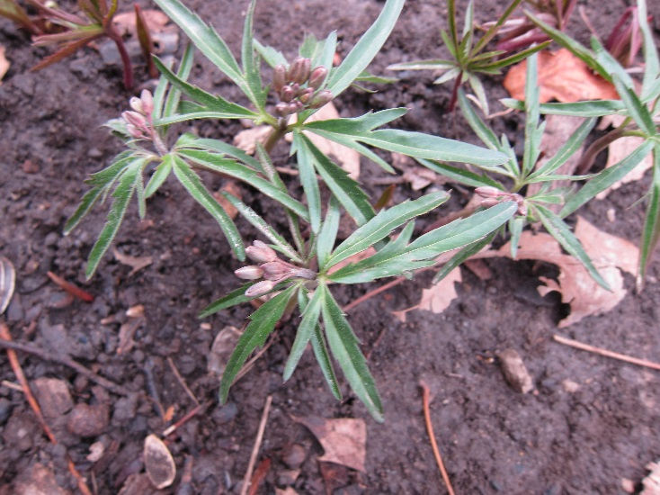
2018-04-09 FLR ChiO 11 Trillium recurvatum | 2018-04-09 FLR ChiO 12 toothwort.JPG

X
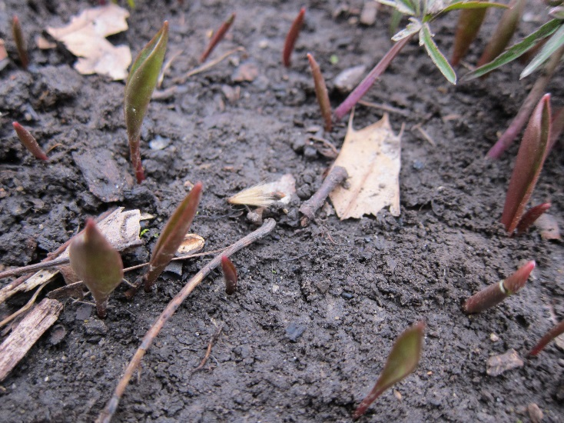 | 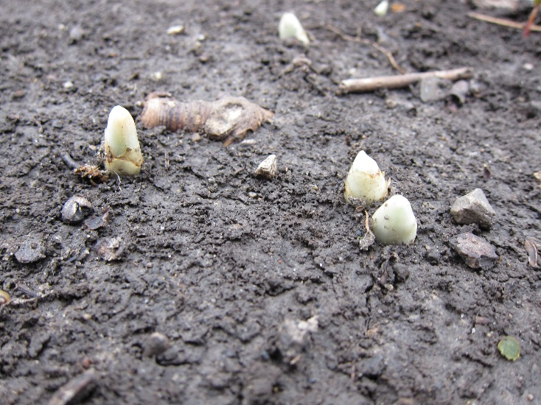
2018-04-09 FLR ChiO 14 Trout lily.JPG | 2018-04-09 FLR ChiO 15 mayapple.JPG
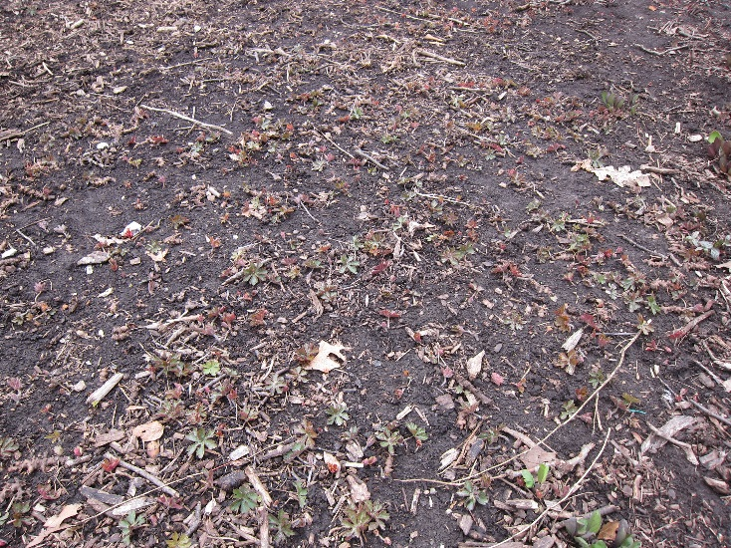
2018-04-09 FLR ChiO 16.JPG

Photos taken by John Marlin at Chi Omega planting on UofI campus April 9, 2018.
Most like may apple are just emerging and are not at full height.
Most of these are also at Burrill Hall and the front and North side of Lincoln Ave. residence Hall.

