Solar Panel Installation at Master Gardener Idea Garden
Step 1 Application
DETAILS OF REQUEST:
What: Solar Panel installation on Idea Garden shed.
Why: To educate the community on sustainable energy and to provide electricity at the garden and lighting for greater safety at night.
Who: Installation and assessment be done in partnership with local community groups and the University of Illinois.
Where: The Idea Garden, located on the University of Illinois Arboretum in Urbana, Illinois.
How Much: The project is has an estimate cost of $10,000-20,000.
Attachment(s): Attachment 1 - Aerial Image of Idea Garden.

PROPOSAL:
University of Illinois (UIUC) Extension serving Champaign, Ford, Iroquois and Vermilion Counties with the assistance of local programs proposes to the Student Sustainability Committee an installation of solar panels at the Idea Garden, located on the University of Illinois Arboretum in Urbana. The accompanying map shows the layout of the garden, the solar panels would be installed at shed (A) and provide power to building. The existing power grid that runs under the garden would be extended to provide power to the rest of the garden to light or provide power at the other structures B1-B4 (garden entrances), C (gazeebo) and D (parking lot). The nearest power hookup is in the new "President's Garden" (Area E). To educate visitors, a sign describing the project will be constructed near the Idea Garden shed.

The solar panels will serve two main purposes:
- To educate the university community about sustainability and renewable energy, and the beneficial impact on the environment as well as its functionality in gardens and community spaces.
- To provide electricity to the Idea Garden shed (lighting, outlets, etc.) and some exterior lights at the garden entrances and parking lot. Currently, the garden is not hooked up to the electric grid.
Our solar panel project will serve to educate the student body and the community on the merits of sustainable energy. It is within close walking distance of campus, so students can easily access it. Each year, various university classes and members of the general public visit the Arboretum and Idea Garden area where our project can be easily viewed. Prior to, or during the installation phase, we plan to hold a free presentation at the site that will discuss how the system was designed to fit our needs. We plan to partner with the Student Sustainability Council and other renewable energy groups in the community to identify possible attendees and advertise the event. It will be open to the public and will serve to educate attendees on our design process so they can apply it to other projects. Following the installation of the system, we will design and install an educational sign about the project so all future visitors can learn from our example of sustainability.
HISTORY OF THE IDEA GARDEN:
The Idea Garden was constructed by Champaign County Master Gardener volunteers in 1996. Master Gardeners, who are volunteers of the UIUC Extension, invest over 4,000 hours of their own time in the garden annually. The garden also receives over 1,000 visitors each season, from both UIUC and the surrounding communities. Since its inception, is the Ide Garden is recognized as both a highlight of the Urbana-Champaign community as well as the University of Illinois.
PURPOSE OF THE IDEA GARDEN:
The mission of the Idea Garden is to demonstrate ideas for garden design and maintenance. It is to provide a learning environment for University of Illinois students, faculty and staff, and the public that promotes environmentally responsible gardening practices. The Idea Garden is to serve as a site for educating the public and students, and to encourage and inspire its many visitors.

Submitted on behalf of the Champaign County Master Gardener Program by:
Ryan Pankau
Extension Educator, Horticulture
University of Illinois Extension, Unit 13
Champaign County
801 N. Country Fair Drive, Suite D
Champaign, IL 61821
Phone: 217-333-7672
rcpankau@illinois.edu

Attachment 1 – Aerial Image of Idea Garden

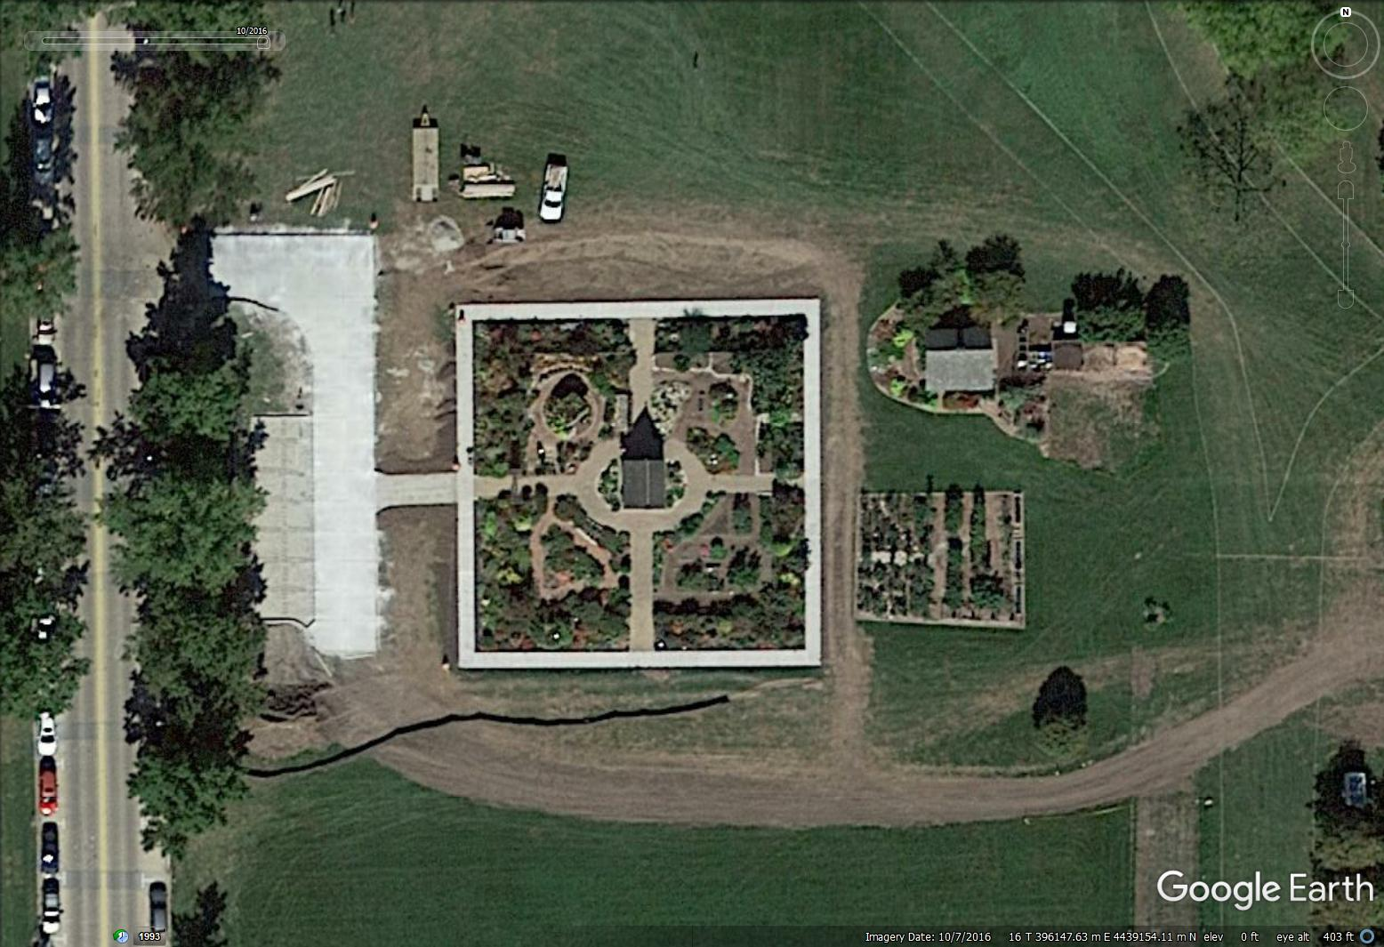
North
Florida Ave.
North
Lincoln Ave.
E
A
C
B4
B3
B2
B1
D

