Please submit this completed application and any relevant supporting documentation by the deadline listed on the SSC website to Sustainability-Committee@Illinois.edu. The Working Group Chairs will be in contact with you regarding any questions about the application. If you have any questions about the application process, please contact the Student Sustainability Committee at http://sustainability-committee@illinois.edu.

General Information

Project Name: Eco-Olympics Competition

Total Amount Requested from SSC: $3,659.07

Project Topic Areas: Land & Water X Education X Energy
Transportation Food & Waste

Contact Information

Applicant Name: Gerard (Paul) Foote
Unit/Department or RSO/Organization: University of Illinois Facilities & Services Energy Conservation
Email Address: gfoote2@illinois.edu
Phone Number: (217)-244-1048

Project Team
Name | Department/Organization | Email
Taylor Holin | President | tholin2@illinois.edu
Mark Toledano | Treasurer | markjt2@illinois.edu
Blake Banks | Marketing and Publicity | jbbanks2@illinois.edu
Kyra Puertz | Marketing and Publicity | kyrapuetz@gmail.com
Julianne Yang | Technical | jyang222@illinois.edu

Financial Contact’s Name: Mark Toledano
Faculty/Unit/Department: Treasurer
Email: markjt2@illinois.edu
Phone: (224)-565-6471

(If Applicable)
Facilities Manager Name:
Email:
Phone:

Project Information

Provide a brief background of the project, its goals, and the desired outcomes.
Eco-Olympics is a 3-week energy conservation competition between campus residence halls. Our mission is to engage a greater percentage of the student population in establishing energy-conscious habits, by developing a sense of community in addition to offering incentives. We believe in the power of individual efforts.

Our concrete goals include: 1) Outreach- get at least 348 students to demonstrate commitment via completion of a survey. 2) Energy reduction- double our reduction from last year (2017: 5960 kwH to 2018 goal: 11920 kwH).

At the conclusion, we will offer a participation award to the hall with the most participants (a sustainable package prize) and an energy reduction award to the hall with the biggest energy reduction (celebration dinner).

How will this project improve sustainability at UIUC?
“82% of campus energy comes from Abbott Power Plant, which burns coal and natural gas, creating steam to heat buildings and generate electricity.” (Illinois Climate Action Plan, 2015) We improve the sustainability of the Illinois campus by encouraging students and employees to implement energy-conscious habits into their daily routine, which will then stay with them for the rest of their lives. Cumulatively, this will greatly reduce each individual carbon footprint. Collectively, this will reduce the global carbon footprint.

Last year, 11 residence halls competed in Eco-Olympics. From these 11 residence halls, 174 students indicated they would like to take a more active role in the competition by completing the survey. From this three-week competition, 5690 kWh of energy was conserved. This amount of energy is equivalent to the amount of energy approximately 9 average American households use in the same amount of time, according to the U.S. Energy Information Administration. Imagine where we could go from here. The number of participants has accumulated over the last few years, but we have the potential to increase it this year by changing our promotional methods and providing different incentives, which we require funding for- see the budget section.

Where will the project be located? Do you need special permissions to enact the project at this site? If so, please explain and attach a letter of support to your application.
The project will be taking place in the residence halls affiliated with University Housing. We spoke to Housing, and we are permitted to proceed with our project just as any other registered student organization would.

Other than the project team, who will have a stake in the project? Please list other individuals, groups, or departments indirectly or directly affiliated to this project. This includes any funding entities (immediate, future, ongoing, etc.) and any entities that will be benefiting from this project.
The University of Illinois Facilities and Services, along with the Institute for Sustainability, Energy, and Environment are affiliated with this project. The students will also have a stake in the project (refer to our website https://ecoolympics.wixsite.com/eco-olympics/history).

Please indicate how this project will involve or impact students. What role will students play in the project?
The students can help their residence hall reduce energy by turning off lights when they leave their rooms, taking the stairs instead of the elevator, washing their clothes with cold instead of warm or hot water, and unplugging their electronics, among other actions. It is our hope that the three-week period which the competition runs for will be sufficient time to form lifelong habits.

Additionally, we provide opportunities for students to be a part of leadership teams within their residence halls, which create events that promote the competition. Students also have the opportunity to apply to be part of the team of directors the following year, which recruits other students, promotes the competition, secures funding, manages the metering data, and plans the awards. Experience in leadership helps prepare students for life after college, while promoting the concept of environmental stewardship.

Have you applied for funding with SSC previously? If so, for what project?
No, we have not.

Scope, Schedule, and Budget verification

What is the plan for project implementation? Describe the key steps of the project including the start date, target completion date, target date for submitting a final report, and any significant tasks or milestones in the table below. Please be as detailed as possible.
The competition itself will take place from March 26 to April 15, 2018. Results, including announcement of the hall with the biggest energy reduction and the hall with the most number of participants, will be published by April 22, 2018. The award night will take place on May 2, 2018. The final semester report will be submitted to the SSC by May 30, 2018.

List all budget items for which funding is being requested. Include cost and total amount for each item requested. Please be as detailed as possible.
We want to both increase the visibility of and establish the validity of this competition by providing substantial incentives. Participants in the hall that reduces its energy consumption by the largest percentage will be provided with a catering event (~$10/ person). Though we are familiar with the funding criteria, continuing the tradition of bringing together students to celebrate sustainable efforts builds comradery and community.

Students in the hall that has the most participants will each receive a “Sustainable Prize Package”, which includes a biodegradable, 100% cotton backpack (~$19.99), an aluminum water bottle (~$2.93), and a notebook made from recycled paper (~$2.69). We estimate that there will be about 60-70 participants from each of the winning halls, and thus we ask for 100 of each item. This brings the total cost to $1999 (backpacks) + $338 (water bottles) + $323 (notebooks) + $1000 (catering- Please see screenshot) = $3660.00. Note that the taxes and shipping have already been included.

The sustainable items will be screen printed with both the Eco-Olympics and the SSC’s logos- as possible.

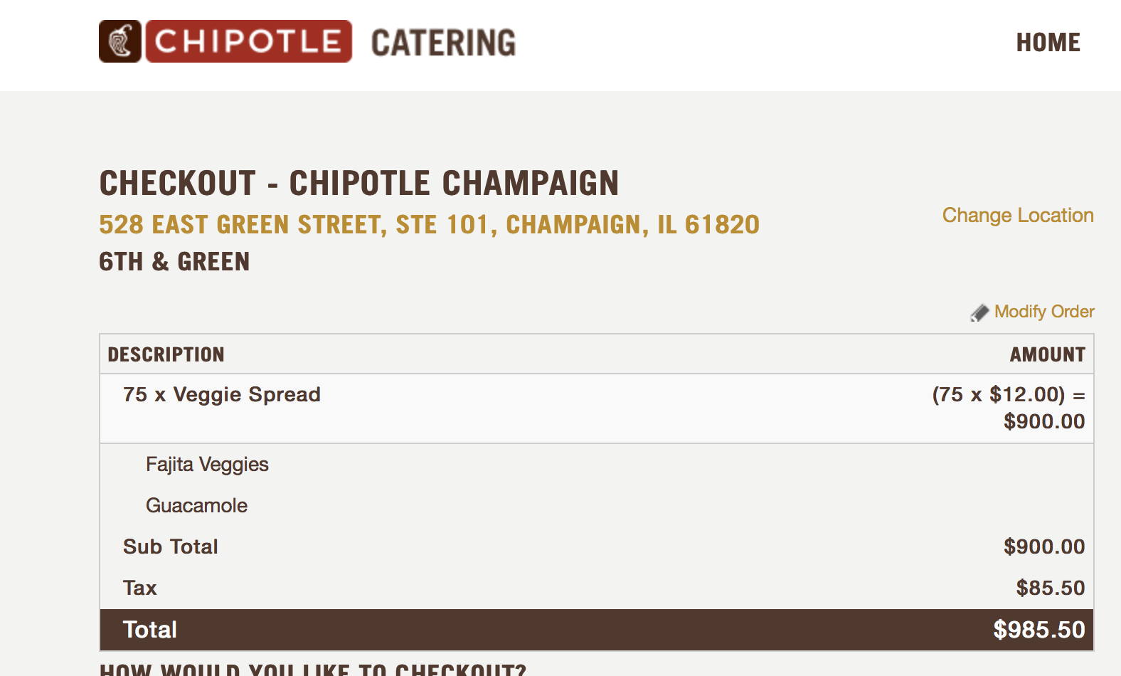

If the project is implemented, will there be any ongoing funding required? What is the strategy for supporting the project in order to cover replacement, operation, or renewal costs? (Note: SSC provides funding on a case by case basis and should not be considered as an ongoing source of funding)
We will not consider SSC as an ongoing source of funding; although we will continue this project next year, we plan to use the energy reduction generated from the competition this year as a basis for appealing Housing’s decision to retract their support. Additionally, we will research alternative funding for the upcoming year; we are only now seeking support from the SSC because Housing pulled their support on an extremely short notice.

Please include any other sources of funding that have been obtained or applied for, and please attach any relevant letters of support.
Institute for Sustainability, Energy, and the Environment has granted us $1,300 for Lucid Technologies’ Energy dashboard.

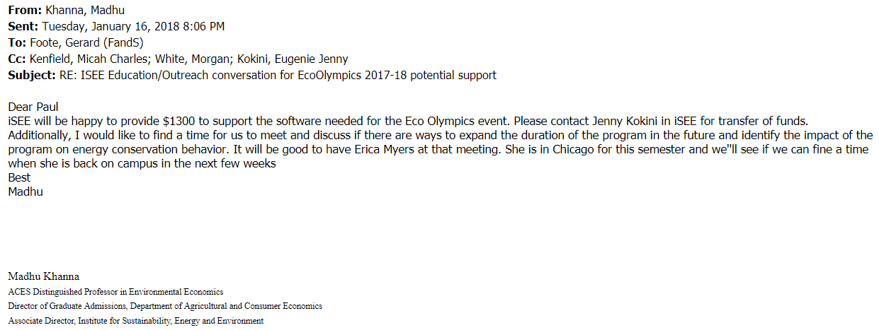

What is the plan for publicizing the project on campus? In addition to SSC, where will information about this project get reported?
In past years, we have relied mainly on University Housing to publicize our project- posters were pinned on bulletin boards within residence halls, and Eco-Olympics updates were sent through the Housing newsletters. This year, we have a plan that we feel will be more successful and reach more students, primarily through social media. We have already been contacting RSOs, such as American Chemical Society, to give brief presentations about what the competition is and where students can register. We have been and will be contacting professors who teach large lectures (primarily consisting of first-year students) to put up a slide about our competition with the sign-up link at the start of class. By February 12th, we will be contacting various campus departments to ask permission to have a graphic about our competition used as the screensaver or desktop background, as well asking if we can be included in their newsletters.

