*Please submit this completed application, the supplemental budget spreadsheet, and any relevant supporting documentation by the deadline indicated in your Step 1 notification letter to* [*Sustainability-Committee@Illinois.edu*](mailto:Sustainability-Committee@Illinois.edu)*.The Working Group Chairs will be in contact with you regarding any questions about the application. If you have any questions about the application process, please contact the SSC at* [*Sustainability-Committee@Illinois.edu*](mailto:Sustainability-Committee@Illinois.edu)*.*

# General Information

**Project Name:** New Baler Feasibility Study

**Total Amount Requested from SSC:** $20,000

**Project Topic Area(s):** Energy Education Food & Waste

Land Water Transportation

# Contact Information

### Project Lead

Applicant Name: Morgan White

Unit/Department: Facilities & Services, Sustainability

Email Address: mbwhite@illinois.edu

Phone Number: 217-333-2668

### Financial Contact *(Must be Full-time University of Illinois Staff Member)*

Contact Name: Mike Alsip

Unit/Department: F&S

Email Address: alsip@illinois.edu

Phone Number: 244-4049

Organization Code: 701

### Facilities Management Contact *(If Applicable)*

Contact Name: Pete Varney

Email Address: pvarney@illinois.edu

**Primary Project Team**

|  |  |  |
| --- | --- | --- |
| **Name** | **Department** | **Email** |
| Ted Christy | F&S | tchristy@illinois.edu |
| Marya Ryan | F&S | maryar@illinois.edu |
| Name | Department/Organization | Email Address |
| Name | Department/Organization | Email Address |

# Project Description

**Please provide a brief background of the project, the goals, and the desired outcomes:**

The 2015 iCAP includes a goal to decrease waste going to landfills from our campus buildings. This is called Municipal Solid Waste (MSW), and our campus goal is to increase the diversion rate of MSW from 30% to 45% by FY20. To that end, the Purchasing, Waste, and Recycling Sustainability Working Advisory Team (SWATeam) submitted a recommendation to start recycling plastics 3-7 at the F&S Waste Transfer Station (WTS). The WTS staff collects and sorts commodity recyclables from the campus waste stream, bales the sorted material, and sells the bales to recycling vendors to support the waste handling operations.

The existing baler at the WTS is unable to handle the wider variety of plastics, so a new baler is required before we can increase the types of plastics collected. Tracy Osby at the WTS identified an appropriate new baler (at a cost of approximately $300K – see materials submitted with Step 1), but the cost of installing the equipment is currently unknown. F&S would like to hire an engineering firm to identify the total construction/installation project costs, so that funding can be pursued to purchase and install the new baler, and thus expand the scope of plastic recycling on campus. We are requesting that the SSC provide funding for this initial “feasibility study.”

It is likely that additional support from the SSC will be requested, in coordination with other funding sources, if the results of this conceptualization are favorable and campus agrees to move forward with the upgraded baler and additional plastic recycling.

**How will the project improve the sustainability of the Illinois campus and how will the project go above and beyond campus standards?**

The 2015 [Waste Stream Characterization Study Phase 2](http://icap.sustainability.illinois.edu/project/waste-stream-characterization-study-phase-2) of four sample campus buildings found an average of 30% recyclable material coming out of typical campus buildings. The bottle shaped plastics were 2.9% and the other plastics were 5.5%. See pie chart and Table 2, below.

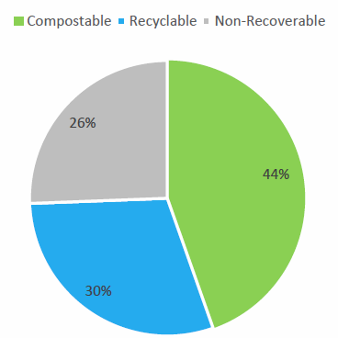 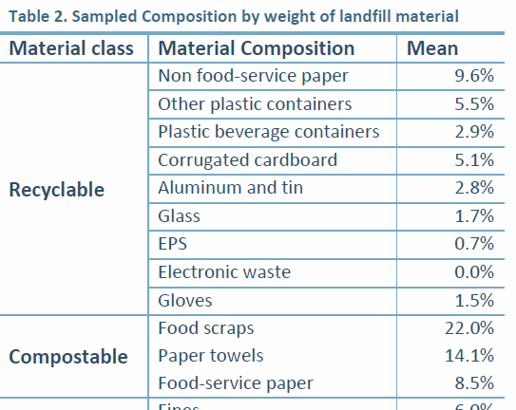

These figures correspond nicely with the results of the 2014 [Waste Stream Characterization Study Phase 1](http://icap.sustainability.illinois.edu/project/waste-stream-characterization-study-phase-1) in four administrative/office buildings on campus. It found 28% recyclable materials with 3% bottle-shaped plastics.

The results of these samples indicates that by increasing the types of plastics collected for recycling on campus, the MSW diversion rate will increase. If we assume the capture rate of the bottle-shaped plastics will be duplicated with the capture of plastics 3-7, then we can estimate the volume of plastics collected in the future. We take the current volume of bottle-shaped plastics, divide by 2.9, and multiply by 5.5, to estimate the future volume of plastics #3-7 collected. This calculation results in an estimated 83 more tons of plastic recycling per year, which is over 160,000 pounds per year diverted from the landfill.



**Where will the project be located? Will special permissions be required to enact the project on this site? If so, please explain and submit any relevant letters of support with the application.**

The feasibility study will look at the infrastructure and interconnection requirements for replacing the existing baler at the Waste Transfer Station, located at 10 E. St. Mary's Road, Champaign, IL. No special permissions are needed, beyond F&S leadership.

**Other than the project team, who will have a stake in the project? Please list other individuals, groups, or departments affiliated directly or indirectly by the project. This includes any entity providing funding (immediate, future, ongoing, matching, in-kind, etc.) and any entities that will be benefitting from this project. Please attach letters of commitment or support at the end of the application.**

none

**Please indicate how this project will involve or impact students. What role will students play in the project?**

There are two students on the related SWATeam who made the initial recommendation. The PWR SWATeam will continue to be informed of progress on this effort, and the student members and student clerk of that team (along with the rest of the team) will be included in discussions and interim results for the feasibility study. There are also opportunities to include students in longer term follow up efforts to seek funding and implement the changes.

The real impact to the students will be if the baler can be approved and funded, so we expand the recycling collected on campus to include more types of plastics.

# Financial Information

*In addition to the below questions, please submit the supplemental budget spreadsheet available on the Student Sustainability Committee website. Submission of both documents by the submission deadline is required for consideration of your project.*

**Have you applied for funding from SSC before? If so, for what project?**

We have applied for SSC funding several times before. Regarding Zero Waste, SSC has funded Waste Characterization Studies, the Recycling Bins for the Quad, and Net Zero Game events. The current SSC project underway is the Zero Waste Coordination project, funded in FY16.

**If this project is implemented, will there be any ongoing funding required? What is the strategy for supporting the project in order to cover replacement, operation, or renewal costs?   
  
Please note that SSC provides funding on a case by case basis annually and should not be considered as an ongoing source of funding.**

After the feasibility study is complete, F&S will seek funding for the purchase and installation of the new baler. Potential funding sources include the Il DCEO “Illinois Recycling Grants Program,” additional SSC support, and a direct campus funding allocation.

It is also possible that there will be some financial contribution allowable from the F&S Waste Management budget; however, the overarching financial strategy for increasing recycling rates has not yet been determined. The leadership for F&S Waste Management is changing on December 4, 2017. Tracy Osby will be moving to a new position with the Building Service Workers, and Pete Varney will provide oversight to the Waste Transfer Station. With these changes in leadership staff for the department, the recurring campus budgetary funds for waste management will be reviewed.

One point of review will be the potential for any future cost savings to help fund the initial purchase and installation of the baler. In the Waste Characterization Studies, the increase in types of plastics collected and baled for recycling included this discussion on the impacts on revenues from the sale of plastic recyclables: “…the perceived loss of revenues from capturing additional types of plastics is due to anticipated reduction in the quality of bails. However, by accepting a greater variety of plastics, more volume for plastics bails will be generated. While the bails will generate less revenue per bail compared to the current system, there will be an increase in total quantities of bails generated. A sizeable increase in acceptable materials will inevitably reduce the materials destined for the landfill and thus reduce costs of transportation and tipping fees. By accepting all plastics, the message to community members would be simplified and more clearly understood. In addition, there would be clarity throughout campus leading to a decrease in landfilled materials.” When this feasibility study is complete, we anticipate having a better understanding of the cost/benefit implications of the increased volume of plastic recycling this baler will allow.

**Please include any other sources of funding that have been obtained or applied for. Please attach any relevant letters of support as needed in a separate document.**

none

# Environmental, Economic, and Awareness Impacts

*In addition to the below questions, please indicate specific measurable impacts as applicable on the supplemental budget spreadsheet.*

**Which aspects of sustainability does your project address, and how? Does the project fit within any of the iCAP goals? If so, how does the project go beyond the university status quo standards and policies.**

This project is directly tied to the Purchasing, Waste, and Recycling goals from the 2015 iCAP. The iCAP objective #6.2 is "Reduce municipal solid waste (MSW) going to landfills. This involves reducing nondurable goods purchases, effectively reusing materials, and recycling. In the latter category, campus will increase the diversion rate of MSW to 45% by FY20, 60% by FY25, and 80% by FY35, while also increasing the total diversion rate to 90% by FY20 and 95% by FY25. MSW sent to landfills should decline to 2,000 tons annually by 2035."

In FY17, the MSW diversion rate was only 26.6%, down from 31.1% in FY14 when the 2105 iCAP was written (see Table 7 below). Based on the estimated impact described above, the diversion rate would go up to 27.8% simply by accepting more types of plastics.

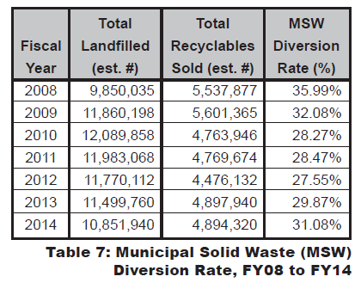

This would be a major improvement in the recycling system available on campus, and it would bring us into alignment with plastics accepted by both of the municipal recycling systems in Champaign-Urbana.

**How will the environmental impacts of your project be measured in the near and long term? What specific monitoring and evaluation processes will you be using to track outcomes and progress?**

In the near term, the deliverables from this feasibility study will be the preliminary engineering design, baler recommendations, estimated capital equipment/installation expenses (CAPEX), and estimated operating expenses (OPEX). The OPEX will also include the estimated energy demand for the new machinery.

The long-term impacts were discussed previously, and the total tons of plastics collected and sold for recycling will be tracked annually and reported on the iCAP Portal and at the Campus Sustainability Celebration each year.

**What is the plan for publicizing the project on campus? In addition to SSC, where will information about this project be reported?**

The project will be included in the iCAP Portal.

**What are your specific, measurable outreach goals? How will these be measured?**

This project does not have outreach goals, with the feasibility study. The outreach goals will be incorporated in the next step, when the new baler gets installed (if funded to proceed).

**Do you have any additional comments or relevant information to aid in evaluation of this application?**

As discussed in the SSC Food and Waste Working Group, the total landfilled pounds per year found from the Waste Characterization Study includes only 30% recyclable material. Based only on this small sampling, if we captured every bit of recyclable material coming out of campus buildings, the diversion rate could only be 30%. Our iCAP goal is 45%. The larger-scale solution will have to involve diversion of compostable materials, such as food scraps and paper towels. Regardless, we need to move forward with any possible improvements to the UIUC recycling system, as quickly as feasible. That’s what this project aims to do.