Please submit this completed application and any relevant supporting documentation by the deadline listed on the SSC website to Sustainability-Committee@Illinois.edu. The Working Group Chairs will be in contact with you regarding any questions about the application. If you have any questions about the application process, please contact the Student Sustainability Committee at http://sustainability-committee@illinois.edu.

General Information

Project Name: Get Mugged

Total Amount Requested from SSC: $7605

Project Topic Areas: ☐ Land & Water ☐ Education ☐ Energy
☐ Transportation X Food & Waste

Contact Information

Applicant Name: Maria Velasco and Jacqueline Coreno
Unit/Department or RSO/Organization: Sustainable Business Committee, SECS
Email Address: vlscdlg2@illinois.edu and coreno2@illinois.edu
Phone Number: (217)607-6516 and (773)606-8369

Project Team

Name | Department | Email
Jacqueline Coreno | SECS | coreno2@illinois.edu
Maria Velasco | SECS | vlscdlg2@illinois.edu
Samantha Delgado | SECS | sad4@illinois.edu
Alexis Ivanic | SECS | ivaniale123@gmail.com
Vanessa Fuentes | SECS | vfuents2@illinois.edu
Kaylee Smith | SECS | kaylees2@illinois.edu
Melissa Wilfong | SECS | wilfong3@illinois.edu
Vaishnavi Naidu | SECS | vnaidu3@illinois.edu

Financial Contact’s Name:
Faculty/Unit/Department:
Email:
Phone:

(If Applicable)
Facilities Manager Name:
Email:
Phone:

Project Information

Provide a brief background of the project, its goals, and the desired outcomes.

How will this project improve sustainability at UIUC?

It will improve sustainability at UIUC by reducing waste by having students bring their own mug instead of purchasing a disposable mug. The reusable mug can be used at multiple locations and with multiple businesses.

Where will the project be located? Do you need special permissions to enact the project at this site? If so, please explain and attach a letter of support to your application.

The project will be located at the University of Illinois campus. We will give students reusable mugs at Anniversary Plaza.

Other than the project team, who will have a stake in the project? Please list other individuals, groups, or departments indirectly or directly affiliated to this project. This includes any funding entities (immediate, future, ongoing, etc.) and any entities that will be benefiting from this project.

University of Illinois students will directly benefit by receiving discounts ($0.50 off any drink) when buying coffee or other beverages in several coffee shops including Espresso Royale and University Housing a La Carte locations (Caffeinator, ISR Chomps, Busey Bean and Green, and Penn Station).
Espresso Royale will benefit by having students bring their own mugs and reducing their waste.

Please indicate how this project will involve or impact students. What role will students play in the project?

This project will encourage students to reduce their waste by using reusable cups when purchasing hot drinks. Student action is key to this project’s success. There is incentive for both the students and the businesses to utilize our reusable cups.The more people bring their mugs, the less businesses will need to purchase disposable cups. It will allow students to be more conscious about environmental issues, specifically waste. It will promote sustainable lifestyles.

Have you applied for funding with SSC previously? If so, for what project?

No.

Scope, Schedule, and Budget verification

What is the plan for project implementation? Describe the key steps of the project including the start date, target completion date, target date for submitting a final report, and any significant tasks or milestones in the table below. Please be as detailed as possible.
- Finalize offers and discounts to be offered with coffee shops. (December 20th, 2017)
- Order reusable mugs (Winter Break)
- Have events at Anniversary Plaza to give out reusable mugs to students of the University. These events will be educational, we’ll give out mugs but we will educate students on how to be more sustainable at the same time. (Throughout the whole month of January and early February)
- Launch campaign (Mid February 2018)

List all budget items for which funding is being requested. Include cost and total amount for each item requested. Please be as detailed as possible.

- Travel mugs (two different options):
Option 1: Torch tumbler
https://www.inkhead.com/torch-tumbler/27207/
Number of cups | Price per unit | Total price: (price per unit * # of cups) + set up fee
500 | $3.10 | $1605
1000 | $2.95 | $3005
2000 | $2.95 | $5955

Option 2: Blue Monday Travel Tumbler
https://www.inkhead.com/16oz-blue-monday-travel-tumbler/26746/
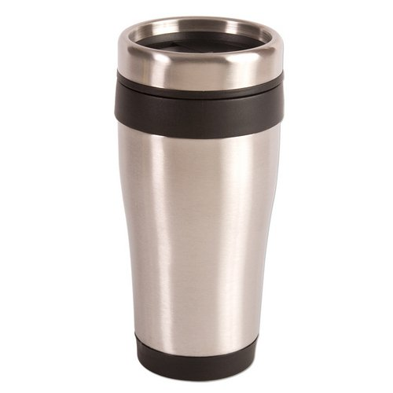
Number of cups | Price per unit | Total price: (price per unit * # of cups) + set up fee
600 | $3.11 | $1921
1200 | $3.01 | $3667
2500 | $2.96 | $7455

Note: we’re open to suggestions about other options to buy reusable mugs in bulk

2) Advertising expenses: $150

If the project is implemented, will there be any ongoing funding required? What is the strategy for supporting the project in order to cover replacement, operation, or renewal costs? (Note: SSC provides funding on a case by case basis and should not be considered as an ongoing source of funding)
The project does not require ongoing funding. Once coffee mugs are ordered, received and distributed to University of Illinois students, the next phase of the project requires promotion of the campaign and working with Espresso Royale at the UGL, Grainger and BIF; and Dining Services.

Please include any other sources of funding that have been obtained or applied for, and please attach any relevant letters of support.
No other sources of funding.

What is the plan for publicizing the project on campus? In addition to SSC, where will information about this project get reported?
We will publicize the project with posters at the locations which have discounts for reusable mugs. Social media will also be utilized by SECS. People can take pictures with their mug, and they will be able to get an additional discount for the picture used with the hashtag #gotmugged.

