Please submit this completed application and any relevant supporting documentation by the deadline listed on the SSC website to Sustainability-Committee@Illinois.edu.The Working Group Chairs will be in contact with you regarding any questions about the application. If you have any questions about the application process, please contact the SSC at Sustainability-Committee@Illinois.edu.

General Information
Project Name: Special Needs Sustainable Goat Enrichment

Total Amount Requested from SSC: $9,999.99

Project Topic Area(s): ☐Energy ☐Education ☒Food & Waste
☐Land ☐Water ☐Transportation

Contact Information
Applicant Name: Emma Kamps
Unit/Department: Veterinary Clinical Medicine
Email Address: ejkamps2@illinois.edu

Phone Number: 8154047204

Project Team
Name | Department | Email
Emma Kamps (Student Leader of 1st – 4th year students) | Veterinary Clinical Medicine | Ejkamps2@illinois.edu
Courtney Hayes, DVM (Faculty Advisor/Sponsor) | Veterinary Clinical Medicine | Ahern@illinois.edu
Ashley Mitek, DVM (Faculty Advisor/Sponsor) | Veterinary Clinical Medicine | Amitek2@illinois.edu
Name | Department/Organization | Email Address

Project Information
Please provide a brief background of the project, the goals, and the desired outcomes:

The College of Veterinary Medicine has two much-loved resident teaching goats, Oz and Andora. Oz is a special needs goat adopted by the college. He has a happy and fulfilled life here, however, due to a previous injury prior to adoption, his hindlimb mobility is limited compared to other goats. He can run and play like any other goat, however, he is at increased risk of fall injury due to his condition. Thus, we need to construct an accessible and safe enrichment area for these goats.

Oz and Andora currently live in a dirt paddock on Hazelwood Drive, off of Linocln Ave. From a behavioral standpoint, goats are curious and social animals that enjoy climbing and grooming.

The goal of this project is to repurpose used broom brushes, street cleaning brushes and other materials from campus housing and facilities that would otherwise be thrown in the trash.

Here are a few examples (these would need to have railings added so that Oz could play too, with no risk of falling):

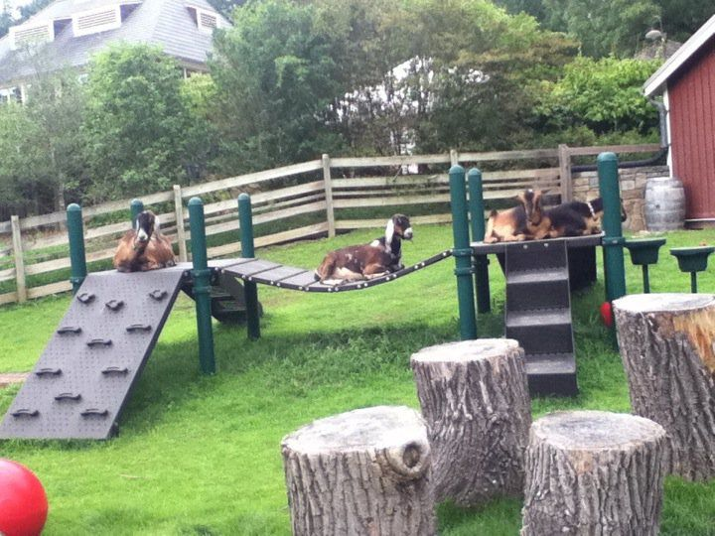

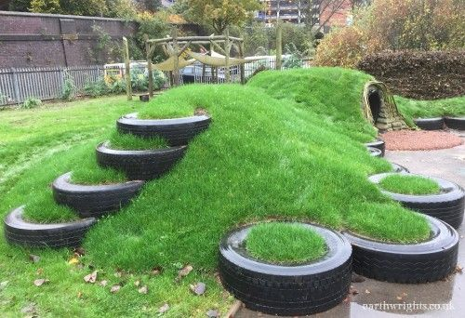

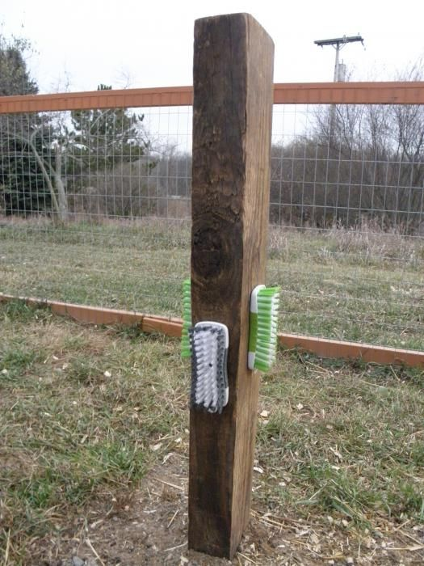

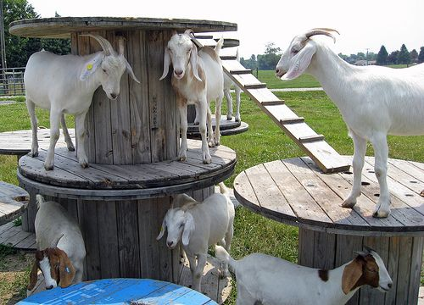

An example of a commercial street cleaning brush for grooming (We contacted university facilities and they are happy to donate their used brushes):
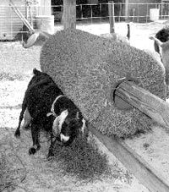

Please provide a brief summary of how students will be involved in the project:

This project is student lead by Emma Kamps, a 2nd year veterinary medical student, with a strong interest in goat medicine. Several other 1st – 4th year veterinary students are also involved in the design and implementation of a sustainable goat enrichment program.

Two faculty, Drs. Hayes and Mitek, will serve an advisory/sponsor role in the project, but the students will run the project.

Please provide a brief summary of the project timeline:

January 2018 – Students organize and collect materials for enrichment

March 2018 – Installation of enrichment materials (this may need to be postponed until April or May depending upon weather)

Additional comments
- We feel that this project is beneficial to the goats, but also helps increase awareness of the need for sustainable animal enrichment because these goats are housed in a very public area of the veterinary college (over 100+ students, staff, faculty and clients drive by these goats everyday)
- If funded, we would create a plaque thanking the Student Sustainability Committee for their support
- Also, if funded, we would look forward to taking a short video of the goats enjoying the playground for social media, and to further the mission of the Student Sustainability Committee
- This project could be used for student-led research projects evaluating the impact of environmental enrichment on goats
- The special needs goat playground will beautify the college while embracing a culture of inclusivity

