Please submit this completed application and any relevant supporting documentation by the deadline listed on the SSC website to Sustainability-Committee@Illinois.edu. The Working Group Chairs will be in contact with you regarding any questions about the application. If you have any questions about the application process, please contact the Student Sustainability Committee at http://sustainability-committee@illinois.edu.

General Information

Project Name: Illini Bike Rental Service

Total Amount Requested from SSC: $7,500

Project Topic Areas: Land & Water Education Energy
Transportation Food & Waste

Contact Information

Applicant Name: Shayan Sharif Zahid & Zequn Wang
Unit/Department or RSO/Organization: NPRE
Email Address: sszahid2@illinois.edu
Phone Number: 6302908201

Project Team
Name | Department/Organization | Email
Zequn Wang | NPRE Energy Systems | zequnw2@illinois.edu
Shayan Sharif Zahid | NPRE Energy Systems | sszahid2@illinois.edu

Financial Contact’s Name: Prof. Rizwan Uddin
Faculty/Unit/Department: NPRE
Email: rizwan@illinios.edu
Phone:

(If Applicable)
Facilities Manager Name:
Email:
Phone:

Project Information

Provide a brief background of the project, its goals, and the desired outcomes.

With an increasing awareness of the climate change and its effects on the climate, many cities like Chicago, Newyork, Beijing and San Francisco etc. have now adopted bike sharing programs as an alternative sustainable transportation method. Universities like Princeton and Yale have also long ago established their bike sharing programs to provide a greener alternative to commute within the campus. Bike sharing has the potential to provide an efficient, cheap, healthy, and convenient way to travel. This project would not only contribute to the reduction of carbon emissions but would also enable the university to meet its sustainability goals.

With this idea in mind the main aim of this project is to increase the awareness and the use of bikes to commute in the campus area. The Illini bike rental is no different than borrowing a book from a library. Students would be able to rent a bike which would be issued to them using the university i-card. The rental duration will start from a day to a week. The bikes after use can be returned to the designated check in/checkout points. A lock would also be provided along with the bike so that the existing bike parking spaces in the campus could be used to lock the bikes around the campus.

Phase 1:
The phase one is a pilot project whereby a fleet of 50 bikes will be maintained by the university and provide free rental bike service. Keeping in mind the issues which were faced with the similar idea in the past, the plan is to keep it free to encourage students to cycle rather than use a car/bus. If the university would charge for the service students would then prefer the free bus over cycling. The idea is to increase the number of cyclists on the road in the first phase and increase awareness to cycle around the campus rather than using a car or bus.

Phase 2:
Once this project picks up pace and the students start showing interest in the illini bike rental service on a daily basis, a bike sharing program can be introduced. New bikes such as FordGoBike, MoBike etc. can be introduced which are equipped with QR codes and a GPS. Same bike stations can then be converted into docking stations which would enable students to self-issue bikes using an app.

How will this project improve sustainability at UIUC?

If we can increase the number of students cycling to the campus, we can reduce a large amount of cars entering in the campus area. This would enhance the air quality and reduce emissions in the campus as there would be less number of cars on the road. Also if large numbers of students start cycling ultimately the number of buses coming into the campus area could be reduced during summer months leading to an even higher reduction in carbon emissions.

Where will the project be located? Do you need special permissions to enact the project at this site? If so, please explain and attach a letter of support to your application.

The project would need 50 bikes in phase one that could be housed on different locations (illini cycle storage) around the campus. The location would need an attendant (student volunteers) who could check in and check out the bikes during university hours. Some check in/checkout locations like libraries can be 24 hours and others can be during university hours. Special permissions might be needed for deciding the locations after discussing them with the facilities department.

Other than the project team, who will have a stake in the project? Please list other individuals, groups, or departments indirectly or directly affiliated to this project. This includes any funding entities (immediate, future, ongoing, etc.) and any entities that will be benefiting from this project.

The university will be the main stake holder as it will own the fleet of the bikes. Also societies like illini cycling club can be incorporated into this program that can carry out events related to cycling in the suburbs of the city.
Please indicate how this project will involve or impact students. What role will students play in the project?

Students would find it easier to cycle to campus if they can issue a free cycle from a convenient location. Buses drop off students at bus stops after which they have to continue to walk to a building, but by using a bike a student can go anywhere in the campus. Students can use existing parking spaces available for the bikes. Also student volunteers can run the illini cycle storage locations.

Have you applied for funding with SSC previously? If so, for what project?

No

Scope, Schedule, and Budget verification

What is the plan for project implementation? Describe the key steps of the project including the start date, target completion date, target date for submitting a final report, and any significant tasks or milestones in the table below. Please be as detailed as possible.

Project Implementation: The project will be implemented in two phases; the first phase is a cheaper alternative to phase two to keep the initial costs down of the project and to increase of chance of success.

Start of the project: The project ideally should start before winters and all the infrastructure should be in place before December. In case the project is delayed the launch of the illini bike rental service can be done in spring which is the best time to promote cycling.

Target date for report: The final Report will be submitted after the initial acceptance of this project. A monthly report would then be issued by students working on the project.

Milestones: The first step will be to ascertain along with the facilities department the locations for the illini bike storage facility. Key areas such as the ARC, Grainger Library, and Illini union will be proposed as preferred locations to the facilities department. The second milestone will be to secure the cheapest bikes (fleet of 50) along with locks. Subsequent marketing by email and campus events will be done in order to spread the word around campus. The last milestone will be to launch the service for the students of the university.

Phase two of the project will incorporate commercially available bikes like the MoBike and the FordGoBike. These bikes will be state of the art bikes with dynamos, GPS and QR code locks as shown below in the pictures.

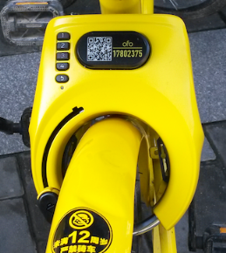
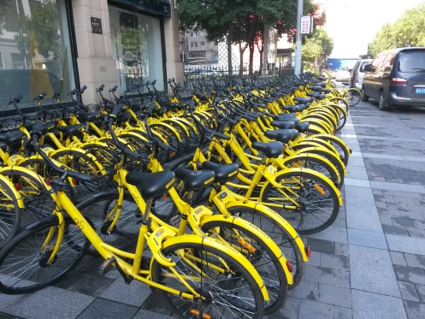
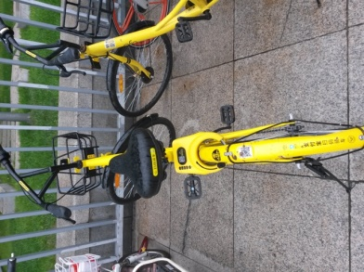

Figure1: Commercially available bikes in china.

List all budget items for which funding is being requested. Include cost and total amount for each item requested. Please be as detailed as possible.

There are four main components for our project:
Item | Unit price | Number | Amount
Bikes | $60 | 50 | $3000
Locks | $10 | 50 | $500
Rebranding(Paint/Logo) | $20 | 50 | $1000
Civil Mechanical Works |  |  | $3000
 |  | Total | $7500

If the project is implemented, will there be any ongoing funding required? What is the strategy for supporting the project in order to cover replacement, operation, or renewal costs? (Note: SSC provides funding on a case by case basis and should not be considered as an ongoing source of funding)

The maintenance of the bikes will be periodically needed which is very low as compared to the total cost of the project. Essential maintenance of the bikes can take place during winters when there will be a reduced load on the system. Also if there is any significant damage to the bike the registered student will be viable to pay damages which will account to replacing the bike.

Please include any other sources of funding that have been obtained or applied for, and please attach any relevant letters of support.

For the second phase of the project the students working on the project are already in contact with possible bike sharing companies such as FordGobike, Mobike, Zagster who would probably be interested in providing further funding and bikes after seeing the success of phase one.

What is the plan for publicizing the project on campus? In addition to SSC, where will information about this project get reported?

On campus societies such as illini bike cycling club could be engaged in order to promote using illini bikes for their cycling trips. Illini bikes could be promoted using events arranged in the memorial stadium. Also marketing can be carried out by engaging student volunteers. Each dorm can have an illini bike champion who would have most miles on a bike this could encourage young freshmen and undergraduate students to compete to collect miles.

