# *Thank you for your commitment to green initiatives at the University of Illinois. One of the ongoing requirements listed in the terms of the funding agreement for your project is the submission of semesterly reports with key information about your project. In addition to this form, please provide additional financial documentation and/or progress photos if available.*

# *Please be as accurate as possible in describing the project (including possible setbacks or challenges in meeting the initial goals of the project). Not fully meeting your project's goals will not disqualify you from making future funding requests as long as your reports are as complete and accurate as possible. If you have any questions, please contact the Student Sustainability Committee, at* [*sustainability-committee@illinois.edu*](mailto:sustainability-committee@illinois.edu)*.*

**Project Name:** Zero Waste Coordination

**Date of Report Submission:** 1/22/2019

**Project Purpose:**

This project is to expand the dual bins on the Quad to other areas of campus, increase use of recycling bins, and promote recycling solutions.

**Detailed Accounting of Expenditures to Date:**

So far we paid $1,415.12 for Anna Barnes in Customer Relations and Communications at F&S to help develop the content for a PowerPoint presentation to staff about how recycling on campus works – in the context of “Use the Bin!” As of 12/31/2018, we have paid $4,940 for Marya Ryan to draft content for the recycling presentation and glove recycling program, map the locations of outdoor waste bins on campus, and assist with research and communications related to glove, glass, battery, and EPS recycling. Of that total, $1,134 was used for the recycling presentation, mapping the outdoor waste bins, and communications related to the campus’s transition to source separation at the point of disposal.

There is now $57,546.88 available for purchase and installation of the new dual bins.



**Project Progress to Date:**

Hired Marya Ryan as an Academic Hourly in Mar. 2017. She has been working 3-5 hours per week since then, with occasional weeks off. Marya’s efforts are recorded weekly in the iCAP Portal under the main “Zero Waste” project at <https://icap.sustainability.illinois.edu/project/zero-waste>. She met with the SWATeam in the spring of 2017 and got up to speed on the ins-and-outs of the various special recyclables projects. Ryan has met with people asking about recycling on campus, including Jessica Tran at Ashton Woods.

Ryan, White, and Micah Kenfield met with some faculty interested in a more detailed analysis of battery recycling impacts in the summer of 2017. One of the faculty members was working with a sustainability fellow, Marcus Smith, on a capstone project to provide such analysis. In the spring of 2018, the faculty members drafted a proposal for a self-funding battery recycling program, which Ryan provided feedback on. The PWR SWATeam has taken ownership of the proposal. SSC declined to fund the proposal, given the uncertainties around the funding sources and the complexity of the issues. The PWR SWATeam will continue to explore battery recycling.

Ryan updated battery recycling instructions on the Portal. Battery recycling information has also been fully updated online at F&S.

In June 2017, we added a work order to pay for design work at F&S for Anna Barnes to help out. She created materials to promote the glove recycling program, using content from Ryan, White, and Kimberly Clark representatives. Ryan made substantial updates to glove recycling material on the Portal, including instructions for new users. She created a web form for program participants to submit contact and location information, and the form has been posted.

In September 2018, the Division of Research Safety (DRS) contacted Morgan White to discuss glove recycling program guidelines to prevent hazardous materials from entering the recycling stream. White and Ryan agreed to obtain PI and teaching coordinator names as well as labs/room numbers where gloves were being collected. In early December 2018, after obtaining information from other universities that considered or implemented glove recycling, DRS advised against allowing laboratories to participate, given the difficulty in implementing and verifying compliance. Morgan White notified participating labs that they would no longer be able to recycle gloves as of Dec. 31, 2018. Updates to the glove recycling information on the iCAP portal are under way.

Previously, Ryan had met with student volunteers from Business for Environmental Responsibility (BER) and obtained glove purchasing reports for them to review. The volunteers obtained contact information for departments that purchase large quantities of gloves but do not yet participate in the glove recycling program. The plan is for the students to help recruit new participants. The students assisted in obtaining PI and lab/room number information for DRS. Ryan let them know that the program will shift recruitment efforts to food service and other venues that do not handle hazardous materials.

In the spring of 2018, with assistance from Anna Barnes, Ryan found a local farmer interested in collecting coffee grounds from the Illini Union Starbucks for use on his farm.

In the summer and fall of 2017, Ryan worked on the glass recycling issue, which involved a new recycling sign for the small number of locations that were to fund their own glass recycling with their own facility (starting with the Wounded Vets building) and handling the issue that arose when CRI was sold to Midwest Fiber and they stopped the service for picking up the glass.

Ryan coordinated with Olivia Harris at iSEE to strategize communication plans about teaching campus how the recycling system works here. She drafted the key message that went to staff about “Use the Bin.” Using content Ryan developed about how the campus recycling system currently works, Anna Barnes created a PowerPoint presentation for staff. The Use the Bin messaging was expected to be presented to key campus staff groups this past spring by student intern Leah Berti. Berti worked with Morgan White to plan these meetings and present the key message of “Use the Bin” so campus staff stop mistakenly telling students, visitors, and new employees that they can put recyclables in the trash cans. Due to scheduling difficulties, the message was presented by Leah to only a few groups.

Ryan also worked with iSEE on a message to participants in the Styrecycle program, updating them about the current status of the program. She assisted with getting the EPS densifier transferred from Midwest Fiber to campus, when Midwest Fiber notified us that they are not willing to house it as CRI had done prior to the sale of the business. The possibility of installing the densifier at the Waste Transfer Station was included in the scope statement for the Feasibility Study SSC funded for a new baler at that location. It was found that the only way to install the densifier at the Waste Transfer Station is to build a small addition, which is cost prohibitive. Ryan will investigate potential alternate homes for the densifier this spring.

In June 2017, we transferred the funding for the student interns to iSEE, so they could do the hiring and oversight of the students hired to help with the special recyclables. They hired two students for the Styrecycle program in the summer of 2017, reporting to Micah Kenfield. The other special recyclables are: nitrile gloves, alkaline batteries, and glass. As mentioned earlier in the report, a SEE minor student worked on a capstone project on battery recycling, for no cost. The glass recycling is on hold while we address the lack of vendor issue. Glove recycling at food service locations on campus is being promoted by BER volunteers, with guidance from Marya Ryan.

With regard to building-specific solutions, a student named Becky Jonas volunteered with Morgan and the PWR SWATeam this spring to improve the impact of indoor recycling bins. She started with the Hydrosystems Lab, and then worked with the buildings from the waste characterization studies. At each building, Jonas mapped the existing and proposed bins, working with facility and building service worker contacts and modifying the indoor collection areas to increase recycling rates at the point of disposal. In the fall of 2018, Building Service Worker leadership gave permission to pilot dual bins in the Newmark Civil Engineering Building. Bins have been ordered for the pilot—14 for paper collection 14 for aluminum can collection. Civil and Environmental Engineering (CEE) students have volunteered to help with the effort. There was a survey done before the bins were installed (during summer 2018), so a future survey can hopefully illustrate the impact of additional bins.

With regard to the campus’s outdoor bins, Ryan mapped the existing ones for the full University District and turned her maps over to the Purchasing, Waste, and Recycling (PWR) SWATeam for their recommendations on locations for dual bins. PWR SWATeam student member Fangxing Liu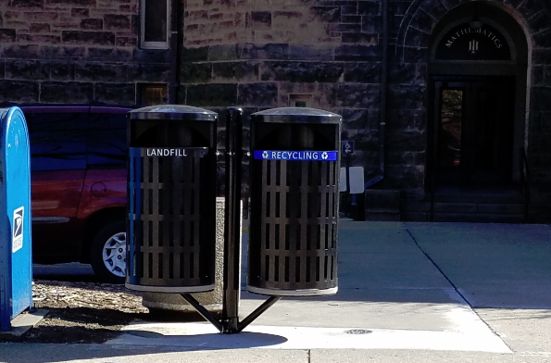 wrote an initial draft recommendation for the consolidation of dual bins outside. See the image below with a screen shot of one page of the map. Additionally, one sample dual bin was installed (with other funding) at Altgeld Hall near Wright Street to test durability. A photo of these bins is shown to the left. Ryan drafted a proposal to the campus Architecture Review Board (ARC) to install the dual bins across the University District in the locations identified by Liu, and the proposal was approved. In the fall of 2018, CEE students volunteered to assess additional bin locations in peripheral areas of campus. The Grounds Department will need to confirm locations identified by Liu and the CEE students.

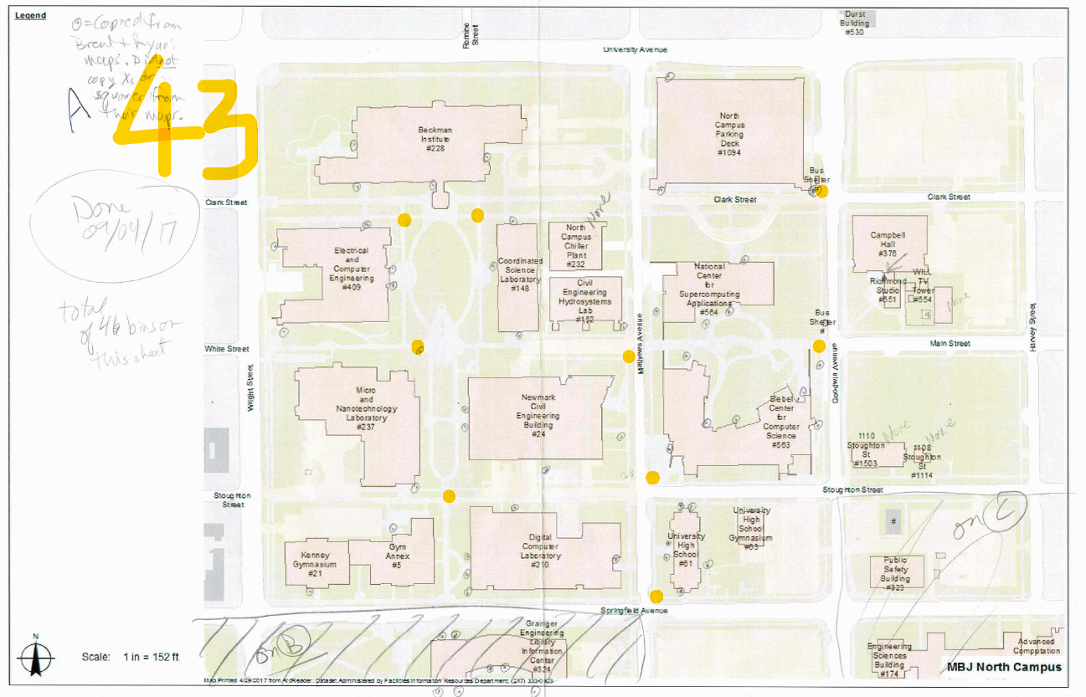

Ryan Welch prepared a preliminary cost estimate for replacing the bins, and an additional estimate has been calculated. Further information and adjustments are needed. MCORE is installing about five dual bins on Green Street with University funding. Installation costs will help in formulating a more accurate estimate for the full project.

During fall 2018, CEE students Junren Wang and Wen-Chi Chen worked on a project to clarify locations and review estimated costs. They mapped the future dual bin locations for the campus, with a total of 161 bins to install. The cost of the first pilot dual bin was about $4,000, so the initial estimate for all of them is about $625,000. The students recommended installing ten dual bins in various locations spread around campus. Morgan White will proceed with work orders to purchase and install the dual bins at those locations this spring. Please see the student report, copied on this email.

**Student Involvement and Outreach to Date:**

Over the summer of 2017, two students were hired for Styrecycle, with three interns working with them for course credit. Marcus Smith worked on a sustainability minor capstone project on battery recycling analysis. Leah Berti worked with Morgan White for course credit to promote Use the Bin to staff. Becky Jonas worked with the SWATeam and White to improve indoor recycling bin placement. Fangxing Liu provided the initial recommendations for changes to the outdoor bin locations. Business for Environmental Responsibility (BER) student volunteers assisted with gathering departmental contact information to help promote the glove recycling program. CEE students assisted with identifying additional outdoor dual bin locations and gathering installation costs to feed into an estimate for installing dual bins around campus.

**Marketing and Promotion Efforts to Date:**

Use the Bin messaging was presented to a few campus staff groups in the spring of 2018 by student intern Leah Berti. Berti worked with Morgan White to schedule these meetings and present the key message of “Use the Bin” so campus staff stop mistakenly telling students, visitors, and new employees that they can put recyclables in the trash cans.

During August 2018, White presented the Use the Bin messaging to the Association of Administrative Professionals (formerly the Secretariat). In 2018, F&S established a new email address for requesting recycling bins or asking recycling questions ([recycling@illinois.edu](mailto:recycling@illinois.edu)), created an online form for requesting tours of the Waste Transfer Station, and provided tours to several classes and interested groups. Unfortunately, there was no count of tour requests or visitors to the Waste Transfer Station, so a count was begun in January 2019. This count is in the form of a pledge to recycle, called “Use the Bin.”

An overview of the F&S Waste Management system, including recycling operations, was presented by the Executive Director Mohamed Attalla to the Senate Committee for Campus Operations in September 2018. In 2019, we intend to develop a recurring messaging campaign for appropriate and consistent recycling behavior for all campus visitors.

**Additional Comments:**

Attalla recently approved hiring a full time Zero Waste Coordinator at F&S. The key responsibilities for this position will be to “educate the campus on recycling, and to push for systemic changes to improve campus recycling” as suggested by the iCAP Working Group. This position will report to Pete Varney and work closely with Morgan White. Additionally, once the position is filled, that person will serve as the F&S staff person on the Purchasing, Waste, and Recycling SWATeam.