- Acceptable potable water lose due distribution system is max 10-15% of water produced
- Water loss control program is 3 steps:
  - Water audit
  - Intervention
  - Evaluation
- http://www.allianceforwaterefficiency.org/uploadedFiles/Resource_Center/Library/water_loss/EPA-Water-Loss-Control-November-2010.pdf
  - In-depth article on control and mitigation of potable water line loss from EPA
- https://www.epa.gov/sites/production/files/2015-04/documents/epa816f13002.pdf
  - Summary of water audit and water loss control for PWS
- According to EPA from san diego union tribune 14% loss due to leaks
- Ashlynn emailed promptly with two sources and some tips
  - Source on water consumption from operations was similar to all of the articles I reviewed for cooling towers
  - Mainly spoke about how different cooling systems have different water withdrawals and water consumption
  - Second source: https://www.eia.gov/electricity/data/water/
  - Was all US data on thermoelectric plants
  - Data has non CHP and CHP plants
  - Information on generators, cooling, boilers, fuel source, energy production, efficiencies
- Emailed Helsinki, London, and Copenhagen CHP plants to try and gather more information on water tracking at CHP plants
  - NO response from Helsinki or London CHP
  - Orsted from Denmark said they cannot help any information they can help with is on their wesite
- Orsted lowered water consumption because lower steam and heat generation at some of their plants
- Units they use are thousand m³
- Wastewater discharge does not include cooling water
- 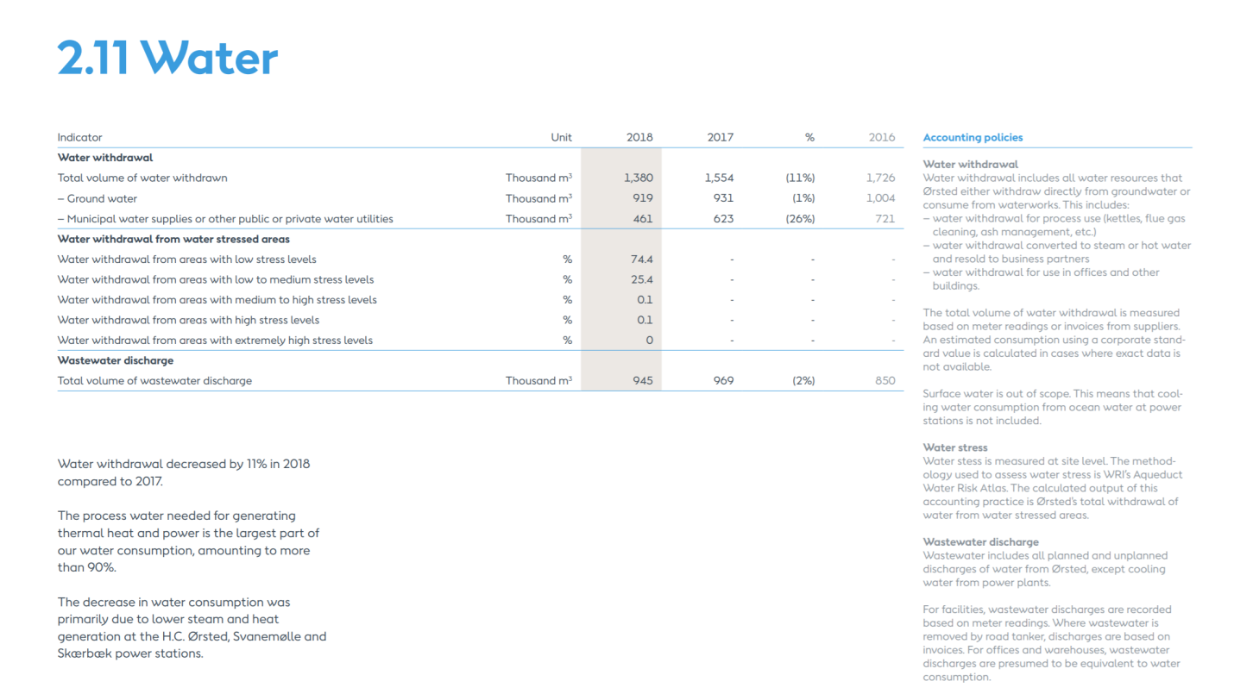
  - Source: https://orsted.com/-/media/Annual_2018/Orsted_ESG_performance_report_2018.ashx?la=en&hash=315A4E48E0AD794B64B9AC56EE7ED2F1
- Helen, helsinki’s main CHP plant owners do not have published reports on their plants
- Selchp, One of London’s CHP plant owners do not have data on water consumption
- BIF grey water system cannot find data in EBS on how much grey water could be used instead of potable water

