ECBS SWATeam Meeting
March 8th, 2019
TBH 115
3pm - 4pm

Attendees: Bill Rose (chair), Karl Helmink, Paul Foote, Dave Boehm, Taylor Holin (clerk)

- Approval of last meeting’s minutes
- Membership Discussion
  - Currently one student vacancy, two vacancies by the end of the spring semester
    - ACTION ITEM: Email Ximing Cai about student recommendations
  - Consulting members, copied onto the emails:
    - Tom Keller
    - Paul Foote
- Progress on ESCO recommendation
  - Reworking previous recommendation to re-submit to Working Group
  - Budgetary
  - ACTION ITEMS:
    - Bill Rose look over set of questions, meet and begin discussion
    - Have Morgan White at next meeting to help with this process
- Square footage and energy usage analysis (Bill Rose)
  - Link to spreadsheet: https://docs.google.com/spreadsheets/d/1X1mX5FGKOsaRewGEtyNonC_KCpvgn88vjBBERoRHrL4/edit?usp=sharing
    - Representative for the set of campus buildings defined as:
      - University District
      - Minus production facilities 0120, 0232, 0276, 0352, 0401, and
      - Including Petascale using meter 1 billing for CW
    - Value used: 1.1 to convert lb of steam to kBtu
  - Definition of UIUC campus:
    - UIUC-owned buildings
    - Within the University District
      - North of Windsor
    - Not counting stand-alone chilled water production facilities
      - Abbott, North Campus CP, Library AC, Vet Med AC, Animal Science AC
    - Includes Petascale
      - Uses metered chilled water, not Energy Billing System chilled water
  - Results:
    - 11% increase in square footage from 2008 to 2019
    - Energy consumption trends upwards (slightly), 2009 to 2018
    - Petascale represents 12.5% of the total budget
    - Without Petascale, the energy consumption trend would hit 50% of the 2009 consumption in year 2037 (thanks to ESCO, retrocommissioning, etc.)
      - By 2050, we would be below 30% of 2009 consumption
    - EUI shows a 10.5% decline from 2009 to 2018. All of this decline is attributable to increased square footage, none to conservation
      - Jevons effect (Andrea Martinez)
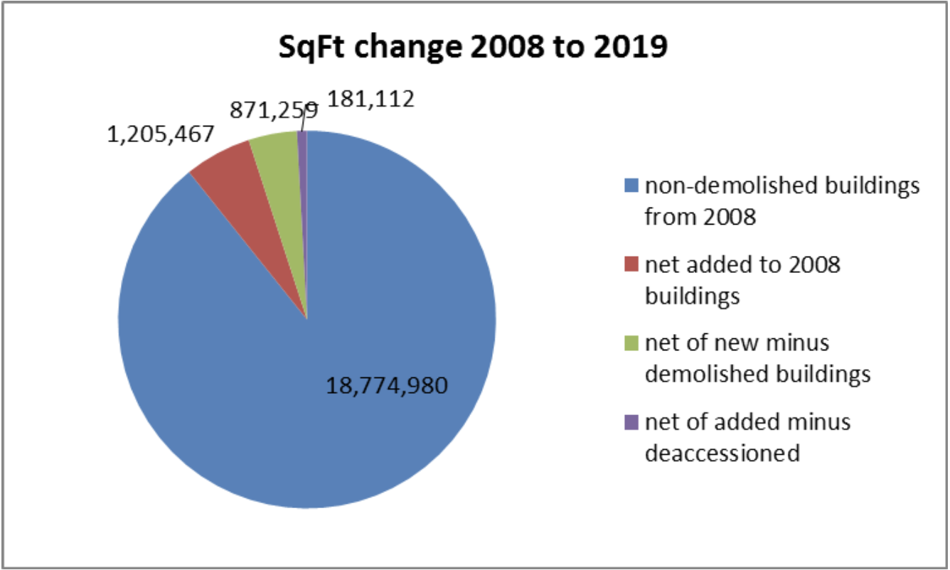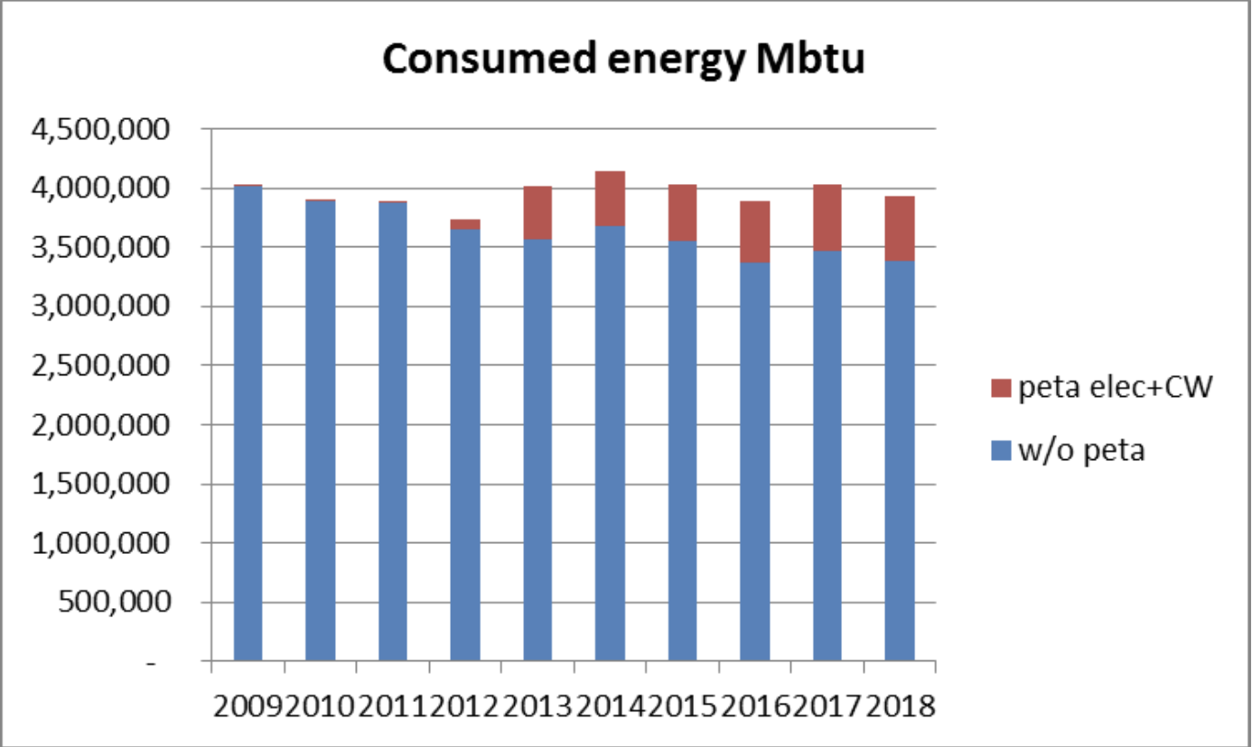
  - Notes:
    - As an occupant, you can only affect net square footage
    - How should we measure?
      - Should be all encompassing
    - You don’t necessarily decrease consumption with increased efficiency
    - Blue (represented on the consumed energy Mbtu graph)- would hit 50% by 2037
    - 2735 is when Red (represented on the consumed energy Mbtu graph) would hit 50%
    - Petascale came online in 2011/2012 -- baseline started before its’ existence, hard to compare savings after the fact
    - Graph should use net number
    - Possibility of comparing Bill’s numbers to another analysis?
    - Findings parallel everything that Paul Foote has found through Eco-Olympics
    - Occupant awareness is critical
- 10-building study (Sarthak Prasad, Bill Rose)
  - Looking at how buildings are following energy codes and standards
  - Building List (initial):
    - Lincoln Hall
    - BIF
    - ECE
    - Wassaja Hall
    - Everitt
    - Yeh Center
    - BNAACC
    - Football Performance Center
    - Alice Campbell Alumni Center
    - Addition to the Memorial Stadium
  - Review process
    - Submittals
    - Energy Cost Budget (ECB - how much it would cost if the building were built to code)
      - Submitted?
      - Accurate, timely
      - Create if necessary
    - “25% better” than code
      - Submitted?
      - How has it been done?
    - Comparison to actual
      - What is modeled and what it actually is
    - Calibrated model
      - The infiltration tweak - changing the model so that it agrees with what the energy actually is (Tom Keller)
      - Air infiltration in building is variable tweaked
    - Narrative, Every building’s different
    - Reviewing lessons learned
  - Ten building matrix
    - Aim: to learn lessons on improving project delivery for new and major-retrofit buildings
    - Proposed edits/changes (Karl Helmink):
      - Delete the following buildings:
        - Addition to Memorial Stadium (lack of independent metering)
        - BNAACC (metering data currently unavailable)
        - Yeh Center at Newmark (lack of independent metering)
        - Football Performance Center (may be okay, but current metering data unavailable)
      - Add the following buildings:
        - MRL (ESCO project)
        - Vet Med - Basic Sciences (ESCO project)
        - Natural History Building (Building just out of warranty)
  - ACTION ITEMS:
    - Communicate and discuss any changes with Sarthak Prasad on project (Bill Rose)
    - Give any further ideas of any buildings to add/delete (keep to number of buildings at 10)
      - Thoughts on LEED buildings?
- Discussion on what impacts building energy use
    - Conduction across the building envelope
    - Glazing: amount, quality, distribution
    - Equipment efficiency
    - Left out: envelope infiltration (airtightness)
- Discussion of an Infiltration Project
  - Kickoff: workshop with hands-on experts
    - What is the scale of infiltration impact?
  - Diagnostics
    - Experience, team, equipment, access
  - Intervention: new skills, not new programs
    - New buildings
    - Major retrofits
    - Retrocommissioning
    - Recommissioning
    - Occupant behavior
  - Measure the impact
- Discussion on what to include in the 2020 iCAP
  - Earmarking campus budget for meeting iCAP goals
    - Estimating monetary needs
  - Conflict between iCAP goals and Utilities Master Plan
    - Master Plan acknowledges space growth possibilities along with iCAP objectives
    - Master Plan predicated on flatline energy use from now until 2020 on the best scenario
    - Needs to be in budget in order to happen
  - Steam, co-gen, and renewables
    - Nuclear? Included in list of renewables under the iCAP
      - Problem: Can’t sell nuclear
    - Renewables are irregular, not as dependable as other energy sources
      - Problem: depends on future battery storage capabilities
    - Do we want the dependability and regularity like we have now? Choice will come between renewables and nuclear
  - Occupant behavior
    - Other programs (freezer challenge, ILO, …)
  - Current focus of discussion: on the message, not dollar amounts yet (this is for future planning and discussions)
- ACTION ITEMS:
  - Email Ximing Cai about student recommendations (Taylor Holin, Bill Rose)
  - Bill Rose look over set of questions regarding recommendation resubmittal, meet and begin discussion
  - Communicate and discuss any changes with Sarthak Prasad on 10 building project (Bill Rose)
  - Give any further ideas of any buildings to add/delete to the 10 building project list (ALL)
  - Regarding future meetings::
    - Meeting(s) with Kent Reifsteck and Mike
    - Meeting with Executive Director of F&S, Mohamed Attalla
    - Having Morgan White at next ECBS SWATeam Meeting
  - Review and add input to Chapter Evaluation Sheet (ALL)
    - https://docs.google.com/document/d/1YE5T1y9nj_2kXuAzGRFdBz1qEaa3e5mpCNCpFrqlVMs/edit?usp=sharing
- Next meeting:
  - TBD - after spring break
  - If not the next meeting, one of them to take place at the Indoor Climate and Research Facility, Bill’s office
    - Shuttle service will be provided (Bill Rose)
  - Poll to be sent out
- Adjournment

