Siebel Center for Design (U16015)
(1) Parcel Information
PIN: 462118326001
According to C-4.00: Storage volume= 5275.12 cubic ft
5’-8’’ single trap
(2) Drainage Area
According to the C1.10 Site Utility Plan and C1.20 Storm Plan:
The total impervious area in the parcel=60.18+1.27+0.58=62.03(Acre)
There is an established stormwater calculation (50% Construction Document Submission 2016) for Design Center:
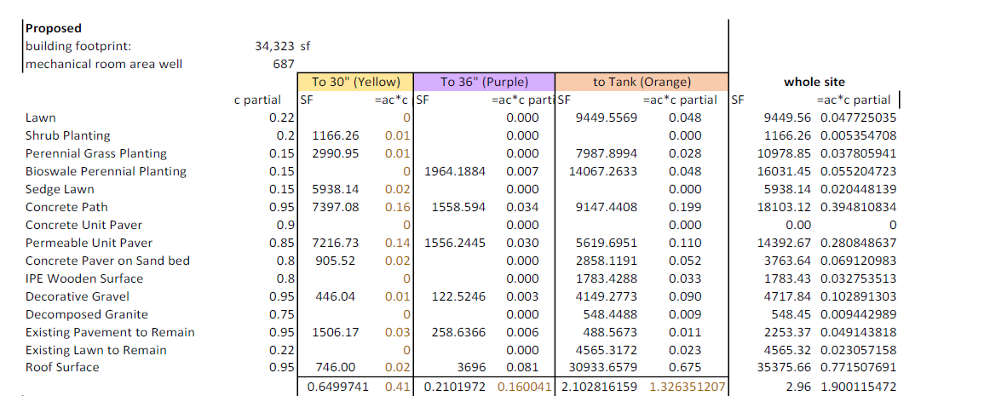
Figure 1. — The Composition of Drainage area for Design Center Detention
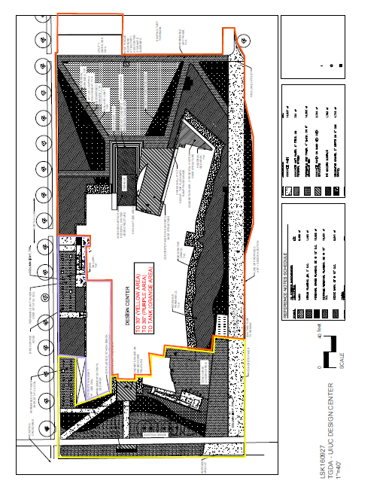
Figure 2. —The Drainage area for Design Center Detention

The drainage area tributary to the design center detention=2.10(Acre)
The impervious drainage area tributary to the design center detention=1.27(Acre)
The pervious drainage area tributary to the design center detention=0.83(Acre)
(3) Runoff Calculation
Based on the impervious drainage area and pervious drainage area tributary to the detention and regulations of Champaign City, use the SWMM model to calculate the runoff of the detention pond.
Parameters:
Drainage Area=2.10 Arce
Curve Number= (1.27*98+0.83*77)/2.1=89.7
Time of Concentration: 10 minutes
Lag Time=6 minutes
NRCS Rain Distribution: type II
24 HR,100 Year
Rainfall Depth=6.89 inches (According to the Hydrometeorological Design Studies Center (https://hdsc.nws.noaa.gov/hdsc/pfds/pfds_map_cont.html?bkmrk=il)
Table 1.— Runoff for the 100-year design storm flowing into the Design Center underground detention infrastructure (storage) and the outflow from the underground detention infrastructure to the storm sewer system (outfall).
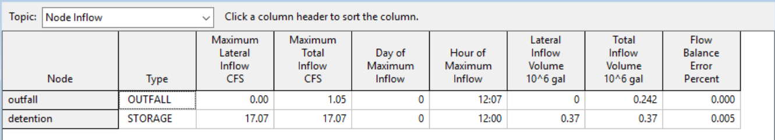
For the pre-development situation, all the impervious area is regarded as lawn
Curve number=77
Table 2.— Runoff for the 5-year design storm flowing into the storm sewer system (outfall) under the pre-development situation
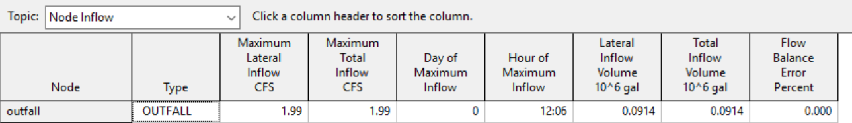
Because 1.05(Maximum Total inflow from the 100-year design storm)<1.99(Maximum Total inflow from the 5-year design storm under pre-development situation)
The discharge from the stormwater management facility resulting from the 100-year design storm is controlled to the pre-development discharge rate for a 5-year design storm.

(3) First flush calculation
Vff = 3,630 * C * A
Vff= First flush volume, post-development (in cubic feet)
C = Post-development runoff coefficient
A = Site drainage area (in Acres)
Cff = 0.05 + 0.009 * IA
IA=impervious percent of drainage area
Cff=0.05+0.009*(1.27/2.1) *100=0.594
Vff=3630*0.594*2.1=4528(ft³) < provided storage volume: 5275.12 CUBIC FEET
(4) Credit/incentives Calculation
possible credit (%) =impervious drainage Area/total drainage area*credit (%) =1.27/62.03*15%=0.307%

