Electrical & Computer Engineering(U08032)
Requirement:
According to URBANA STORMWATER UTILITY FEE CREDIT AND INCENTIVE MANUAL 2012
1. Meeting the first flush requirements
2.Permeable pavement system must be designed with an underdrain system.

(1) Parcel Information
According to the County GIS Web Maps Disclaimer (http://www.maps.ccgisc.org/mobile)
PIN: 912107451001
b. According to Sheet C5.1
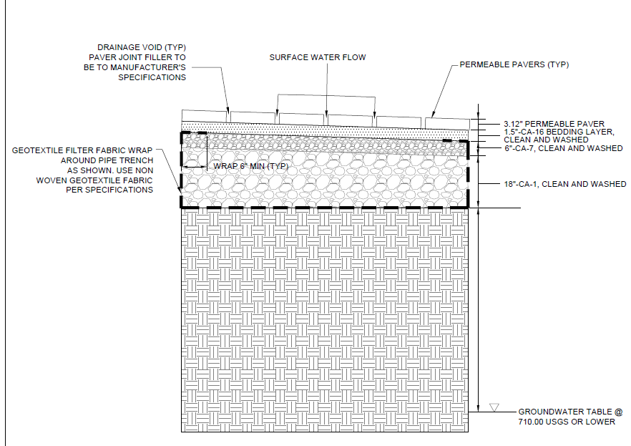
Figure 6 The structure of the pedestrian permeable pavers

(2) Site Drainage Plan
The permeable pavement is regarded as impervious area. According to the impervious_Area_on_UI_Parcel_Rev_2018_09_26 layer, the area of permeable pavement near the Electrical & Computer Engineering is regarded as impervious area.

The total impervious area in the parcel=7.49(Acre)
The drainage area tributary to the ECE permeable pavement=0.19 (Acre)
The impervious drainage area tributary to the ECE permeable pavement=0.11 (Acre)
The pervious drainage area tributary to the ECE permeable pavement =0.08(Acre)

(3) First flush requirement
Manual02550PP
Vff = 3,630 * C * A
Where: Vff= First flush volume, post-development (in cubic feet)
C = Post-development runoff coefficient
A = Site drainage area (in acres)
Cff = 0.05 + 0.009 * IA
For the concept of “post development”, there are many understandings：
In the Stormwater Utility Fee Credit and Incentive Program Training (city of Urbana, 2013) https://www.urbanaillinois.us/sites/default/files/attachments/credit-and-incentive-program-training-19sep2013.pdf, according to the example calculation for the permeable pavement, the permeable pavement is regarded as the totally impervious area)
Cff = 0.05 + 0.009 * 0.11/0.19*100=0.57
Vff=3630*0.57*0.19=393.129 ft³

V pavement=A pavement*H*α
A pavement= The area of ECE permeable pavement (arce)
H=the depth of the pavement
α=bed porosity
According to the Sheet 5.1 and Project Manual 321443, the porosity of the pavement is not given.
A factor of 30% voids are used to calculate the volume:
V=1832.1ft²*30%*18/12ft=824.4ft³
Vprov>Vff
Conclusions:
the permeable pavement has an underdrain system as shown in sheet 5.1
possible credit (%) =impervious drainage Area/total drainage area* credit (%)=0.11/7.49*15%=0.22%
The possible credit can achieve because of the ECE permeable pavement is 0.22%

