Football Performance Center(U17018)
- Parcel Information
- According to the Champaign County GIS Web Maps Disclaimer (http://www.maps.ccgisc.org/mobile)
PIN: 462118326001
b. According to Sheet 1.0
provided storage volume:18,103.48 CUBIC FEET
unit headroom:10’-0’’ doubletrap
- Drainage Area
According to C-301
The runoff from the proposed football performance center and new parking lot (east of the exiting indoor practice facility) is routed into the detention pond.
**some modifications are required for the impervious_Area_on_UI_Parcel_Rev_2018_09_26 layer because the proposed IPF addition, proposed football performance center and new parking lot are not shown as impervious area on the ArcGIS layer. Steps are recorded:
a. Select the parcel including the football performance center detention and export the selected feature. This was named as fpc_parcel it was added as a layer into the ArcGIS;
b. In the CLIP tool, the impervious_Area_on_UI_Parcel_Rev_2018_09_26 layer was used as the input feature and the fpc_parcel was used as the clip feature; the output feature was named fpc_impervious;
c. The new parking lot was added as a feature;
d. The ArcGIS Union tool was used to merge the new parking lot, the proposed IPF addition, the proposed football performance center and the fpc_impervious layer
e. ArcGIS was used to calculate the total impervious area in the fpc_parcel parcel
f. Create a new feature to show the drainage area determined by analyzing plan sheet C-301, which shows that the runoff from the proposed football performance center and new park lot (east of the exiting indoor practice facility) goes into the underground detention infrastructure.
Based on plan sheet C100 it was determined that the runoff from the proposed IPF addition doesn’t go into the detention pond.
g. ArcGIS was used to calculate the area of the catchment draining to the underground detention infrastructure.
h. Using the ArcGIS CLIP tool, the fpc_imperviousarea layer was clipped by the drainage area to determine the fpc_ImperviousDrainageArea layer.
i. ArcGIS was used to calculate impervious area draining into the underground detention infrastucture
The results are shown as follows: **
The total impervious area in the parcel=61.83(Acre)
The drainage area tributary to the football performance center detention=2.77(Acre)
The impervious drainage area tributary to the fpc detention=1.82(Acre)
The pervious drainage area tributary to the fpc detention=0.95(Acre)
The results are similar to the calculation in the given storm calculation document.
- Runoff Calculation
Based on the impervious drainage area and pervious drainage area tributary to the detention and regulations of Champaign City, use the SWMM model to calculate the runoff of the detention pond.
Parameters:
Drainage Area=2.77 Arce
Curve Number=(98*1.82+77*0.95)/2.77=91.52(using the tr 55 table2-2a to determine the curve number)
Time of Concentration: 10 minutes
Lag Time=6 minutes
NRCS Rain Distribution: type II
24 HR,100 Year
Rainfall Depth=6.89 inches (According to the Hydrometeorological Design Studies Center (https://hdsc.nws.noaa.gov/hdsc/pfds/pfds_map_cont.html?bkmrk=il)
Figure 1 and table 1show the inflow to and outflow from the detention infrastructure for the 100-year design storm. Figure 2 and table 2 show the inflow to and outflow from the detention infrastructure for the 50-year design storm.
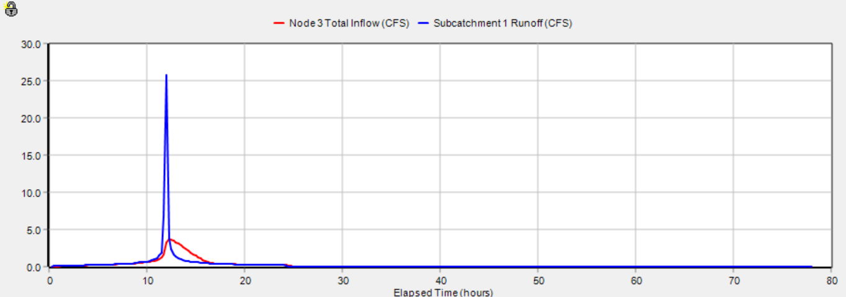
Figure 1.—Graph showing the runoff for the 100-year design storm flowing into the FPC underground detention infrastructure (blue curve) and the outflow from the underground detention infrastructure to the storm sewer system (red curve).

Table 1.— Runoff for the 100-year design storm flowing into the FPC underground detention infrastructure (Node 2) and the outflow from the underground detention infrastructure to the storm sewer system (Node 3).
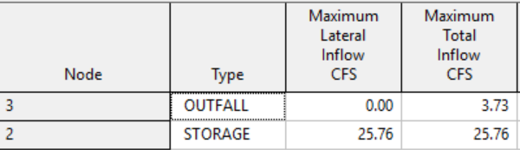
peak 100-year discharge is 1.346 cfs per Acre (about 7 times higher than the requirement (0.18 cfs/Acre))
24HR,50 Year
Rainfall Depth=5.99 inches
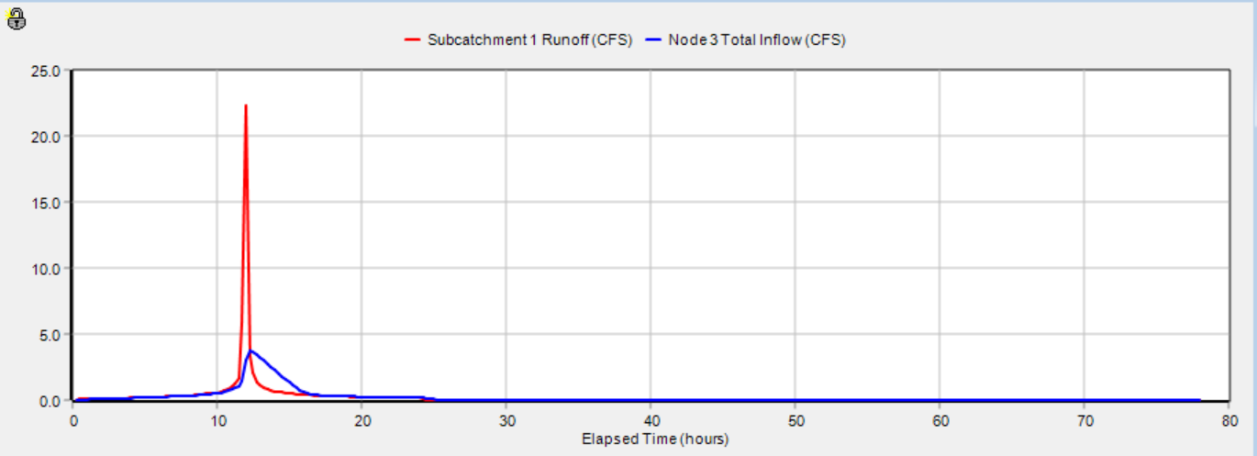
Figure 2.—Graph showing the runoff for the 50-year design storm flowing into the FPC underground detention infrastructure (blue curve) and the outflow from the underground detention infrastructure to the storm sewer system (red curve).

Table 2.— Runoff for the 50-year design storm flowing into the FPC underground detention infrastructure (Node 2) and the outflow from the underground detention infrastructure to the storm sewer system (Node3).
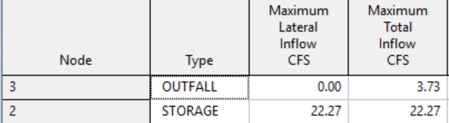
peak 50-year discharge is 1.346 cfs per Acre

According to the Champaign Stormwater-Utility-Fee-Credit-and-Incentive-Manual (2016), The Rate Reduction Credit is available to all developed properties that install and maintain a stormwater rate reduction device that results in oversizing a detention basin by at least 20 percent over that which is required by the City stormwater management regulations.
According to THE MUNICIPAL CODE OF CHAMPAIGN, ILLINOIS, the drainage system for a development shall be designed to control the peak rate of discharge from the property for the 100-year, 24-hour event to levels which will not cause an increase in flooding or channel instability downstream when considered in aggregate with other developed properties and downstream drainage capacities. The peak 100-year discharge shall not be greater than 0.18 cfs per Acre of property drained.
According to the results shown above, the football performance center detention does not meet the requirement. In other word, it cannot achieve the credit because limit is 0.18 cfs/Acre and the sites outflow is 3.73 cfs/Acre.
- Credit/incentives Calculation
possible credit (%) =impervious drainage Area/total drainage area*credit (%)
No credit can be achieved
The infrastructure can only achieve $250 incentives (per 10 years)
##relevant requirements for the incentives:1) the stormwater management feature must capture, store and/or treat a 1-inch rainfall from a minimum of 500 square feet of impervious area; 2) the amount of the incentive is 25% of the construction cost, up to a maximum incentive of $250 per incentive category, and; 3) each property is eligible to receive no more than one incentive disbursement for each of the three categories (Runoff Rate Reduction, Runoff Volume Reduction, and Water Quality Control) in a lifetime.

Vff = 3,630 * C * A
Where: Vff= First flush volume, post-development (in cubic feet)
C = Post-development runoff coefficient
A = Site drainage area (in Acre)
Cff = 0.05 + 0.009 * IA
IA=impervious percent of drainage area
Cff=0.05+0.009*(1.82/2.77) *100=0.64
Vff=3630*0.64*2.77=6435.264(ft³) < provided storage volume:18,103.48 CUBIC FEET
We can only get the incentive ($250/10year).

