IGB
(1)Parcel Information
PIN: 932118401001
According to C-202: Storage volume=24,000 cubic ft
height 10’
(2) Drainage Area
According to C-104 R
The drainage area is determined by the elevation. The detention pond is lowest in elevation. Part of the runoff goes into the pipes in the Gregory Street.
The total impervious area in the parcel=151.96(Acre)
The drainage area tributary to the football performance center detention=4.33(Acre)
The impervious drainage area tributary to the fpc detention=2.13(Acre)
The pervious drainage area tributary to the fpc detention=2.20(Acre)

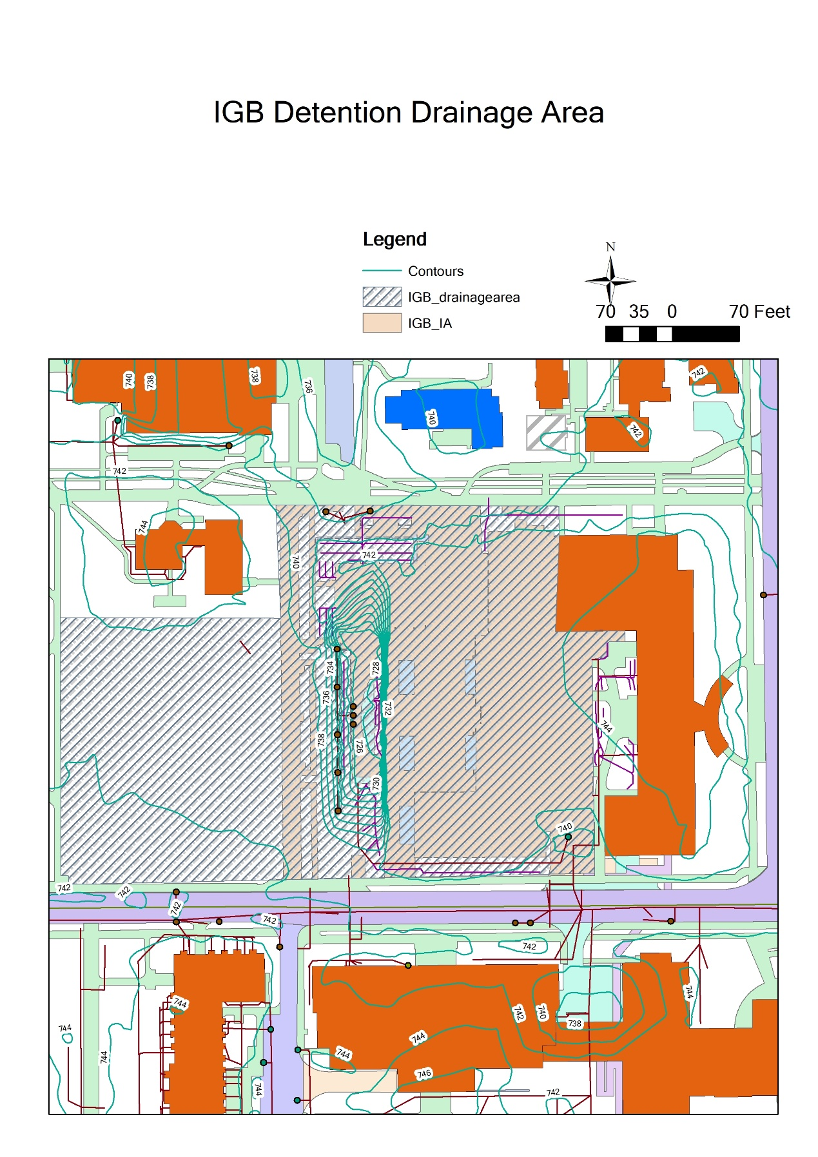
Figure4-Estimated drainage area tributary to the IGB detention
(3) Runoff Calculation
Based on the impervious drainage area and pervious drainage area tributary to the detention and regulations of Champaign City (URBANA STORMWATER UTILITY FEE CREDIT AND INCENTIVE MANUAL 2012), use the SWMM model to calculate the runoff of the detention pond.
Parameters:
Drainage Area=4.33 Acre
Curve Number= (98*2.13+77*2.20)/4.33=87.33 (using the tr 55 table2-2a to determine the curve number)

Due to the big diameter of the orifice (2ft), the detention has a high outflow peak and low detention depth (3.52ft). The designed depth of the detention is 10’ so there are 6.48ft depth of the detention unused based on this calculation.
More detailed calculation is needed after having the pump information

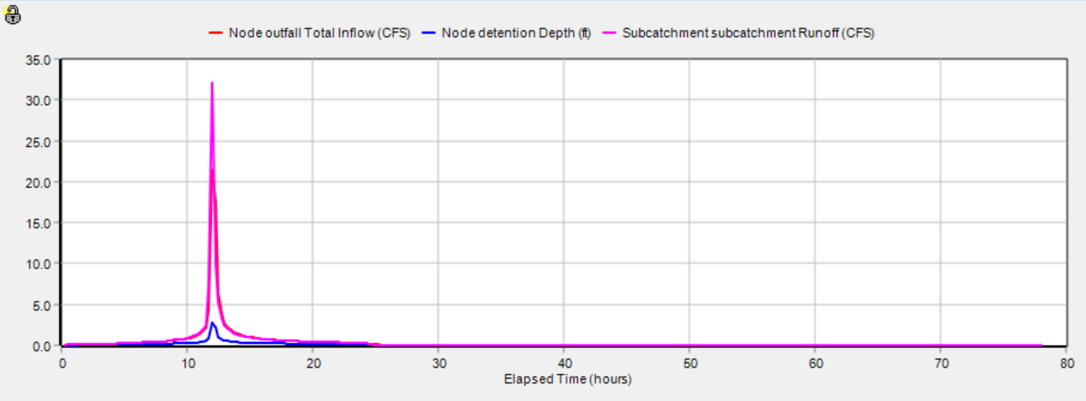
Figure 5.—Graph showing the runoff for the 100-year design storm flowing into the IGB underground detention infrastructure (pink curve); the outflow from the underground detention infrastructure to the storm sewer system (red curve); the detention depth (blue curve).

Table 3.— Runoff for the 100-year design storm flowing into the IGB underground detention infrastructure and the outflow from the underground detention infrastructure to the storm sewer system and the depth of the underground detention.

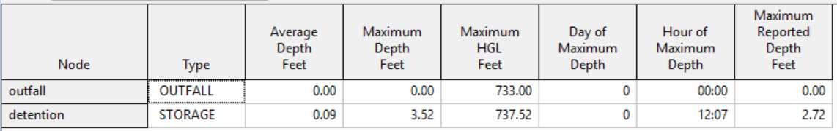
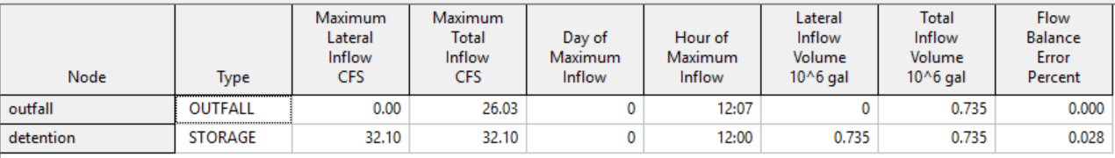

(3) First flush calculation
Vff = 3,630 * C * A
Vff= First flush volume, post-development (in cubic feet)
C = Post-development runoff coefficient
A = Site drainage area (in Acre)

Cff = 0.05 + 0.009 * IA
IA=impervious percent of drainage area

Cff=0.05+0.009*(2.13/4.33) *100=0.49
Vff=3630*0.49*4.33=7701.77(ft³) < provided storage volume:24,000 CUBIC FEET

Conclusions:
More information is needed for the pump.

