SWATeam Recommendation
Name of SWATeam: Land and Water

SWATeam co-Chairs: Reid Christianson & Art Schmidt
Date Submitted to iSEE: 4/2/2020

Specific Actions/Policy Recommended (a few sentences):

The Land & Water SWATeam recommends that a single data repository and online dashboard should be established to ingest, archive, and disseminate data from various sustainability related monitoring on and around campus. This could potentially be a dashboard included on the iCAP Portal.

Currently, there is a need to keep permanent records of original data and measurements from a variety of sensors and applications and in a variety of formats. The university should be able to provide reliable, secure online access to sustainability-related monitoring data, to manage all monitoring network locations, to integrate data acquisition systems and external databases, and automate continuous data importing. Data such as water quality, soil moisture, green roof monitoring, nitrogen content will be tracked. Data can be input as public or private (such as data from research papers before publication) and entered manually or pulled from other platforms and software. The goal is to be able to provide online tools to visualize, analyze, and download data.

The SWATeam has identified two potential options to develop this system, such as the College of ACES Soil Diagnostics proprietary software. Additionally, personnel from the Ven Te Chow Hydrosystems Lab in the Department of Civil & Environmental Engineering have developed a natural-resources data-management system that is able to assimilate and store data from a wide variety of sensors and provide online access to user-selected data streams (described in Explanation and Background section).

The Land & Water SWATeam recommends that iSEE provide support to make this system the repository and dashboard for all sustainability-related monitoring across campus. This would provide a single portal that would enable students, faculty, University staff and administration, and the public to access these monitoring data.

Rationale for Recommendation (a few sentences):
Over the years, several studies of the impact of sustainable practices on various environmental parameters have been conducted on campus. The campus focus on improving sustainability is leading to rapid expansion of such monitoring. However, data from most of these efforts are only available by finding the appropriate PI (if they are still on campus) and requesting the data. Data, if still available, are stored in a wide variety of formats (including propriety formats from instrument manufacturers. For example, data from the ACES Agricultural Research Farm’s Nutrient monitoring in the Embarras River (SSC funded, 2019) are stored in a proprietary, password-protected system managed by the instrument manufacturer; data from the grey-water monitoring at BIF (SSC funded, 2017) are managed by Facilities and Services and, to our knowledge, are not available on-line; data from the monitoring of the BIF green roof are stored in password-protected server in the Civil Engineering Department. Several other studies have been implemented in recent years (e.g., geothermal piles for the Hydrosystems Lab renovation, monitoring of the Red Oak rain garden) and we anticipate that the number of sustainability monitoring efforts will increase in keeping with recommendations from the 2020 iCAP. This recommendation would provide the tools necessary to make these monitoring efforts readily useful to researchers, students, practitioners, decision-makers, and to others outside of the University of Illinois.

Connection to iCAP Goals (a few sentences):
Providing a repository and dashboard for sustainability related monitoring data is consistent with many goals from the iCAP because baseline data are essential to monitor the progress toward these goals. As an example, the following are some of the goals from the 2015 iCAP, related to the Land-Water SWATeam that this would benefit. However, since the database is sensor-agnostic, the same system would be useful for monitoring related to all aspects of the iCAP
Objective 5.1, “Obtain and publicize more granular water use data by FY 16”
Objective 5.6, “Investigate the water quality impacts of stormwater runoff and potential ways to reduce stormwater pollutant discharges by FY18.”
Objective 5.4, “Inventory and benchmark campus’ existing landscape performance by FY17.”
Objective 7.5, “Increase carbon sequestration in campus soils by determining the sequestration value of existing plantings...”
Objective 7.6, “Reduce nitrates in agricultural runoff and subsurface drainage by 50% from the FY15 baseline by FY22.”

Perceived Challenges (a few sentences):
Will require effort to identify the different monitoring and data streams. Some researchers may be hesitant to share the data.
Will require publicizing of the repository so that researchers are aware of the opportunity to share their data here, and to obtain data from other researchers, and so that students and teachers are aware of this resource.
Will require some programming to add new scripts to ingest data from sources that are not currently in data base.
May be some push-back from F&S because they have an online Energy Dashboard. However, this does not have the functionality that is needed to serve the range of data types being proposed. For example, the proposed repository would be able to display and monitor GIS data.
Some sensors require manual site visits to download data, and hence will not be available real-time. As inter-farm connectivity improves, these sites can be transitioned to real-time updating with wifi-enabled sensors.
Suggested unit/department to address implementation:
Suggest that iSEE should be the administrative lead. Another possibility could be the Water Resources Center. Civil & Environmental Engineering (specifically, Mr. Andy Waratuke, the developer of the existing implementation) would have a key role in expanding the existing platform to serve all the sustainability data and in the day-to-day operation.

Anticipated level of budget and/or policy impact (low, medium, high):
Cost would be low to medium. Initial development could be done on existing server. As database becomes operational would suggest purchasing a dedicated server and backup or exploring options such as Amazon Web Services. In the first year we anticipate about 1.5 months of Mr. Waratuke’s time to oversee the implementation and about 400 hours of an undergraduate to develop scripts for all the different data streams. After this anticipate on-going support of about 1 week per year for Mr. Waratuke. The estimated cost of implementing this recommendation is $10,000-$15,000 with an estimated cost of $4,000 per year for ongoing annual maintenance.

Individual comments are required from each SWATeam member (can be brief, if member fully agrees):

Team Member Name | Team Member’s Comments
Reid Christianson (co-Chair) | .(Unavailable for comment)
Art Schmidt (co-Chair) | I support this recommendation. Providing a single access point to the wide variety of sustainability-related monitoring data from different entities across campus will benefit everyone looking to assess and improve the campus sustainability efforts. This will also provide a valuable resource for research and teaching related to sustainability.
Rabin Bhattarai | . (Unavailable for comment)
Bruce Branham | (Unavailable for comment)
Brent Lewis | I support this recommendation. It is imperative that the university is tracking data to support our sustainability goals. Providing a single access point will provide transparency and create a depot for future academic research.
Eliana Brown | I support this recommendation.
Allen Parrish | Ways to access data is going to be important to monitor our improvements and continue to achieve iCAP goals.
Jamie Ellis | I support this recommendation. Beyond the need to retain data sustainability related monitoring data is the need for these data to be accessible to researchers and decision makers.
Claire Samojedny | (Unavailable for comment)
Vikram Sudhan Muthuvel | (Unavailable for comment)
Ella Liskiewicz | (Unavailable for comment)

Comments from Consultation Group (if any; these can be anonymous):

Explanation and Background (can be supplied in an attachment):

The data management system we propose to use for this was developed by personnel from the Ven Te Chow Hydrosystems Lab. This data management system couples GIS and database services to provide data query, visualization, and retrieval by geographic region as well as by search strings. The database supports time series and intermittent observation data from monitoring sites and spatially distributed data, such as synoptic sampling or topographic/bathymetric survey data. This database has a flexible back-end utilizing MySQL or SQLite for data storage/retrieval and PHP or Python to manage server calls, although other database systems may be easily substituted. The web-based front end was written in JavaScript and utilizes Free and Open Source Software (FOSS) and an in-house code base for data display and retrieval. The front end is capable of exporting data to the user computer in multiple formats including KML, SQLite, or text file. Data in the database is saved in a compressed binary format making it data-agnostic; with the inclusion of the appropriate JavaScript library for interpretation, data of any base type can be saved/displayed. The following figures illustrate current application of this data management system to networks of river and atmospheric monitoring stations in the Chicago metropolitan area. These data include sensors operated by different agencies and a wide variety of data types.
.
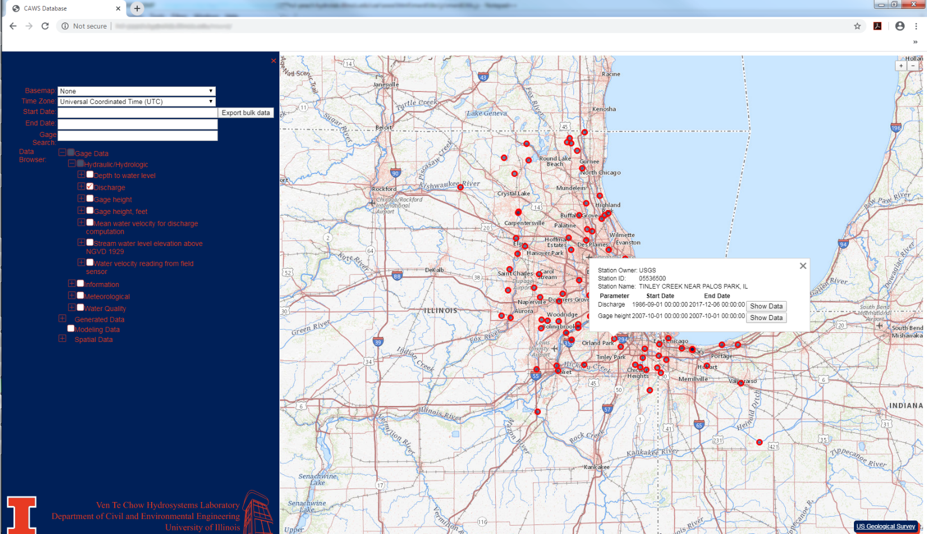
Figure 1.—Screen capture showing query selection screen on left, stations meeting selection criteria displayed on map to right, and overview of single selected station in display box.
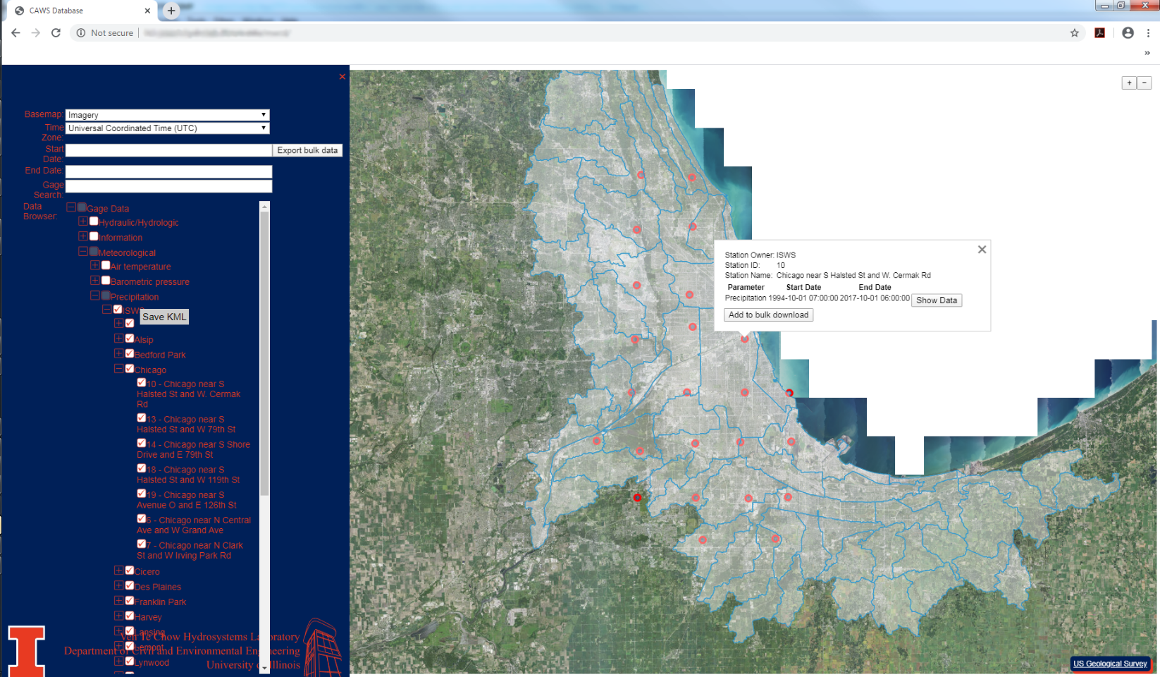
Figure 2.—Screen capture showing option to produce Google Earth .kml file for user-selected set of features.

