Water Fountain Retrofit Final Report
By Morgan Johnston – August 25, 2014

Project purpose
This project was to funded for retrofitting existing water fountains on campus with glass fillers, to discourage the use of disposable water bottles on campus. The concept and proposal were put forth by the Illinois Student Senate Environmental Sustainability Subcommittee, and the award was facilitated by Facilities & Services.

As stated in the project proposal, this project was aimed at “encouraging the student body to wean off of disposable water bottles and promoting reusable water bottles, with the greater goal of curbing litter and wasteful discarding of recyclable bottling materials. Through primary surveying, we have all heard many students state that they would be in favor of more trouble-free water bottle filling stations. Our first goal in this process is to encourage the use of reusable water bottles or thermoses, et.al., thereby relieving the dependency on disposable bottled water sold on shelves and in vending machines across campus. With this in mind, we propose to retrofit campus water fountains with water filling stations, in the form of glass filler attachments by which users can easily fill reusable water containers. Through our primary surveying as a committee, we have heard much in the way of student support for a greater number of water bottle filling stations in main buildings on campus. Reaching the primary goal of providing students with an easier alternative to purchasing bottled water will represent the first step in our effort to address the educational, financial, and ethical issues that concern the disconcerting use and waste of disposable water bottles on campus.”

Project summary
This project was awarded in the spring of 2013, and the award letter was received in June 2013. The primary project contact was originally Felicia Speranske for the proposal and the spring 2013 semester. After her graduation in May 2013, the primary contact for the project became Amy Liu.

In Fall 2013, Amy Liu and David Mischiu prioritized buildings for the glass filler retrofits. Morgan Johnston submitted work orders, and Mark Warner managed the project installation.

Also during Fall 2013, Amy Liu coordinated the Tap That marketing campaign, to encourage reusable water bottles.

Problems encountered

None

Pictures of finished project
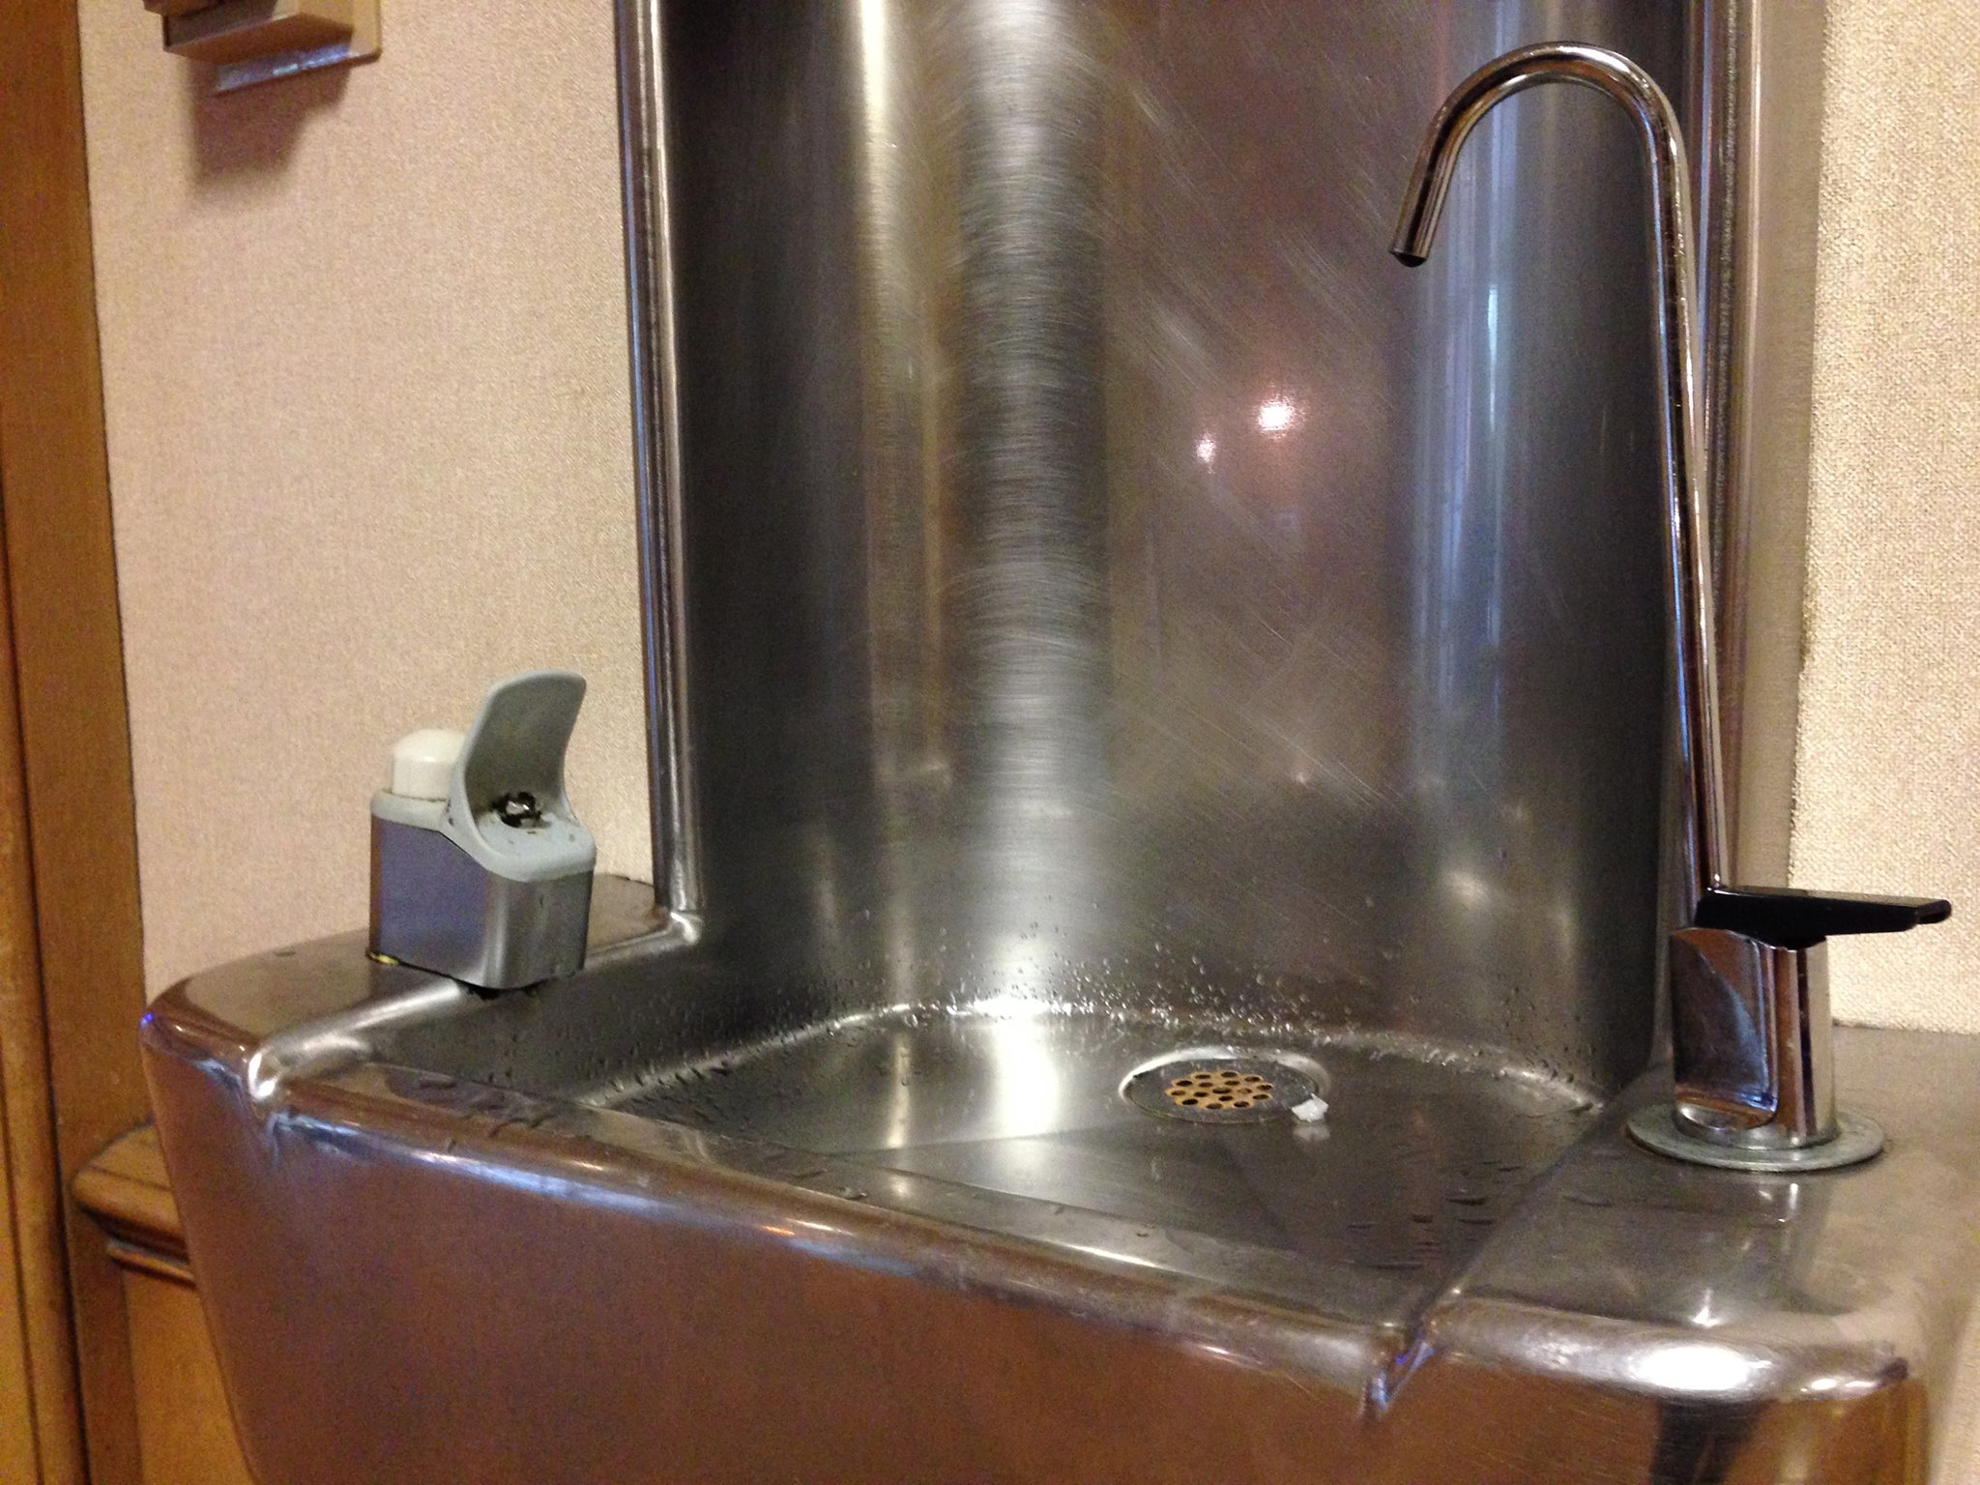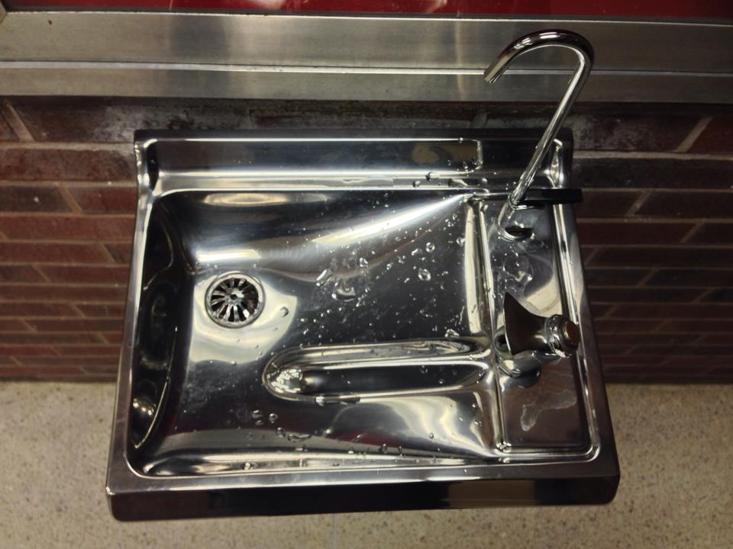

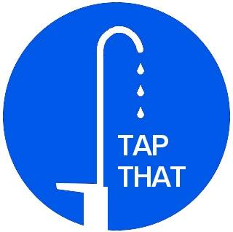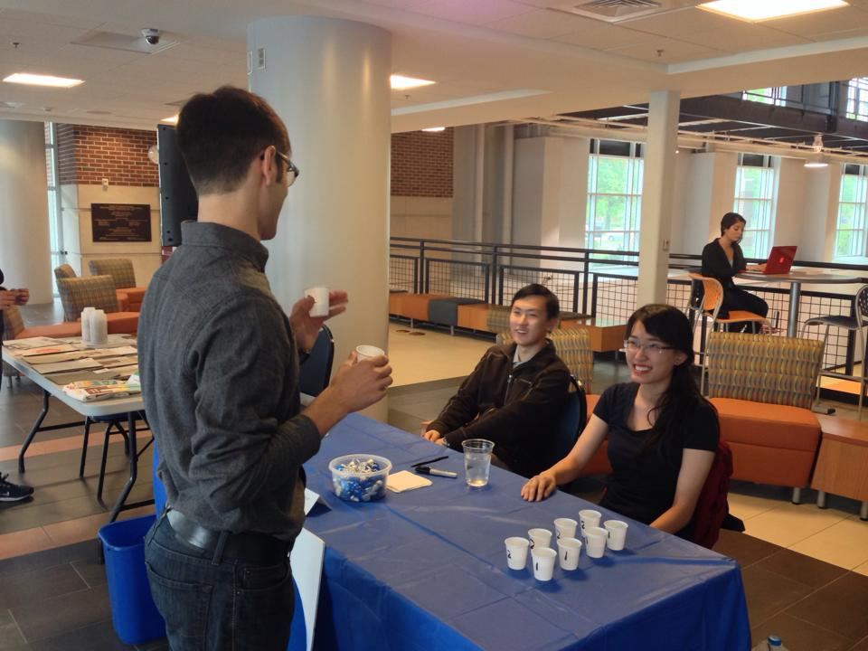

A financial statement that lists how the funds were specifically utilized

Work Order | Building | Amount
10236880 | ACES Library | $ 1,879.24
10236879 | Main Library | $ 1,831.14
10232178 | Grainger Library | $ 1,900.06
10232177 | Natural Resources Building | $ 1,858.00
10232176 | Siebel Center | $ 1,326.29
10232175 | Loomis Lab | $ 2,110.10
10232174 | Armory | $ 1,708.76
10232173 | Undergraduate Library | $ 1,944.50
10232172 | Wohlers Hall | $ 601.60
 |  | $ 15,159.69

The remaining funds should be returned to the SSC funding pool.

Statistics on student involvement/outreach
This project was initiated by students.

On Oct 24, 2013, there was an outreach event in conjunction with Campus Sustainability Day. The calendar described the event as follows:
“11am-1pm: Tap That - Water Taste Test The event involves students doing a blind test between tap water and bottled water. Then we survey which drink they prefer and what difference they can detect. Illini Union Anniversary Plaza (Quad Side”
From October 19 to November 22, 2013, the Tap That campaign included a Facebook page. The page received 98 likes.

