Contact Information:
Nicole Gamble
ngamble2@illinois.edu
(224)659-6812
Restoration

Definition: Taking an area of land and returning it to a period that had function and biodiversity.
Example: Turning an agricultural field into a forest.

Benefits | Drawbacks
- Low maintenance  - Aesthetically eye pleasing  - Add biodiversity to the area  - Community project  - Improved soil quality  - No use of fertilizers | - More animal species in the area  - To be well maintained, there should be no litter in restored area  - Susceptible to invasive species

Restoration Plan for Orchard Downs
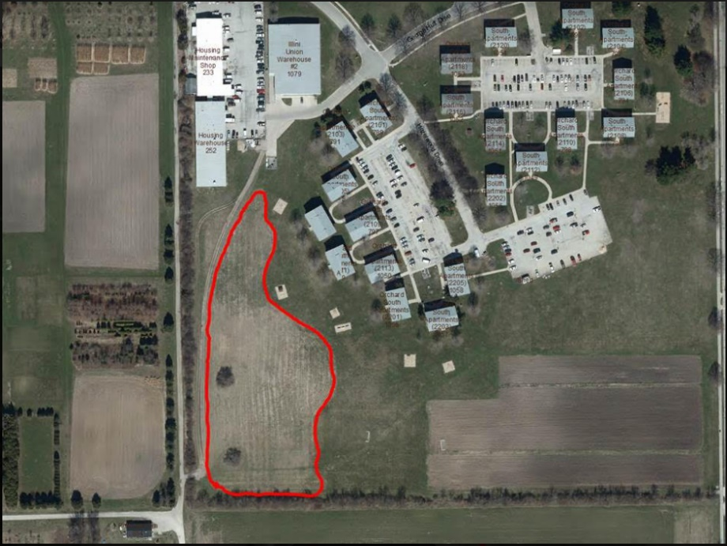
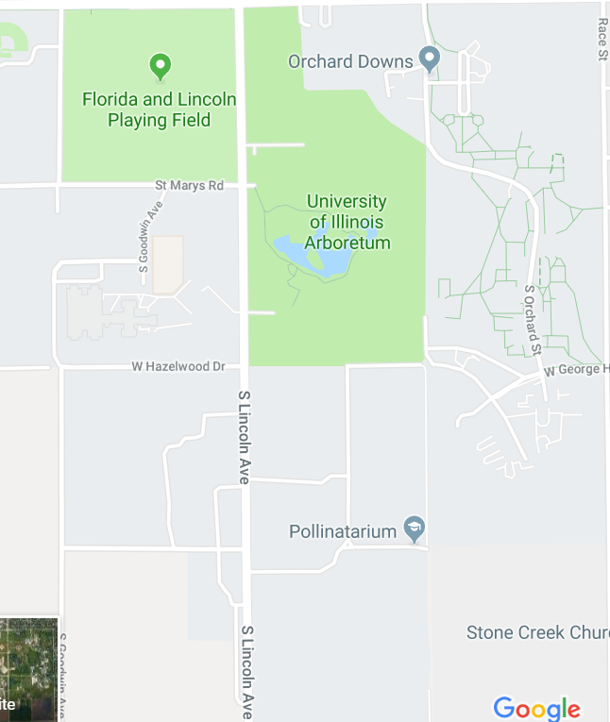
My plan is to use this low mow area and restore it to a prairie garden over the course of four years. The reason I want to do this project is to give students hands on experience with restoration, as well as involve and educate the community about restoration. This project will be funded and maintained through the organization, “Students for Environmental Concerns.

Prairie Garden
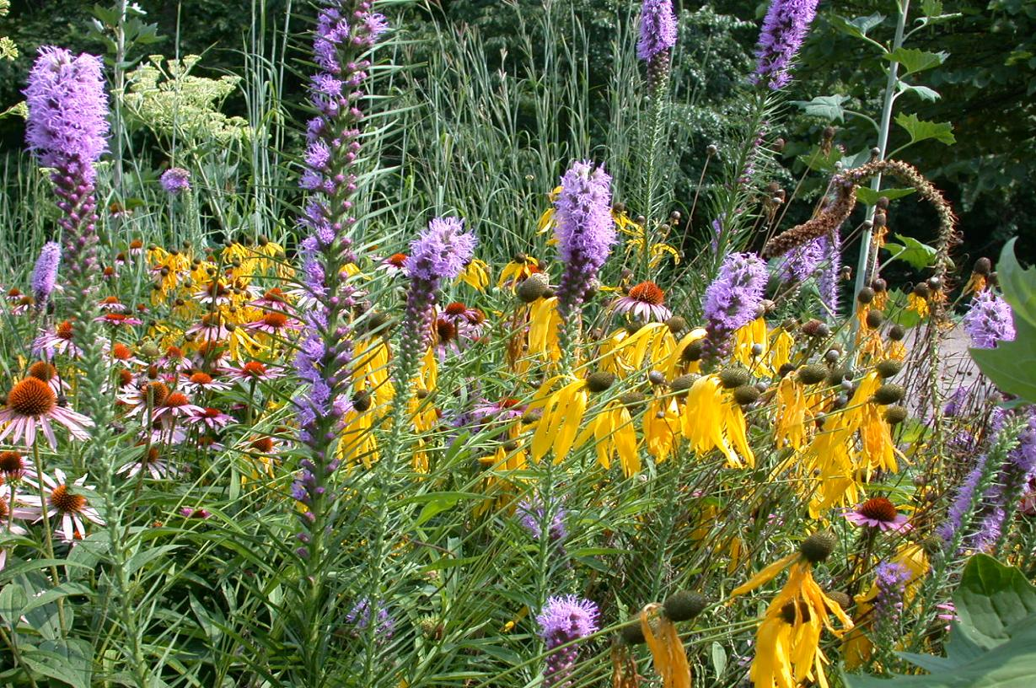

Prairie State Conservation Coalition
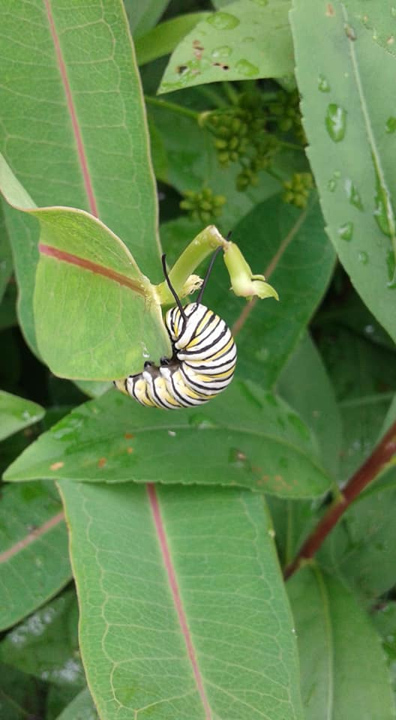
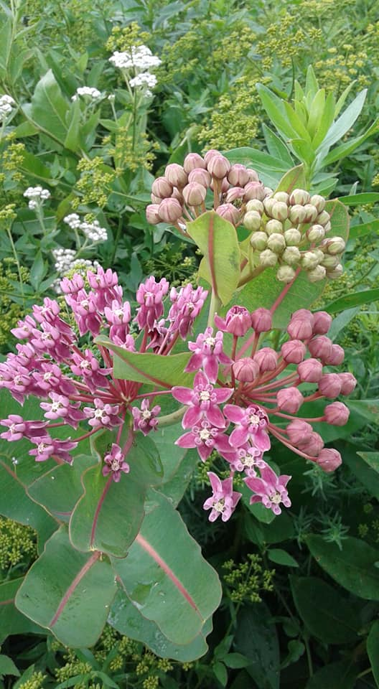

Flowers:
- Yellow Coneflower (Ratibida pinnata)
- Common Milkweed (Asclepias syriaca)
- Bee balm (Monarda didyma)
- Blue Wild Indigo (Baptisia australis)
Species:
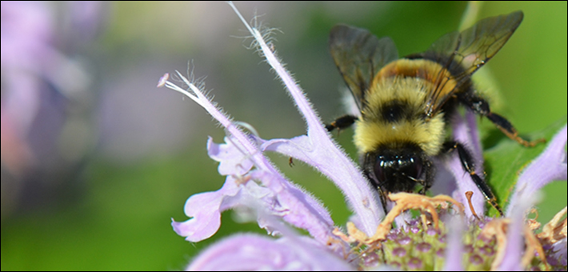
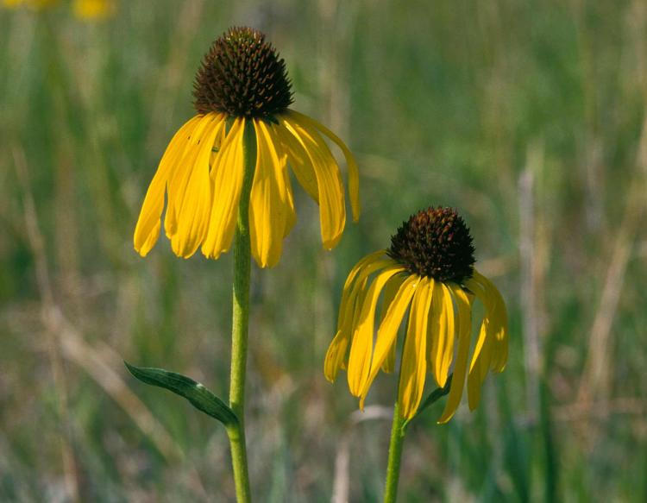
- Rusty Patch Bumblebee (Bombus affinis)
US Fish and Wildlife Service
- Monarch Butterfly (Danaus plexippus)

