Carbon Offset Manual

What is carbon offset?
Carbon offset the action or effort to compensate for carbon dioxide emissions arising from industries and human activity, by participating in schemes that will make equivalent reductions of carbon dioxide in the atmosphere. It is a method used to combat climate change. It does not reduce the amount of carbon emitted but instead counteracts the amount to balance out the environment.

Why is carbon offsetting important?
Although you can try to reduce your carbon footprint, you can not make it completely disappear. Carbon offset is an important way to compensate for carbon emission. In doing so, offsetting leaves a positive impact on the environment and can help reduce climate change but also has other benefits. It also benefits the economy and the well-being of the people by creating new jobs and a healthy environment for people to live in.

How can you carbon offset?
Carbon offset can be done multiple ways. The ways that our programs is organizing include:
- Planting a Tree
- Volunteering at the Student Sustainability Farm for ___ hours
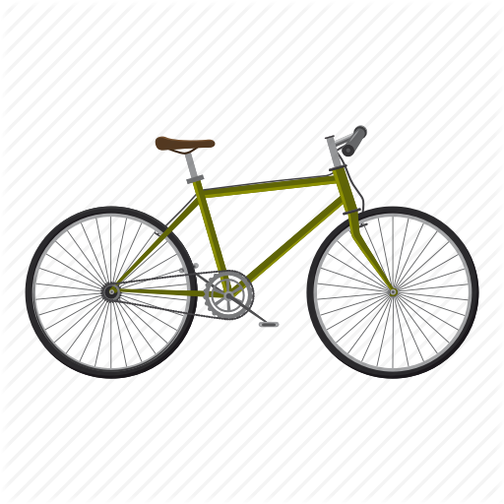

Other ways to offset at home:
- Walk, bike, take public transportation
- Air dry your clothes
- Reduce the amount of meat consumed
- Reuse and recycle what you can - buy less or buy used (especially clothes)
- Plant a garden
- Eat locally
- Unplug your devices when they’re not in use

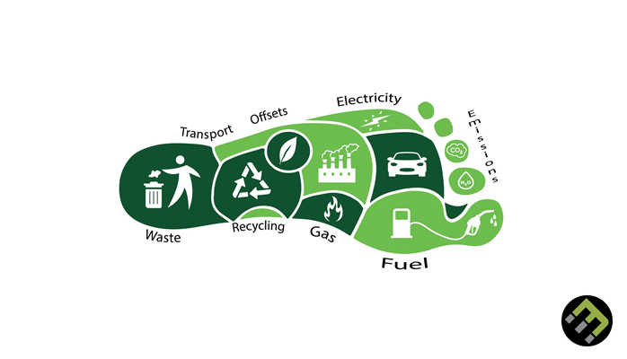
What is your carbon footprint?
Curious about how much you impact the earth with your carbon emissions? Want to know what parts of your lifestyle leave impacts on the earth? If you click on this link and follow the instructions of the website, you will be told how many earths you will need to store all of the carbon you are emitting.
https://www.footprintcalculator.org

How many trees should you plant for your study abroad trip?
- ≤ 4,999 miles: 1 tree
- 5,000-6,999 miles: 2 trees
- 7,000-8,000 miles: 3 trees
- ≥ 8,001 miles: 4 trees
- OR: you can volunteer at the Student Sustainability Farm for 2 hours to replace the planting of one tree.

Link to information about your trip’s miles:
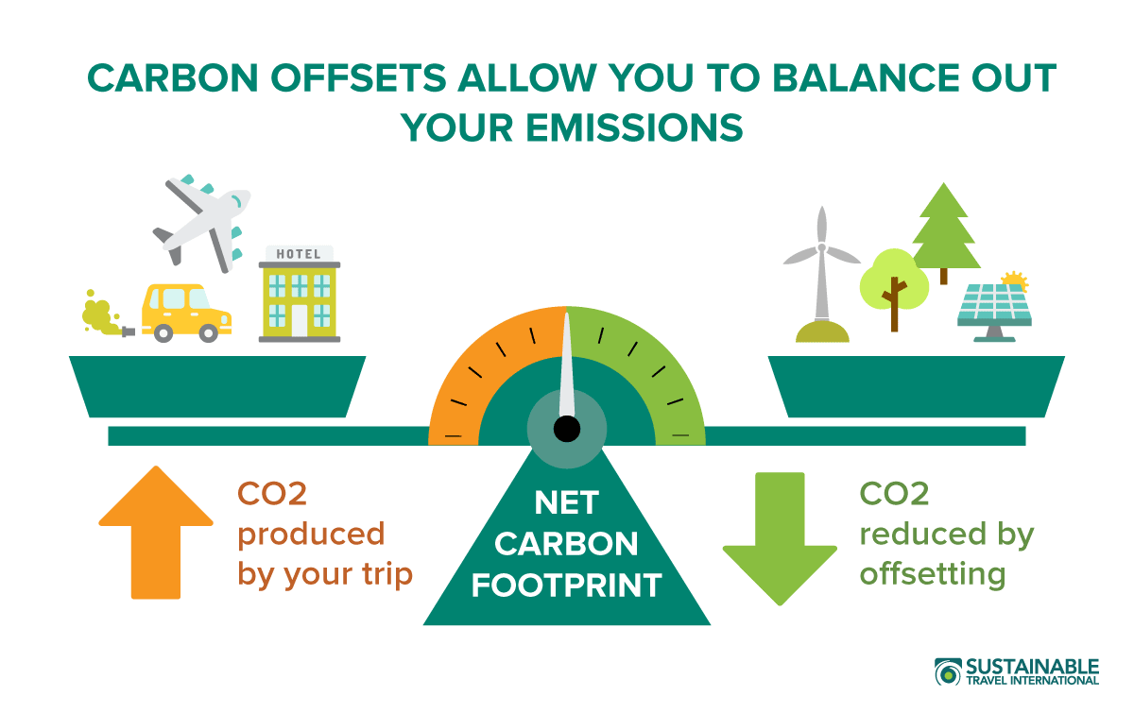
https://docs.google.com/spreadsheets/d/1s74mV6C_MPjnZzhUWZghksQCJY62vfDqTfQFZM3ib9M/edit?usp=sharing

