AASHE STARS Report 2020 University of Illinois Urbana-Champaign Improvements
Victoria Bittman & Gianna Elias

Introduction

The Sustainability Tracking, Assessment & Rating System or STARS is a system for colleges and universities to report their sustainability performance. A total of 1,004 institutions use this ranking system to determine their overall performance in sustainability efforts and gain international recognition. In 2019 the University of Illinois Urbana-Champaign was ranked Gold with an overall score of 72.89. The purpose of this project is to determine where the university’s weaknesses are and where they can gain points for the 2020 and future STARS Reports in order to receive a platinum ranking.

Water

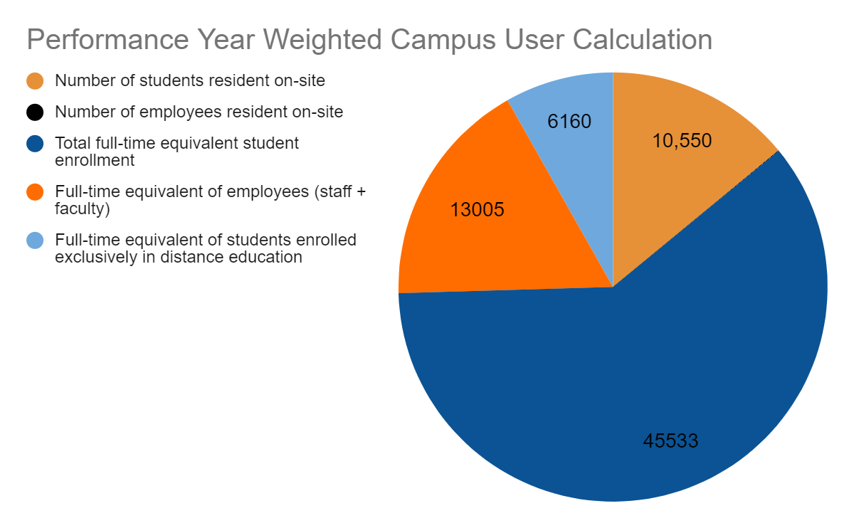
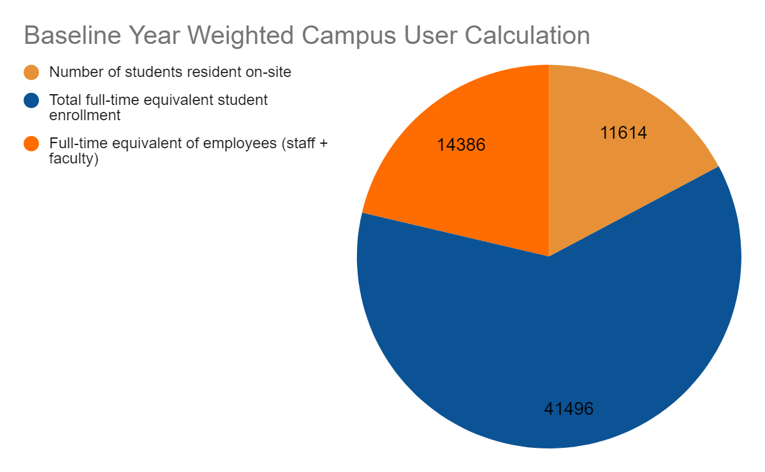
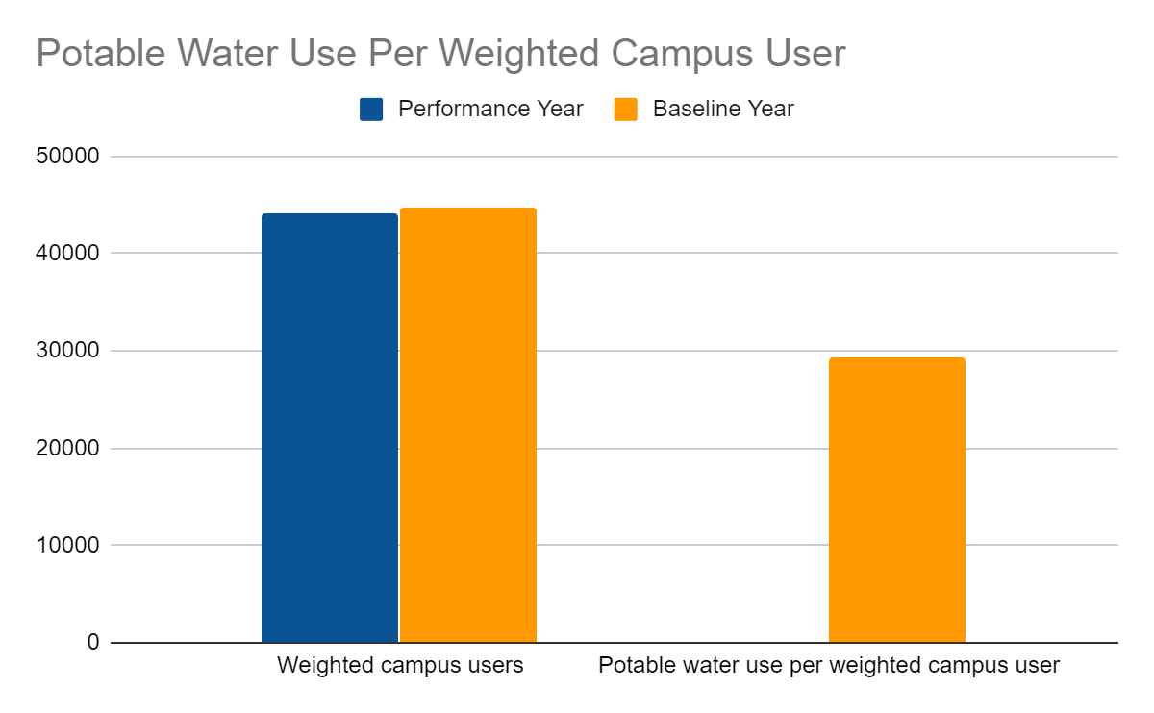
In the 2019 STARS Report the university received a 5.33/7.00 score in the Water section with a 3.33/5.00 in Water Use and a 2.00/2.00 in Rainwater Management. In 2019 most of the Water Use section points came directly from potable or drinking water since total water use was not reported. Potable water use is calculated by determining the total number of weighted campus users. This number takes into account the number of students and employees on site, total full-time students and staff, and full-time students enrolled in distance education. The university submitted a baseline year, and then compared the number of weighted campus users water consumption in the baseline year to 2019. Figure 1 shows the distribution of users used to calculate the total in the baseline year, and Figure 2 displays the performance year distribution. The number of users are similar, however, Figure 3 shows a drastic decrease of 99.93 percent between the baseline and performance year water consumption. Although exciting, it can be concluded that these numbers were inaccurately recorded, and should be fixed for the 2020 report. The university also reports numbers on potable water per unit of floor area in the university. These numbers were similar to the weighted campus user calculations with a 90.93 percent decrease between the two years. These values should be corrected as well. When asked if the university wishes to pursue reductions in total water use per acre of vegetated grounds, they report no. Pursuing this in the future could bring up the total water score. All other water sections were left blank except for a brief description of the instituion’s water recovery and reuse initiatives which with a mention of the Krannert Art Museum’s native planting near its entrance. One section left blank was a description of the institution’s initiatives to replace plumbing fixtures, fittings, appliances, equipment, and systems with water-efficient alternatives. This section could mention how the Land & Water SWATeam updated plumbing fixtures to low flow fixtures. These included 2,500 faucet aerators and 120 water-saving urinals. Another section left blank was the institution's water-related behavior change initiatives. This includes the use of signage and competitions around the university. A possible addition to this section could be the One Billion Gallon Water Challenge initiated in Spring 2014 by the Illinois Sustainable Technology Center. With the addition to these sections and the reporting of the total campus water use, the water section of the report should be brought up in numbers significantly.
Figure 2
Figure 1
Figure 3

Energy

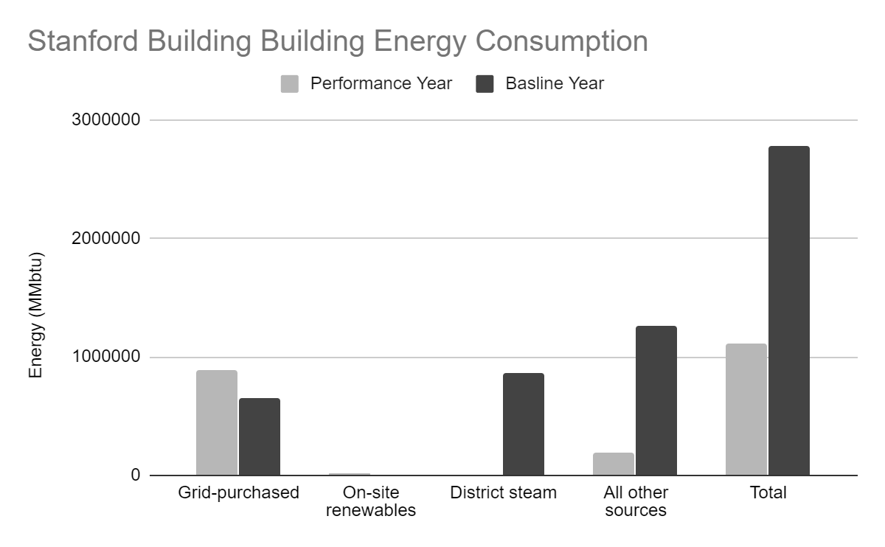
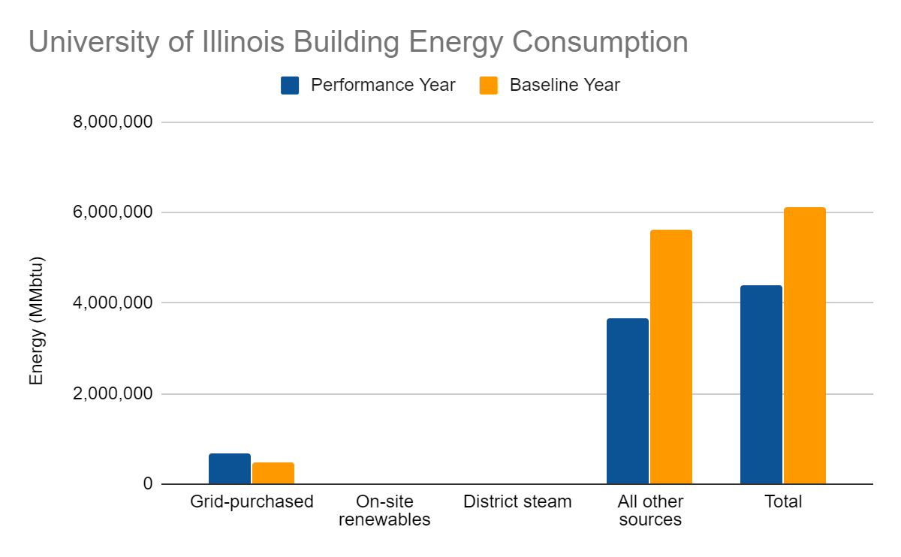
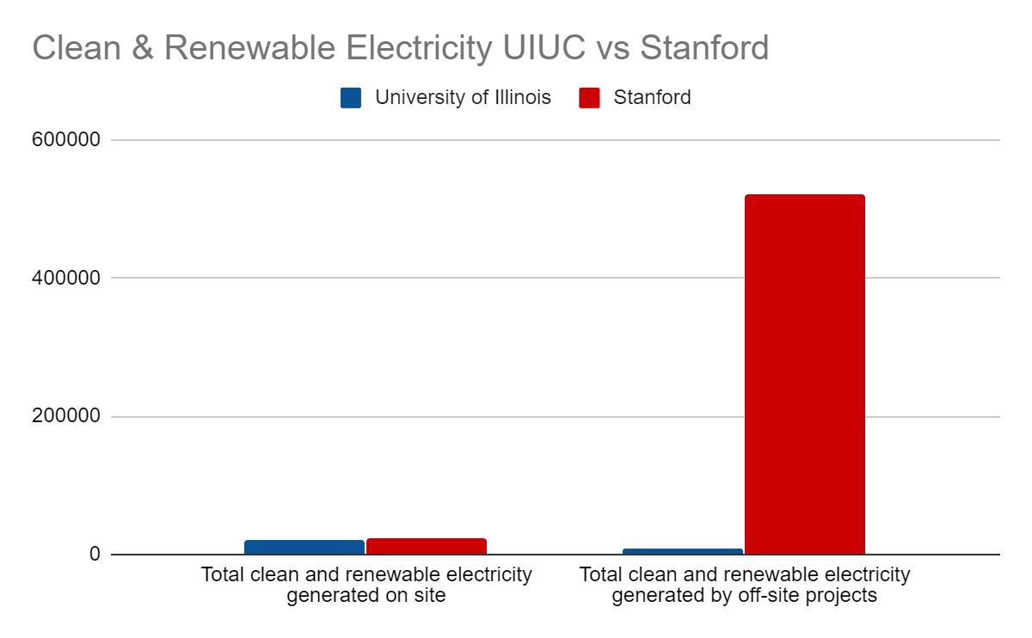
The Energy section of the University of Illinois’s STARS report received one of the lowest scores on the report with a total of 3.52/10.00 points. The building energy section received 3.49/6.00 points and the Clean and Renewable Energy received a low 0.03/4.00 points. To evaluate the university’s low numbers for building energy consumption the scores of the University of Illinois and Stanford were compared. Between the baseline and performance years, Stanford cut their energy consumption in half with a reduction of 51.48 percent (shown in Figure 5) whereas the University of Illinois only reduced their numbers by 23.71 percent (shown in Figure 4). Although cutting the university's building energy consumption in half is a lofty goal, it is something to be aimed at in the future. An area the university can gain points easily is the institution's initiatives to shift individual attitudes and practices in regard to energy efficiency. This was not reported on in the 2019 report, but there are many current projects that could be included. One of these projects includes the Eco-Olympics, an energy competition amongst residence halls on campus. Another project is Illini Lights Out. In this section, Stanford mentioned a current project called My Cardinal Green. Users that participate in this online project can collect points by performing energy efficient tasks around campus. Once one collects a certain amount of points, they receive a reward. If implemented correctly, this would be a good project to add onto the University of Illinois’s sustainability efforts. Other sections left blank include: energy use standards and controls employed by the institution (e.g. building temperature standards, occupancy and vacancy sensors) and passive solar heating, geothermal systems, and related strategies employed by the institution. Most of the points that the University of Illinois did not earn in the Clean and Renewable Energy section of the report came from the energy generated by off-site projects. Both UIUC and Stanford generated about the same amount of renewable energy on-site. However, although the University of Illinois consumes four times the amount of energy (due to student population differences), Stanford generates 64 times the amount of renewable energy off-site than UIUC (see Figure 6). This drastic difference in numbers is due to the fact the University of Illinois put the Wind Power Purchase Agreement into effect in 2019, and numbers still need to be built up. These should be corrected, and points will be gained back in the 2020 report.
Figure 5
Figure 4
Figure 6

Transportation

The University of Illinois received 4.81/7.00 points in the Transportation category of the 2019 STARS Report with a 0.17/1.00 in Campus Fleet, a 1.80/2.00 in Student Commute Modal Split, a 0.84/2.00 in Employee Commute Modal Split, and a 2.00/2.00 in Support for Sustainable Transportation. In the Campus Flett category, 1.00 point is awarded for schools in which their entire campus fleet is composed of vehicles that are alternatively fueled/powered. Not many schools have a high scoring in this category, but universities who have a higher score than U of I have a greater number of vehicles in their campus fleet and have descriptions of the institution’s efforts to support alternative fuel and power technology in its motorized fleet. A long term plan to raise this score would be to increase the number of buses that are alternatively powered or more sustainable. A quick way to raise the university’s score in this area would be to add a description. The Student Commute Modal Split has a high number of points, but the Employee Modal Split still needs some work. A campus mode-share survey was sent out in January 2019 to collect the commuter data for both students and employees, and it was found that a total of 42 percent of the university's employees use a more sustainable commuting option, but no data was given on the distribution of employees that walk, carpool, bike, use public transportation, etc. One way to entice employees to take this survey, thus allowing the university to obtain more detailed information, is upon completing the survey, the employee’s name will be entered into a drawing to win a prize such as Illini Sustainability spirit wear. Current work is being done by WIEFX Sustainability Scholars to improve commuting to work. The Bike Path Renovation: Armory Avenue Path South of Gregory Hall project by Natalie Hill is making it easier for employees and students to bike to class. Another project by Chikako Minaj and Riya Gyanmote is currently being performed to add more electric vehicle charging stations on campus. This will eventually allow more people to drive electric cars to work. One last way to convince employees to commute to work more sustainably is to put closer parking marked specifically for low emission vehicles. With all of these modifications, the score in commuting will eventually grow. Since the university received a 2.00/2.00 in Support for Sustainable Transportation, it needs to maintain these great numbers.

Air and Climate

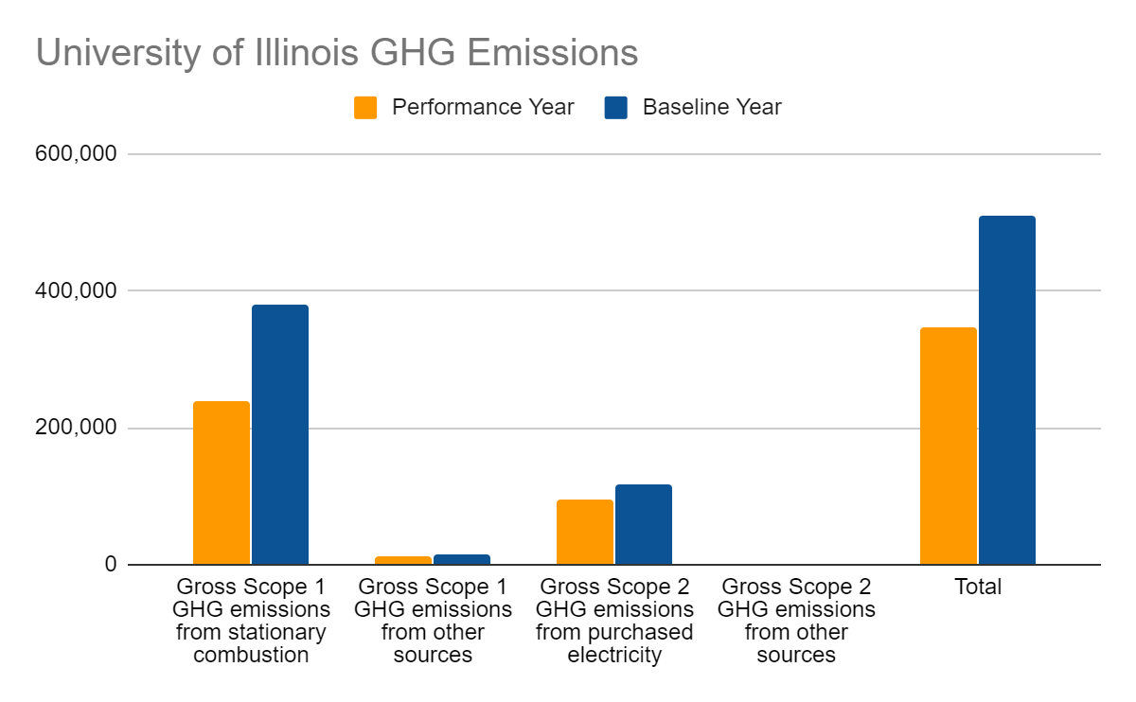
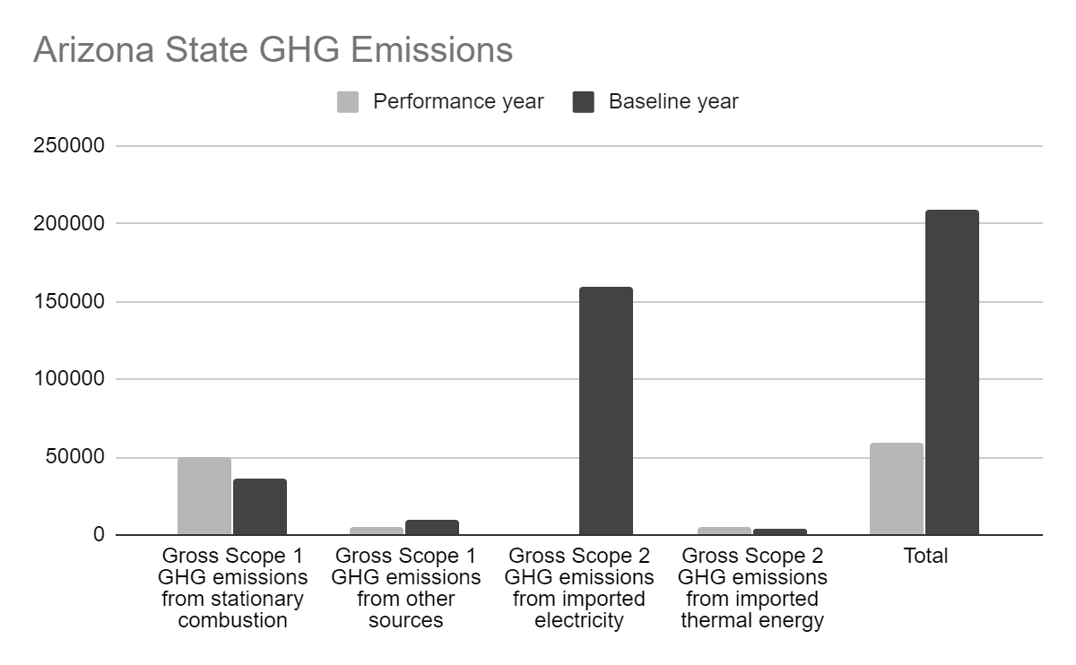
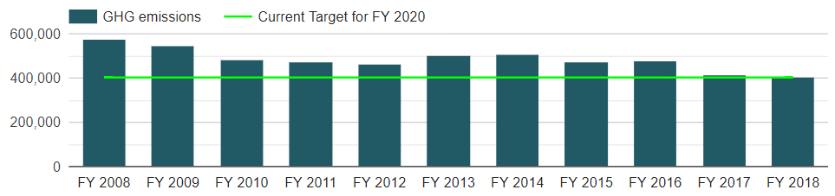
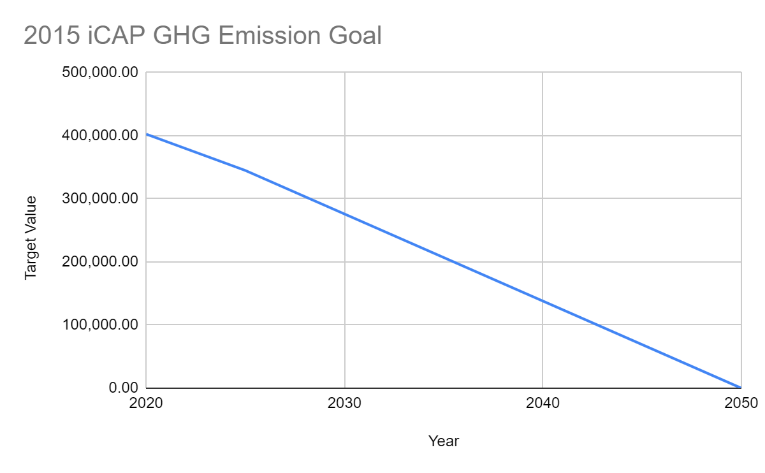
In 2019 the University of Illinois scored a 5.46/11.00 in the Air and Climate category with a 4.46/10.00 in Greenhouse Gas Emissions and a 1.00/1.00 in Outdoor Air Quality. Although the university has a good scoring in Outdoor Air Quality, Greenhouse Gas Emissions need to be improved. Arizona State reported a decrease in their net Scope 1 and Scope 2 GHG emissions per weighted campus user of 100 percent whereas the University of Illinois had a decrease of 34.12 percent (shown in Figures 7 and 8). One of the programs that Arizona State has implemented is an air travel carbon fee that is used to plant trees in an urban forestry program. This program is similar to the current Study Abroad Carbon Emission Offset program implemented by WIEFX Sustainability Scholars Leah Courtney and Parima Michareune. Other programs that Arizona State initiated are a car-sharing program, a pedestrian transportation promotion, and a Campus Metabolism web tool which displays real-time energy use and generation on their campus. Programs like these could help offset our carbon emissions. Arizona State provided a link as a brief description of what they are doing to lower Greenhouse Gas Emissions. A link to the 2015 iCAP could be displayed here, showing Figure 10. Once the University of Illinois obtains its goal of zero carbon emissions (Figure 9), the campus will receive a perfect score in this category.
Figure 10
Figure 8
Figure 7
Figure 9

Grounds

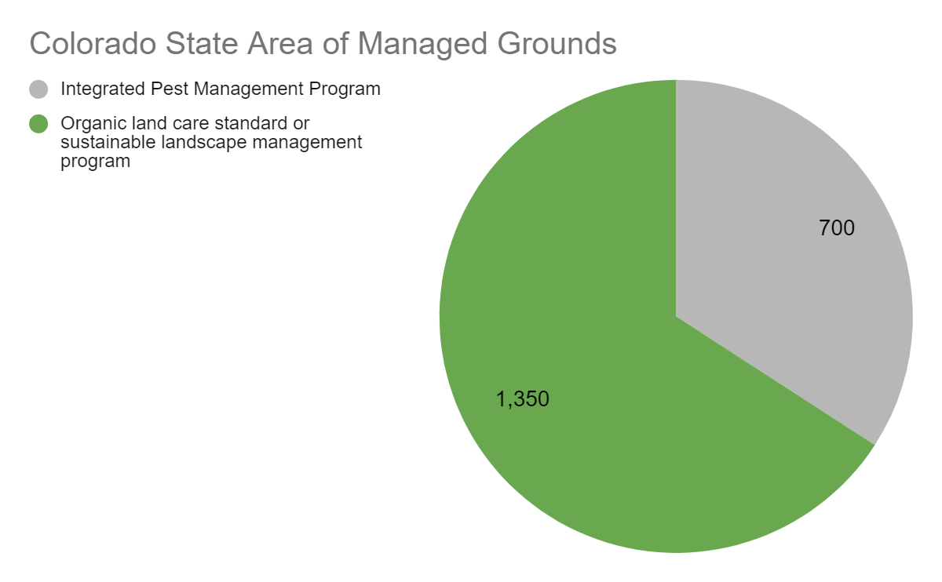
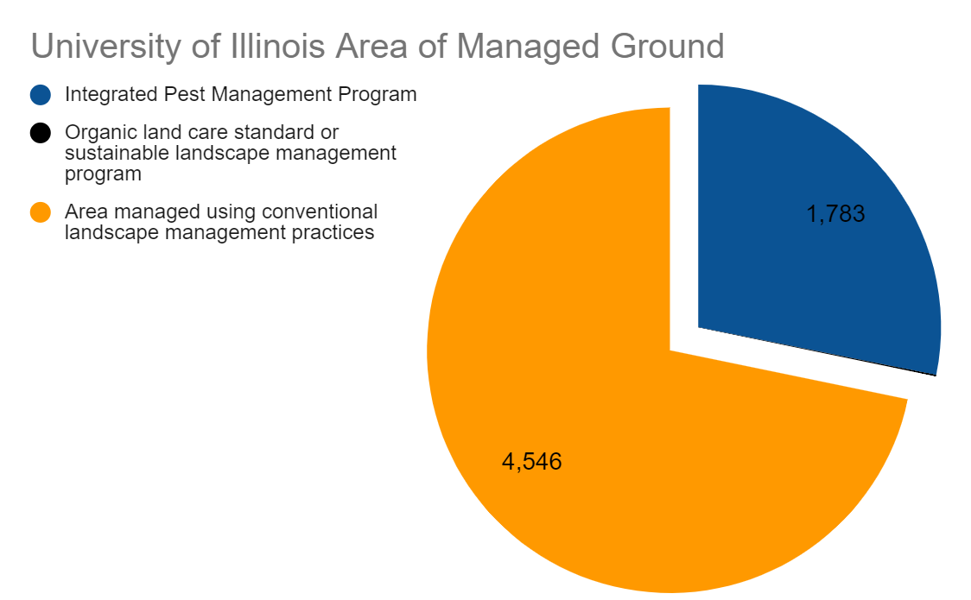
In 2019 the University of Illinois received a 2.28/400 in the Grounds section of the STARS Report. They received a 0.28/2.00 in Landscape Management and a 2.00/2.00 in Biodiversity. Colorado State, a platinum ranked school, received a 1.66/2.00. in Landscape Management. While the University of Illinois and Colorado state have similar percentages in grounds managed in accordance with an IPM program ( 28.15% UIUC and 34.15% Colorado State), Colorado State maintains 65.85 percent of its grounds in accordance with an organic program whereas the University of Illinois reported it only managed 0.09 percent. Figure 11 shows that the University of Illinois is still managing 4,546 acres of land with conventional landscape practices whereas Figure 12 shows Colorado State manages zero acres of land with conventional landscape management. One way to increase the amount of land managed organically would be to expand the student sustainable farm. One easy way to increase the amount of points in this section would be to add descriptions to blank areas of the report such as the institution's approach to energy-efficient landscape design, the institution's approach to hydrology and water use, and a copy of the IPM plan or program.
Figure 11
Figure 12
Building

Under the 2019 STARS Report, the University of Illinois at Urbana - Champaign scores a 3.69/8.00 under the building category. Now the biggest loss for the university falls under the building operations and maintenance category and scored a 1.00/5.00. Now this is because of the over 20,000,000 square feet of floor area on campus, the report states that none of the floor areas are LEED O+M certified and this is significantly impacting the score. LEED O+M is a certification based off of the operations in a given building and procedures taken to lessen the toll on the environment. This certification is meant for older buildings who were not built with LEED certification in mind because the environmental impact of tearing down the building completely is far greater than the benefit of building a new LEED certified building. Going through this process will be the most efficient way of gaining points because this is the main way to receive points within this subcategory of buildings.

Waste

The University of Illinois at Urbana - Champaign currently scores a 4.06/10 on the most recent STARS Report. Within this category the university is only receiving 3.06/8 points for waste minimization and is marked not pursuing construction and demolition waste diversion. Both of these categories are places for improvement and an opportunity for more points. One thing is in the most recent report, there is no mention of the recycling facility run by the university which could improve the score because it provides evidence that the university actually sorts the materials that are recycled by students and faculty and therefore increase the score because the report specifically asks for affirmation that materials are sorted. Another reason the university may have lower scores than other universities is because many other universities have baselines that are much smaller than U of I’s so they have an advantage when it comes to showing growth from the baseline year however this is not something that can be changed. Another way to decrease waste or increase the amount of recycling goods is finding ways to replace waste produced by on campus locations like Urbana Market by replacing containers with reusable materials and ensuring materials can be easily recycled. Also in the dorms make sure the recycling bin is clearly marked in both the rooms and in the trash room because, at least on Carr Hall first floor, there was very little to distinguish between recycling and trash so they both became trash by default. Similarly, as the university grows its composting initiative will fall under this category because it’s eliminating food waste and will increase the sustainable actions of the university. In the upcoming report, the university needs to report any recycling of construction materials that is done to increase the score there and ensure that there are clear guidelines for the university to follow when it comes to what to do with excess materials.

Food and Dining

Currently the University of Illinois is scoring a 2.00/8.00 for the Food and Dining portion of the STARS Report. The university receives full points for sustainable dining however are marked non-pursuing for food and beverage purchasing on campus which is what’s costing the university additional points. Now the first step to start getting points from this section is to report on all of the university’s current purchasing of food and beverage. A big part of this category is making sure that the university is buying what they can from local resources and is ethically produced. So one way is getting food products from local farms and the student sustainable farm and other farms near campus. Arizona State University checks in with the dining halls to make sure they are maximizing their use of local produce and making sure that all menus are possible due to the climate so that the campus stays as locally produced as possible. They also have an ingredient of the month that is incorporated into meals based off of what’s in season in the community around them and solely use cage free eggs.

Purchasing

In the 2019 STARS Report, the University of Illinois at Urbana - Champaign received a 2.76/6.00 in the purchasing section. In this category two of the subcategories were marked as not pursuing; electronics and office paper. Due to this they are the categories to be focused on in this upcoming year. First off, the university should start switching to paper with recycled materials to reduce the carbon footprint of the university. To start gaining points the university’s paper must be at least 10% recycled which will gain 0.2 points and will lead the university to the correct direction. The university should also encourage professors to switch to recycled paper or reduce the amount of printing and paper copies they require for class so that the classes become more environmentally friendly. This mentality should also be promoted in more administrative offices so that the entire university is working to decrease the carbon footprint. Now, to gain points in electronics the university needs to use machines with repurposed parts to decrease wasting those materials. This should be encouraged within each department and within the student body. To encourage students to buy laptops and other devices with repurposed parts, the school could start an initiative program that sets special rates in the beginning of the school year for students who buy repurposed devices instead of laptops made of entirely brand-new devices. The university should also set up a recycling location where students can recycle their electronics so parts can be returned to the manufacturer or repurposed on campus and therefore decrease the need to buy brand new parts and help companies decrease their production of parts. Even when a computer shuts down there may still be parts that work.

Other

In the 2019 AASHE Report the university only received 4/16 innovation and leadership points available for universities. Those three points were received for innovative new ideas that are not part of the regular AASHE report requirements. The three programs currently covered is the Field of Flame initiative and its work with biomass heating, Inner Voices Social Theater which brings awareness to the important issues and encourages student engagement, and Q Magazine which is for students to publish articles relating to their certificate and gain experience while working alongside professors. We also have the green event certification and green lab points which were .5 points each. Now all the other possible places for points are given by .5 however just getting a couple will really add up and improve the university’s chance of receiving a platinum score.
Innovation | Meet Requirements | Innovation | Meet Requirements
Sustainability Course Designation | No - some courses need to be officially about sustainability | Spend Analysis | No - Comprehensive spend analysis to determine if purchasing is sustainable. Ie supply chain carbon measurements
NSSE Sustainability Education Consortium | No - has participated in Sustainability Education Consortium and administered National Survey of Student Engagement | Bicycle Friendly University | Yes - New possible points
Academy-Industry Connections | No - Consulting contracts be reviewed for possible conflict of interest, no ghost writing, no sponsored research, no confidential corporate research | Stormwater Modeling | Maybe - Use stormwater modeling to assess impact of LID practice and green infrastructure, I believe campus is starting to do that
Green Athletics | No - Athletic events, buildings and transportation must be sustainable | Campus Water Balance | Maybe - Calculated a natural water balance for the campus to assess sustainability of its water withdrawals.  There is guidance on how to do this on criteria page
Green Event Certification | Already received | Natural Wastewater Systems | No - uses natural wastewater systems to treat and manage 10% of water through on site filtration or reuse
Hospital Network | No - Carle needs to be a global green and healthy hospital/ practice green health/ healthier hospitals initiative | Pre-Submission Review | Yes - submit current version to STARS Review Template and addressed inconsistencies, all credits must be reviewed, it can be either internal or independent
Fair Trade Campus | NO - Need to be a member of Fair Trade Campaign USA | Community Stakeholder Engagement | No - Institution has a formal community stakeholder engagement that follows AA100 Stakeholder Engagement Standard
Certified Green Cleaning | No - needs the Green Seal Environmental Standard for Commercial Cleaning or ISSACleaning Standard | Pay Scale Equity | No - maximum compensation scale ratio 1:15. 1 is lowest paid full time employee and 15 is highest paid senior admin
Green Laboratories | Already received | Adjunct Faculty Compensation | No - university provides average $6,000 per course to adjunct faculty members
Sustainable Dining Certification | Yes - We are a member of the Green Restaurant Association | Campus Pride Index | No - 4 stars or higher by Campus Pride Index  We aren’t rated yet  https://www.campusprideindex.org/
Grounds Certification | Yes - We are part of Bee Campus USA | Serving Underrepresented Groups | No - institution is designated as a minority-serving institution, historically disadvantaged university, indigenous institution or equivalent
Pest Management Certification | No - need to be certified under EcoWise, GreenPro or Green Shield
So currently there are four additional categories we definitely qualify for which will gain us an extra two points in this category. There are some that require a little extra calculations here on but the university may qualify for in the future.

Conclusion

Overall, the university is on the right track to achieve their goal of becoming a platinum level school. With consistent improvements on the university’s approach to sustainability and student engagement the university will continue to improve their score and reach the 85 point threshold needed to become a platinum level school through their STARS report. The major weaknesses for the University of Illinois lie in nine different categories and if we make a 1.5 point improvement to each category we will meet our goal.

Resources

https://www.istc.illinois.edu/research/water/one_billion_gallon_water_challenge
https://sustainability.illinois.edu/campus-sustainability/icap/swateams/land-water-swateam/
https://icap.sustainability.illinois.edu/project/eco-olympics
https://bikeleague.org/sites/default/files/BFU_Award_List_2019_ALL.pdf
https://www.gbes.com/credentials-overview/leed-ap-overview/leed-ap-om-overview/

