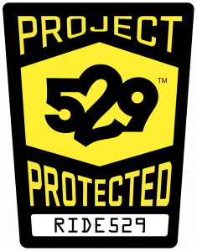
Bicycle Registration is MANDATORY!

Register your bicycle to protect your ride.

There is a one-time $10 registration fee to purchase a theft-deterring 529 Shield sticker.

Scan the QR code to learn more or go to go.illinois.edu/mybike

