SWATeam Recommendation
Name of SWATeam: Zero Waste

SWATeam chair(s): B.K. Sharma & Timothy D. Stark
Date submitted to iWG: 4/2/21

Recommendation title: Join the NERC (Northeastern Recycling Council) Government Recycling Demand Champions
_
For internal use only: Date reviewed by iCAP Working Group:

Specific actions/policy recommendation:

University of Illinois to join the NERC Government Demand Champion Program.

Suggested unit/department to address implementation:

Unsure – IWG to determine? Rationale for recommendation:
- Free technical assistance in training, recognition, and tools to support efforts in the program. This will help us find more Post-consumer recycled (PCR) products by engaging with existing or identifying new vendors, provide training opportunities to department buyers, and/or provide the SWATeam with innovative engagement tools to increase buy-in across campus.
- Aligns with State of Illinois Procurement Code (ILCS 500/45-15 & ILCS 500/45-20)
- First University to join the program
- National recognition for sustainability commitment
- Support a circular economy Connection to iCAP goals:
Objective 5.1 – Create sustainable procurement reporting guidelines and increase compliance to 100% of business managers through training and outreach.

This recommendation will aid in the adoption of more sustainable purchasing guidelines by providing assistance and support in buying sustainable products, specifically PCR products.

Perceived challenges:

If the University intends to establish itself as a ‘Champion’ in this program, there must be a commitment to purchase PCR products. Prior to the creation of university-wide sustainable purchasing guidelines, enforcement of this across university departments may be tricky. Establishing the university as an ‘Advocate’ role rather than a ‘Champion’ will help to mitigate this issue by giving the university more time (1 year) to prepare to commit to purchasing PCR products.

Anticipated timeline of implementation:

August 2021: Sign NERC Commitment letter to be a Government Recycling Demand Champion

August 2021 – August 2022: Continue working on Objective 5.1 (Creating sustainable purchasing guidelines) and identify PCR vendors and products to purchase from.

August 2022: Transition to Advocate Role and begin purchasing PCR containing products where possible and report these purchases to NERC.

Anticipated budget (identify if cost is up-front or continuous):

No known costs

Individual comments are required from each SWATeam member (one or two sentences):

Team Member Name | Team Member’s Comments
BK Sharma  (co-chair) | I fully support this recommendation. I think it is a great way to increase sustainability on campus.
Timothy Stark  (co-chair) | No comment available.
Yuanhui Zhang | I fully support this recommendation. PCR is an important item need to dealt with to achieve zero-waste.
Caitlin Aylmer | I fully support this recommendation.
Thurman Etchison | I support this recommendation.
Aaron Finder | I support this recommendation.
Michael Olinger | I support this recommendation.
Shantanu Pai | No comment available.
Leah Courtney | I fully support this recommendation.
Maddy Liberman | This recommendation will help support a circular economy at the University, so I fully support it.
Cassidy Steel | I support this proposal.

Further explanation and background (can be supplied in an attachment):

- NERC Government Recycling Demand Champion Fact Sheet is attached.

- NERC Reporting Form is attached.

Example Products:

Existing vendors

Office Max/Office Depot: Binder dividers, Pens, Draw Dividers, etc

(From Office Max/Office Depot we have data on how many PCR products are already purchased and PCR alternatives that are available for non-PCR products)

Binder Divider Example

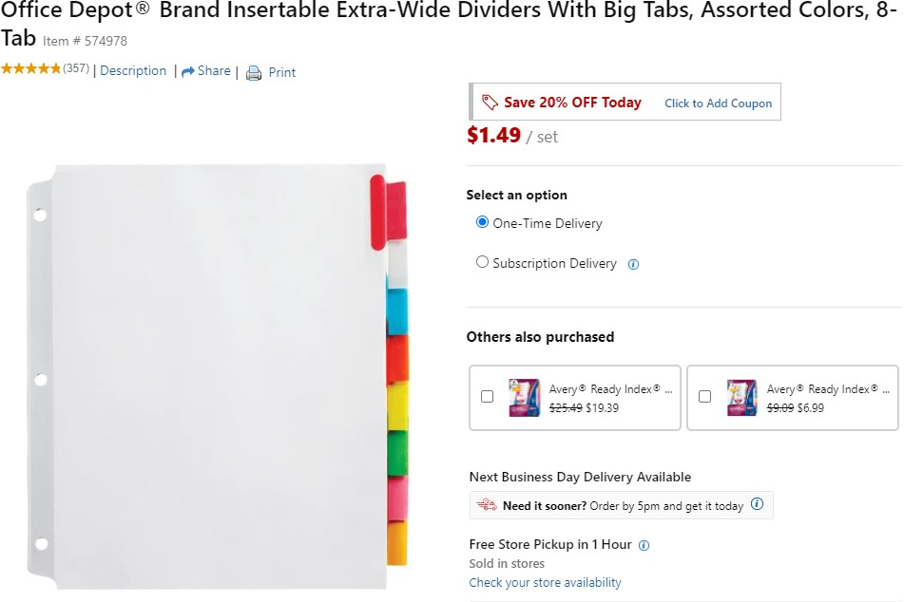
ThermoFisher Scientific Pipette tip Example
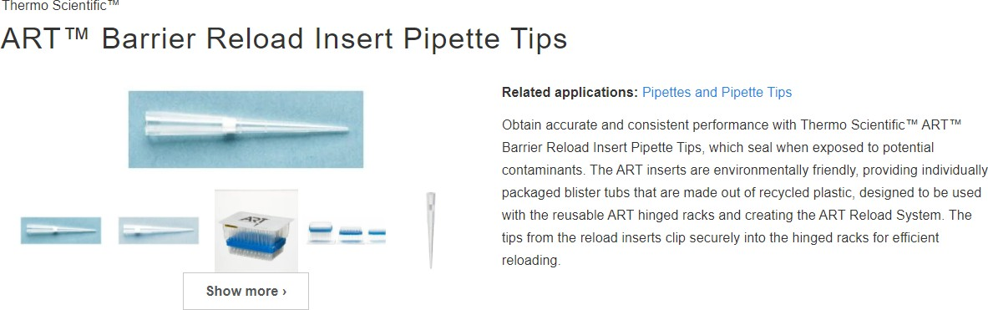

Other item examples
- Trash Bags
- Benches
- Bike racks
- Waste containers

Comments from consultation group (if any; these can be anonymous): Timeline might be aggressive

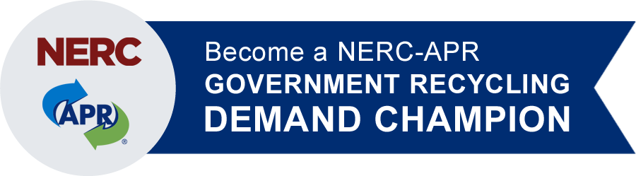

Consistent, reliable demand is CritiCal for reCyCling to be a mature, vibrant and sustainable industry.
ensure the future of Plastics recycling
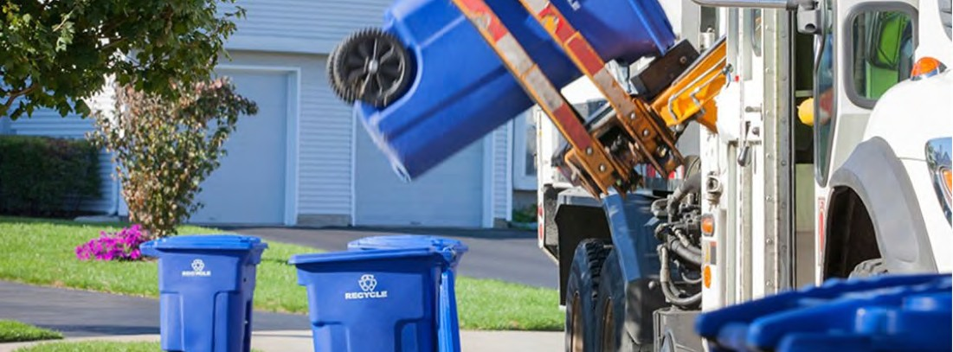
be Part of the SucceSS of PlaSticS recycling
become a nerc-aPr government recycling Demand champion.
Government Recycling Demand Champions commit to purchasing products that contain post-consumer recycled plastics (PCR) in order to stimulate and create domestic markets for recyclable plastics and thereby driving sustainable plastic recycling.
Any and all neW purchases of products with PCR apply. We welcome all state, regional, and local government entities, as well as public and private schools and colleges/universities, in the u.s. to become demand Champions.

Members of the recycling Demand champion Program recognize:
- Consistent, reliable demand for recycled plastic is critical for recycling to be a mature, vibrant and sustainable industry and,
- A strong demand for recycled plastics is needed not only to maintain but also
to build strong domestic plastic recycling markets.

recycling Demand champions look for their efforts to:
- Strengthen and increase domestic demand for residential mixed plastics,
- Help prevent “ocean plastics” by stimulating strong North American markets,
- Boost a “circular economy” for plastic packaging, and
- Mitigate reliance on export markets.

Your organization’s commitment to purchase products manufactured with PCR will make a significant and measurable impact to strengthen the plastic recycling markets.

Demand creates value. Value drives recycling.
For more information, visit: NERC.org/projects/government-recycling-demand-champions or contact Lynn Rubinstein (lynn@nerc.org).
“Given the current fragile recycling economics, a demand-pull for recycled plastics… is needed to start building positive momentum in the near term.”

Ellen MacArthur Foundation, New
Plastic Economy Catalyzing Action

We must strengthen demand for recycled plastics in the U.S. to replace lost export opportunities.

With record low prices for virgin plastic, it has become financially challenging for end-markets to use PCR resin. Consequently, public demand for PCR is essential to support the industry.

Using PCR provides significant environmental benefits - including energy savings and avoided greenhouse gas emissions.

Participating in this critical program is simple.

steP
1

Sign coMMitMent letter
Pledge – We will be a NERC-APR Government Recycling Demand Champion!
“We commit to participate in the NERC-APR Government Recycling Demand Champion Campaign to drive PCR use in products. We will increase our purchase of items with PCR within one year, and report to NERC in a timely manner so positive impacts may be collectively reported. We believe demand creates value and value drives recycling.”
See the full commitment letter. To submit a commitment letter, email it to Lynn Rubinstein, NERC, lynn@nerc.org.

steP
2
PurchaSe Pcr containing iteM(S)
Examples:

  - Roll-out carts
  - Outdoor furniture - picnic tables, benches, etc.
  - Plastics lumber, piers, decking
  - Infrastructure drainage pipes
- Recycling & garbage containers
- Office recycling bins
- Trash bags
- Other PCR-containing plastic products,
including electronics

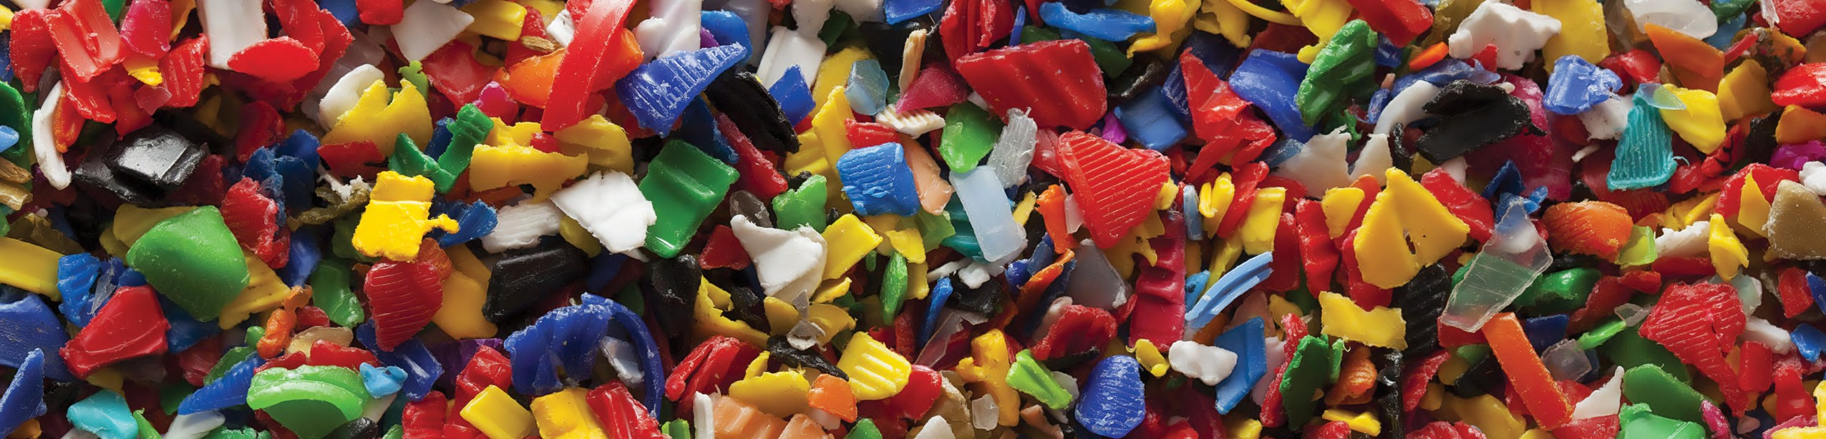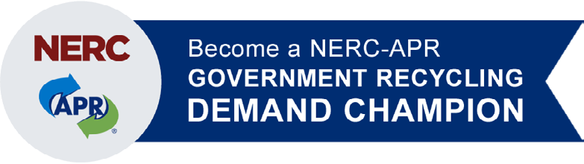

Let’s Get Started!

The Northeast Recycling Council, Inc. (NERC)’s mission is to minimize waste, conserve natural resources, and advance a sustainable economy through facilitated collaboration and action. Visit NERC.org.

The Association of Plastic Recyclers (APR) is the international trade association representing the plastics recycling industry. APR works to enhance the quality, increase the supply, expand the demand, and communicate the value of recycled plastics. Visit PlasticsRecycling.org.
See vendors selling items containing PCR, and links to public sector cooperative purchasing opportunities.

steP
3

rePort PurchaSeD iteM(S)
By the following year of becoming a Government Recycling Demand Champion, purchase PCR containing item(s) and report to NERC.
The annual reporting form is available online.

ongoing

ProMotion & recognition
Your organization’s prominent role in expanding the markets for recyclable plastics will be actively promoted by NERC and APR. Visit NERC.org/projects/government-recycling-demand-champions for a list of current Government Recycling Demand Champions.
You will receive a certificate recognizing your commitment as a Government Recycling Demand Champion.

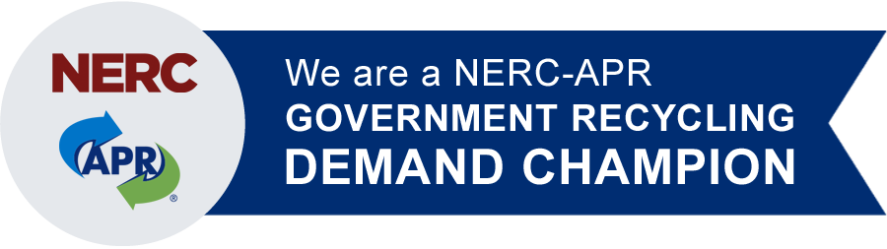
Reporting Form
2021

The NERC-APR Government Recycling Demand Champion Campaign enables government organizations committed to recycling and who recognize that “demand creates value and value drives recycling”, to proactively impact the domestic plastic recycling marketplace through their purchasing practices. This report verifies the positive impact your organization has had as a Champion. Please send completed reports to NERC (lynn@nerc.org).

Please complete a separate form for each type of product with plastic post-consumer recycled content that you purchased since becoming a Champion through June 30, 2021.

Today’s Date:

Organization Name:

Contact Person:

Email Address:

Documentation of your NERC-APR Government Recycling Demand Purchase
Government Demand Champion’s data will be consolidated to calculate the NERC-APR Government Demand Champion Campaign’s overall impact.

Date(s) of purchase: _

Product type & model number: _ (carts, infrastructure pipe, etc.)

Product manufacturer:

Number of items purchased: (quantity/size of carts, length of infrastructure pipe, etc.)

Percentage of PCR in the product, if known:

Please complete the following statement to certify the purchase of the above stated products.

I, _ (your name) certify that these products were purchased by

_ (organization name) between the month we became a Government Recycling Demand Champions through June 2021.

Optional: Please attach invoices for the items purchased that contain PCR.

Photos speak a thousand words. Please include photos (action photos, - products in use, etc.) so that they can be used to illustrate what NERC-APR Government Recycling Demand Champions have accomplished.

