Engagement Sustainability Working Advisory Team

Date: April 30, 2021
Location: Zoom
Time: 3 to 4 pm
Attendees: Ann Witmer (co-chair), Alexa Smith (clerk), Meredith Moore (Sustainability Programs Coordinator), Ximing Cai (iWG), Morgan White (iWG), Jie Hu (faculty), Sammy Yoo (staff), Dave Guth (staff), Keilin Tarum Jahnke (faculty), Kate Gardiner (staff), Hiba Ahmed (student), Fina Healy (student), Miranda Johnson (student)
Absentees:

Agenda:
- Definition of Sustainability
- Definition of Engagement
  - https://www.c2es.org/site/assets/uploads/2017/10/C2ES-Best-Practices-Sustainability-Engagement.pdf
- Areas of Engagement Mind Map to focus on next semester
  - ISEE Informatics Intern?
  - Sustainability Research/Job Board
  - Climate Action Plans 101: How Higher Education Institutions Can Lead the Charge Toward A More Sustainable Future
Meeting Notes:
- Definition of Sustainability
  - Social equity
  - Concise
  - Systems-thinking
  - Administrative duty
- Definition of Engagement
  - https://www.c2es.org/site/assets/uploads/2017/10/C2ES-Best-Practices-Sustainability-Engagement.pdf
  - Adaptable
  - Group-focused (as opposed to individual engagement)
  - Funding and Administrative components
  - Not the messenger of sustainability events
  - Working with groups of people
- Moving Forward...
  - Engagement Team = Strategic planners for sustainability
  - Looking for barriers to lack of sustainability engagement
  - Meet with Morgan White, Ximing Cai and Meredith Moore over the summer to discuss the MindMap
  - Potential action steps for our team:
    - Establishing funds to conduct research (for specialized or departmental research)
    - ISEE Informatics Intern to collect metrics
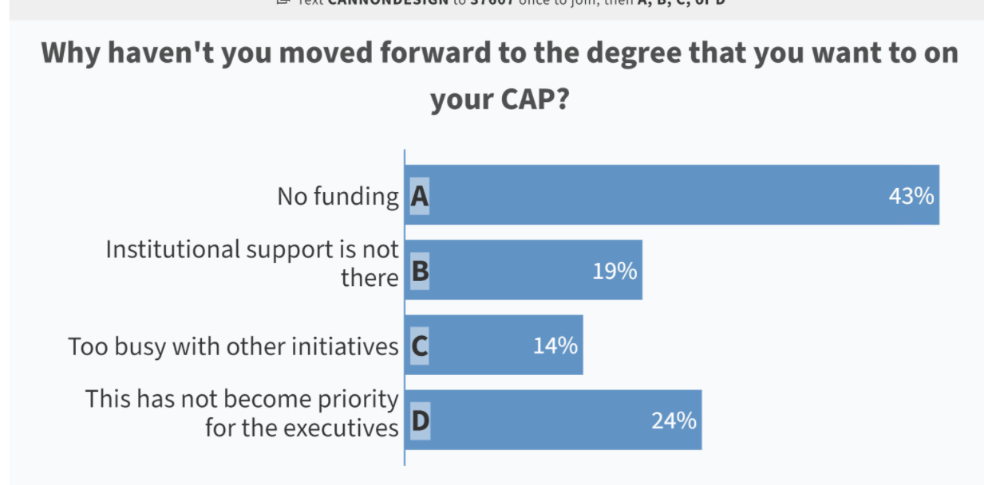
- Climate Action Plans 101: How Higher Education Institutions Can Lead the Charge Toward A More Sustainable Future

Action Items:
- Reach out to Alexa if you’re interested in working on the Mindmap, refining our sustainability and engagement definitions, and meeting with Morgan, Ximing and Meredith over the summer 😊
- Have a great rest of your semester and a great summer!

