Funding Criteria
A. General Rules
- Students, faculty, and staff are encouraged to submit requests for funding. Student-led projects require a faculty or staff sponsor in order to have funds awarded.
- Funding can only go to university-affiliated projects from students, faculty, staff, and departments.
- All SSC projects must make a substantial impact on students. All SSC funding is 100% from student green fees, so the projects funded by the students must benefit them.
B. Things SSC Can Fund, On A Case-By-Case Basis
- SSC can fund feasibility studies and design work; however, it must work toward ultimately addressing a sustainability need on campus.
- SSC can fund staff positions that are related to improving campus sustainability. Strong preference will be given to proposals receiving matching funding from departments and/or plans for maintaining continuity of the position after the end of the initial grant.
- SSC can fund outreach events with a central theme of sustainability, provided their primary audience is the general campus community.
- SSC discourages requests for food and prizes but will consider proposals on a case by case basis.
- SSC can fund repairs and improvements to existing building systems as long as it works toward the goal of improving campus sustainability.
- SSC can provide departments with loans for projects with a distinct payback. Loans will require a separate memorandum of understanding between SSC and departmental leadership pledging to repay the award in full and detailing the payback plan.
C. Things SSC Will Not Fund:
- SSC will not fund projects with a primary end goal of generating revenue for non-University entities.
- SSC will not fund personal lodging, food, beverage, and other travel expenses.
- SSC will not fund any travel expenses.
- SSC will not fund tuition or other forms of personal financial assistance.

Instructions
Submit this completed application and one map, graphic, or picture to Sustainability-Committee@Illinois.edu. Please adhere to the session word counts. The committee holds the right to decline applications over the designated word counts. If you have any questions about the application process, please contact the Student Sustainability Committee Coordinator at sustainability-committee@illinois.edu.

Project Name: Re_Home wall rehab and siding
Total Amount Requested from SSC: $60,000
Primary Project Leader Name & Email: Steve Ford, seford@illinois.edu

Project Abstract: In less than 100 words, briefly describe your project.
The Re_Home was designed and built by students for the 2011 US DOE Solar Decathlon Competition. Following the competition, the house was set up at the Agricultural and Biological Engineering Farm and has been used by Illinois Solar Decathlon club. It serves as a valuable educational facility for students from different colleges and schools on campus to learn sustainable living with zero energy. Unfortunately, the wall and siding have deteriorated in the past 9 years due to water intrusion. The proposed SSC grant requests funding to rehab the wall and install new siding with a drainage plane system.

 | Education | Energy | Food & Waste | Land & Water | Transportation
Project Category | Yes | Yes

Project Team Member List (student projects must include their faculty/staff advisor’s information)
Name | RSO/Department | Email Address
Steve Ford | Senior Research Engineer, ABE | seford@illinois.edu
Xinlei Wang | Professor, ABE | xwang2@illinois.edu
Tim Lecher | Facility Manager, ABE | tlecher@illinois.edu
William “Hunter” Bolen | Student, ABE | wbolen2@illinois.edu
Sri Theja Vuppala | Research Engineer, ABE | sritheja@illinois.edu

Questions | Yes | No
Is this a student-led project? |  | X
If applicable, have you received approval from Facilities & Services and/or site manager? | X
Do you have a plan for ongoing funding beyond SSC? (SSC cannot guarantee ongoing financial support) | X
Beyond SSC, do you have sources contributing funding or support (ex. staff time, external grants, etc.) to this project? | X
Have you applied for SSC funding previously? | X

Project Timeline
SSC funding agreements remain active for two years. Please list your project’s timeline and/or milestones.
Once funding is provided the project will begin immediately and will conclude within a 6 month time period provided that materials are available and weather permitting.

Project Description
In 250 words or less, describe your project. What does your project hope to accomplish? What are your project’s deliverables? Bullet points welcome.
The Re_Home was designed and built by students for the 2011 US DOE Solar Decathlon Competition. Following the competition, the house was set up at the Agricultural and Biological Engineering Farm and has been used by Illinois Solar Decathlon club. It serves as a valuable educational facility for students from different colleges and schools on campus to learn sustainable living with zero energy. Unfortunately, the wall and siding have deteriorated in the past nine years due to water intrusion. There is a need to rehab the wall and install new siding with a drainage plane system to increase the life span of the building and make it more useable by the Illinois Solar Decathlon Club and other organizations. Funding is requested to pay for the cost associated with the new siding. Estimated costs include the following:
- Siding and Materials: $18,000
- Labor: $ 42,000
- Total: $ 60,000

Once the renovation is completed, we will use the house for educational purposes for a wide variety of courses, visits by current and prospective students, etc.

Environmental Impact
In 200 words or less, how does your project increase environmental stewardship at UIUC? If applicable, what is the carbon, water, waste, and/or energy savings? Does your project relate to the iCAP? Bullet points welcome.
This project will further enhance awareness of sustainable measures at UIUC. Energy efficient systems, like the Re Home, have been used to educate and inspire our students to make sustainable decisions for building design. Since the home was built in 2011, the Illinois Solar Decathlon (ISD) has hosted many educational tours for UI students, K-12 students from the state of Illinois, and local community. Our goal is to use Re_Home sustainably by hosting prospective and current students and also events in the house. The house will also be used as a staging area for the autonomous farm, which was launched in 2020 as a joint effort between the Illinois Center for Digital Agriculture and the Department of Agricultural and Biological Engineering at Illinois. The farm is a testbed for advanced AI-driven capabilities for automated production farming, plant breeding, and scientific research. This house will expand the ever-growing demonstrations of practical, sustainable, and renewable energy production. In terms of energy usage, the house is more than net-zero, exporting more energy than its consumption. This project aligns with iCAP goals because the house is increasing sustainability outreach within student groups by demonstrating their efforts in the sustainability field.

Student Impact
In 200 words or less, how will this project benefit students? How will students be involved with this project? What educational components are in your project? Bullet points welcome.
The Illinois Solar Decathlon is an interdisciplinary registered student organization with over hundreds of undergraduate and graduate student members. Over the past 12 years, ISD has built five solar powered net-zero houses, and have been rewarded for their efforts by the U.S. Department of Energy. The RE_Home will be used to educate students and local community regarding sustainability and energy efficiency. The house also served as a lab for students to participate in simulated home visits in social work. We will continue to use the house as a teaching lab for the following:
- ABE 374 – Environmental Control for Buildings
- ABE 436 - Renewable Energy Systems
- ARCH 231 - Anatomy of Buildings
- ARCH 474 - Capstone Design Studio
- ECE 333 - Green Electric Energy
- NPRE 201 - Energy Systems
- TSM 232 - Materials and Construction System
- TSM 371 - Residential Housing Design
- TSM 372 - Environmental Control & HVAC Systems
- TSM 438 - Renewable Energy Applications
- ENG 491 - Interdisciplinary Design Project
- ENG 571 - Theory Energy & Sustain Engineering
- SOCW 506 – Social Work Practice With Children and Adolescents
- SOCW 507 - School Social Work Practice
- SOCW 509 - Advanced Clinical Assessment & Interviewing

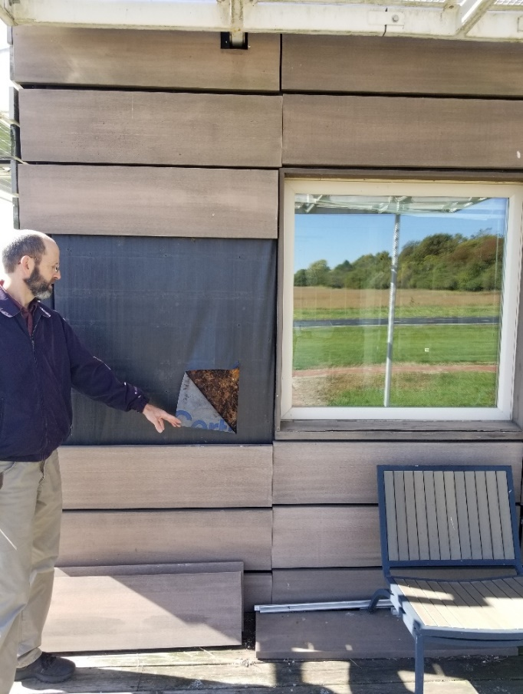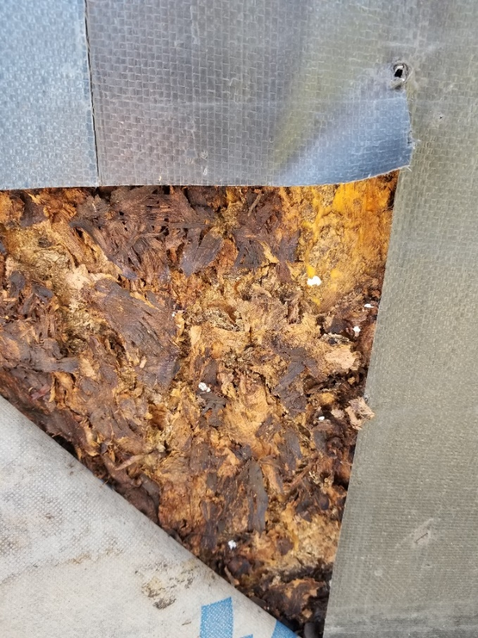
Above: Exterior siding panels are falling off the house due to fasteners pulling out of the water damaged sheathing.

