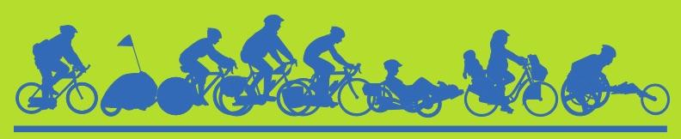

Champaign-Urbana Annual Bike to Work Days 2021, 2022, and Bike Month 2022 Sponsorship Opportunities

Dear Community Service Organization/NFP/Business:

Biking and Walking, The New Normal!

With the Covid 19 pandemic subsiding, we are working to keep the momentum of a new normal of increased physical activity going in our communities. Though the past months have been difficult for all of us, activities such as bicycling and walking increased – bicycle shops are still working to meet demand!

As with most activities the past 15 months, organized bicycling events were canceled and left to individual pursuit. There was no Bike Month 2020 and though there was a national Bike Month for May 2021, it was locally observed with only a handful of small events and no community sponsorship. Instead, a Bike Day involving Bike to Work activities, a reopening of the University of Illinois Campus Bike Center, and Light the Night giveaway is planned for mid-September. Additional activities welcoming back in person students, a potential celebration of the completion of the MCORE project, presence at the Market at the Square, and the popular Moonlight Ride will also be possible. In May 2022, we intend to build on these activities and continue encouraging A New Normal.

As a business, a non-profit, or an agency, your mission achieves ongoing recognition through the educational marketing of community-building events such as CU Bike to Work Day and Bike Month. Your past support has allowed us to complete 10 past Bike Months. Bicycling is universally recognized for promoting health, environment, equity, independence, and fun. By joining with the Champaign County communities in presenting this year’s Bike to Work Day and next year’s Annual Bike Month you are reflecting your commitment to these values.

The “Sponsorship Levels and Recognition” chart below provides the options. If you have a preferred benefit level, you can complete the quick survey located at https://tinyurl.com/y8ym7xz9 or read on for contact information. Your sponsorship will allow CU Bike Month to provide free T-shirts to registered participants. These shirts are popular with our communities and various editions are seen regularly. We will be seeking funding now and through next May so that we can have separate editions for each Bike to Work Day planned.

In turn, funds raised by asking participants to contribute to CU Bike Month will support various activities related to bicycling such as the westward extension of the Kickapoo Rail Trail, youth participation and educational outreach, and local bicycle training facilities. We thank you for your ongoing support in making Champaign County the most bike-friendly county in the state. The next page provides more information on various events and anticipated attendance. The project goals of the 2021-22 Bike Month participant fundraising and the planning team are listed on the third page. With your help, we are looking forward to continued growth in a thriving community.

CU Bike Month 2021-22 Suggested Sponsorship Levels and Recognition per (?) T-Shirt Edition

Level | Donation | Back of T-shirt Logo Placement | Website
Diamond* | $5,000 | Contributors will be listed vertically, with the largest sponsors on top. The names/logos are largest at the top and decrease in size for each donation level. We ask for some grace as logos are challenging to evenly size, and the t-shirt designer seeks to make the back of the shirt be as aesthetically pleasing as the front.  * CU Bike Month Diamond and Platinum level sponsors will be recognized by name early and often during announcements, presentations, and where appropriate during media events and interviews. | X
Platinum* | $2,500 |  | X
Gold | $1,250 |  | X
Silver | $750 |  | X
Bronze | $300 |  | X
Friend of Bike Month | $100 |  | X
Gifts-in-Kind |  | If the value exceeds $300, we will add you to the shirt. | X
Volunteer Support |  |  | X
CU Bike Month Partner Agencies |  | Appear together at the bottom. | X

As mentioned, to be a sponsor of Bike to Work Day 2021, Bike to Work Day 2022, and CU Bike Month 2022 you may do the survey at https://tinyurl.com/y8ym7xz9, or you can directly contact:

Jeff Yockey  Board Member, Champaign County Bikes  info@ChampaignCountyBikes.org  217-565-1785 | Champaign County Bikes  PO Box 2373  Champaign, IL 61825
CCB is a 501(c)(3) organization and will send your organization a receipt.

Please provide or send in the following information:

● The contact person for your organization, and their contact info.
● The dollar amount your organization will provide for CU Bike Month 2019.
● A check for this amount, made out to: Champaign County Bikes. EIN# 02-0810177
● A vector file (.ai or .jpeg) of your current logo.

Social media, calendars, news releases, and other means are used to raise awareness of CU Bike Month and point people to our website/registration site: www.CUBikeMonth.org

Major CU Bike Month 2021 and 2022 Events -- check for updates on www.CUBikeMonth.org

September 15, 2021 Bike to Work Day, Reopening (need title), and Light the Night
TBA – MCORE Celebration
Full Moon Ride
School Walk and Roll event
2022
May 1 - Bike to Work Day – 12 Welcome Stations around Champaign/Urbana/U of I; about 500-1,000 participants
May 3, 10, 17, 24 - XTRA City bike ride - 5:30-8:30pm
May 4 - U of I Campus Youth Instructor Workshop & Bike Rodeo - 9am-2pm
May 4, 11, 18, 25 - Bike to Market - Urbana’s Market at the Square - 7am-12pm; about 50 interactions per week
May 4 - Community Used Bicycle Sale
May 8 - K-12 Bike to School Day - 7:30am-9am
May 11 - Traffic Skills 101 Bike Safety Class
May 12 - Mother’s Day Ride – 2-5pm
May 15 - Ride of Silence - 7pm-9pm
May 17-19 - Bike to Worship Weekend
May 18 - Playing it Safe Bike Rodeo & Helmet Sales - 9am-2pm
May 18 - Prairie Cycle Club Spring Metric - Weaver Park - 9 am
May 18-19 - Full Moon Ride; approximately 100 participants
May 22 - Bike Month Celebration & Sunset Ride plus Music - Weaver Park - 6:30-8:00pm
May 24 - Critical Mass - Alma Mater - 6pm

Bike to Work Days have been our signature event involving an estimated 1,000 cyclists and volunteers. In past years, 20% of all cyclists visiting our Welcome Stations were first-time bike commuters. Throughout the months of September 2021 and May 2022 (National Bike Month) we will encourage Champaign County citizens to get out and ride their bikes for fun and experience some of the other side benefits bicycling offers as well. See www.CUBikeMonth.org for our calendar listing the 20+ bike events planned for May, along with additional information.

2021-22 Funding Projects: Bike Trails, Facilities, & Education

This year and next we will ask our CU Bike Month participants to give generously to these projects, with a $25 gift being the target amount, and larger gifts being encouraged. Kids participating in our Bike to School Day event next May will be given a free Bike Month 2022 t-shirt. Our aim is that for every $1.00 you contribute to CU Bike Month 2021-22 as a sponsor, $1.50 will be raised for our Trails and Education Fund from the cyclists you are helping to encourage. Your encouragement will build capacity that encourages others!

2021-22 CU Bike Month participants are supporting these key causes:

Local and Popular |  |  | Youth and Family
Trails |  | + | Education
217 | KRT |  | Bikes | Classes  Events
Expand the KRT to the east and promote InterCity trail system to the west (217), linking Urbana and Champaign to the trail. |  |  | Teach kids and adults how to safely ride a bike. Education creates a culture of bicycling and driving safety.

Encouragement events, like the ones planned, play a huge role in getting more people out on bikes. We continue to believe that it is appropriate to ask cyclists who are benefitting from the work and encouragement of city officials, advocates, and our CU Bike Month sponsors to join us in investing in the future of bicycling in our community. In years past, participant donations have helped to:

- Kickstart the Kickapoo Rail Trail;
- Obtain an educational bike fleet for youth;
- Financed 2 donated trailers to make our bike safety courses more accessible.

Since 2016 we have used our bike fleet to teach hundreds of kids basic bike safety and handling skills, and some even to ride a bike! Your help in promoting CU Bike Month through items like t-shirts and programming publicity gets more people out on bikes safely and encourages further generosity among our area cyclists.

As a 501(c)(3) organization, CCB will handle the CU Bike Month Fund sponsorships and donations. All sponsors and donors to CU Bike Month will receive acknowledgement and a receipt from CCB. A CU Bike Month Report will be generated at the end of Summer 2022.

CCB will strive to have a trailer present at many of the events during CU Bike Day or Month events. If you are interested in being a trailer sponsor, contact CCB Board Members Jeff Yockey or Audrey Ishii. Major trailer sponsors will be recognized on the graphics used on the trailer for the typical three-year life of these.

Jeff@ChampaignCountyBikes.org 217-565-1785 audrey.l.ishii@gmail.com 217-367-2813

The CU Bike Month budget for 2021-22 is $17,500 with a goal of reaching over 2,000 cyclists during each of the months of September and May. The CU Bike Month budget covers promotion and education materials, design and purchase of the Bike Month t-shirts, and other event expenses.
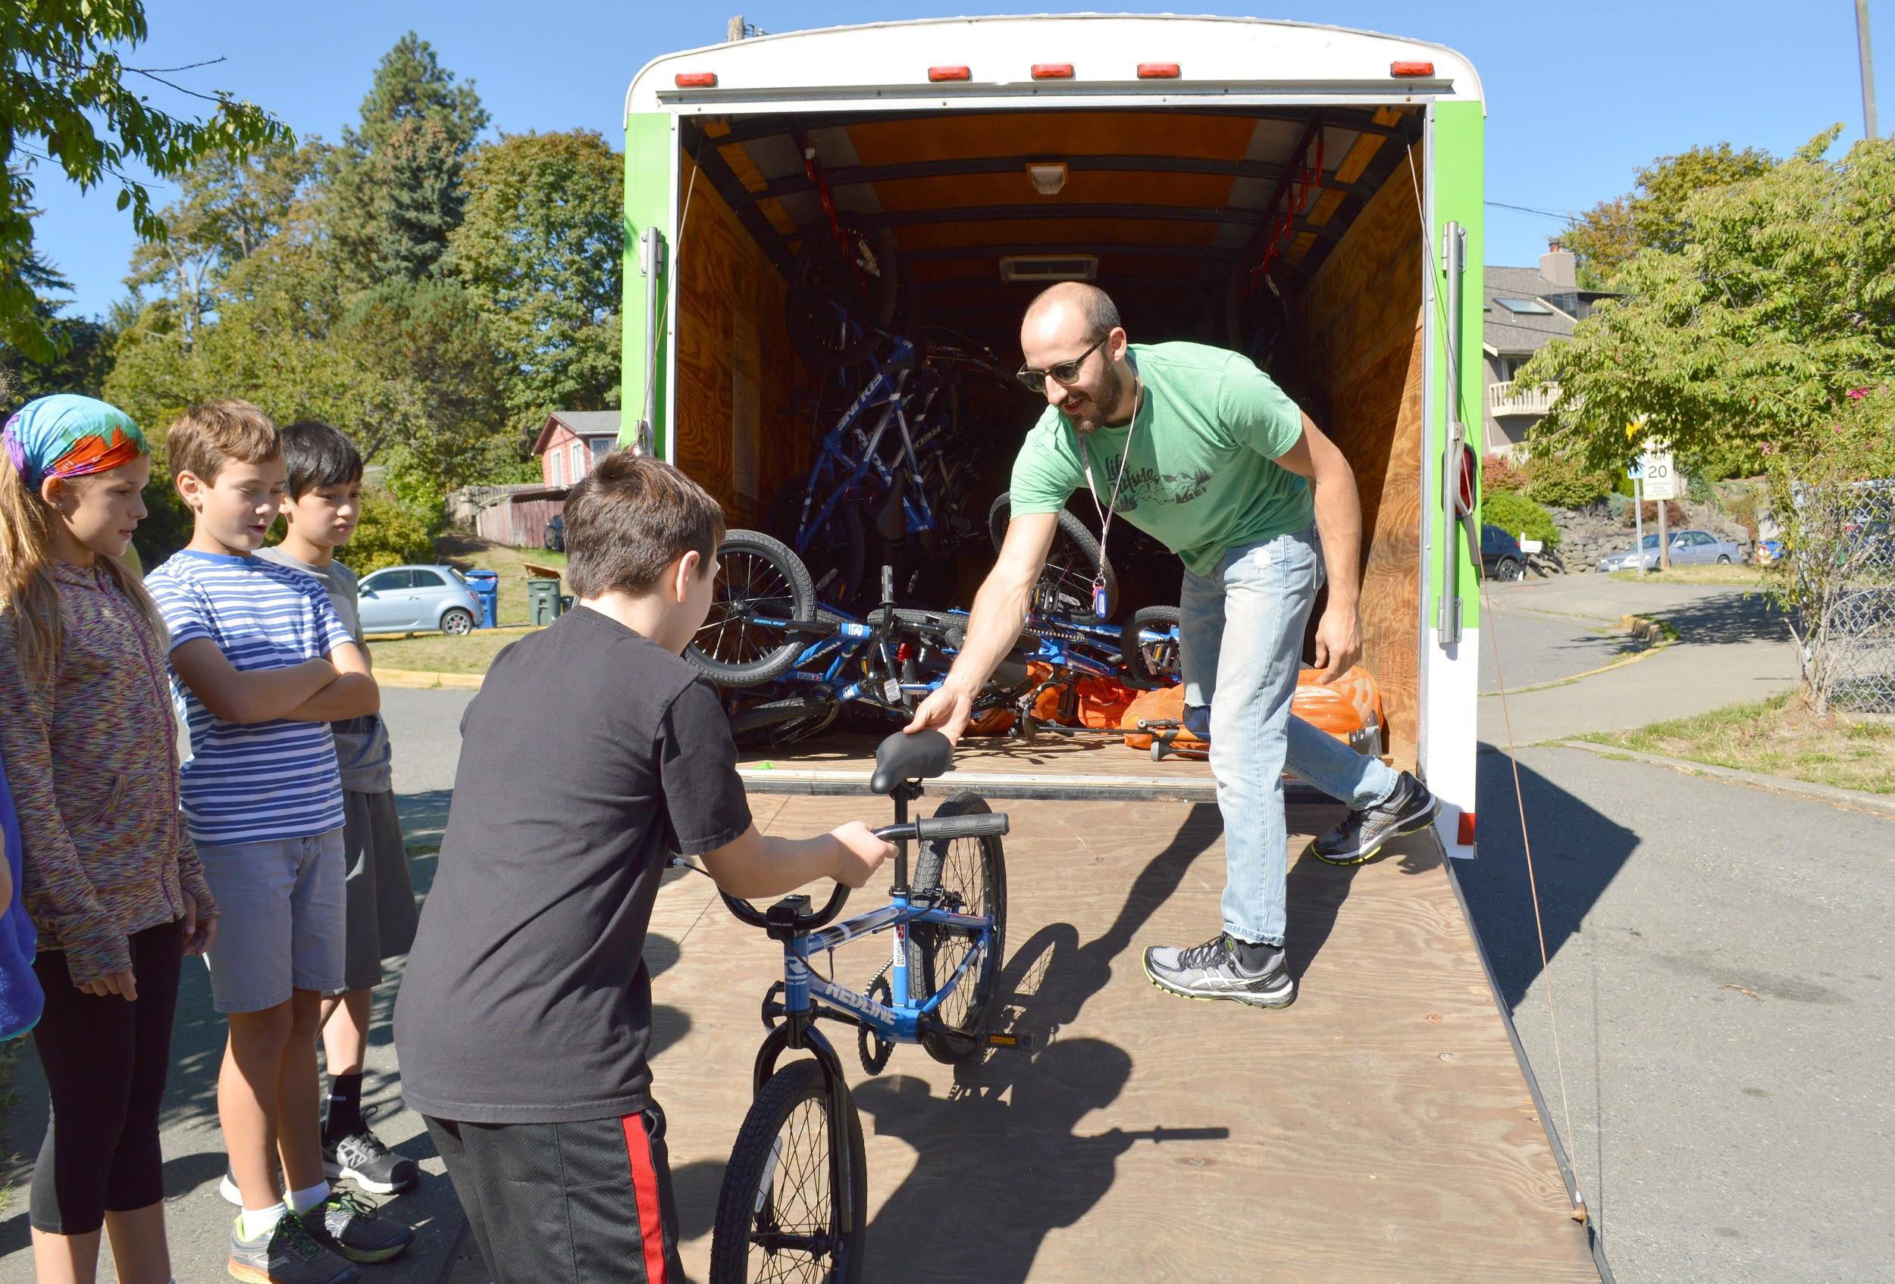
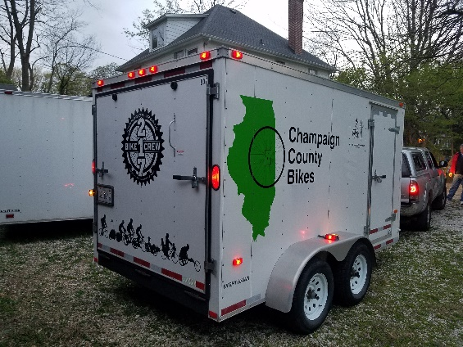

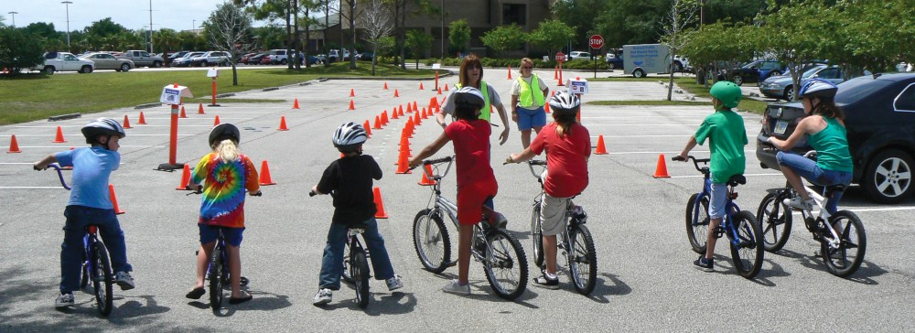
Top left: Bike trailer similar to CCB trailer with a wrap; top right: CCB trailer supporting an educational event; bottom: Safe Routes To School organized Bicycle Rodeo.

The CU Bike Month 2021-22 Planning Team (listed below) thanks you for making Bike to Work Days and CU Bike Month possible.

Jeff Yockey / Charlie Smyth | Champaign County Bikes
Cynthia Hoyle | CU Safe Routes to School Project
Evan Alvarez | Champaign Urbana Mass Transit District
Ben LeRoy | City of Champaign
Lily Wilcock | City of Urbana
Gabe Lewis | CC Regional Planning Commission
Morgan White/Sarthak Prasad | University of Illinois
 | Village of Savoy
Mary Ellen Wuellner | CC Forest Preserve District/Kickapoo Rail Trail
 | The Bike Project
Susan Jones | Prairie Cycle Club

