SmartWay Social Media Posts – June 2021

Post 1:

Using the #EPASmartWay logo helps differentiate your company from the competition. Be sure to let your customers and stakeholders know that you’re leading the way on clean, sustainable supply chain management. Learn more: epa.gov/smartway

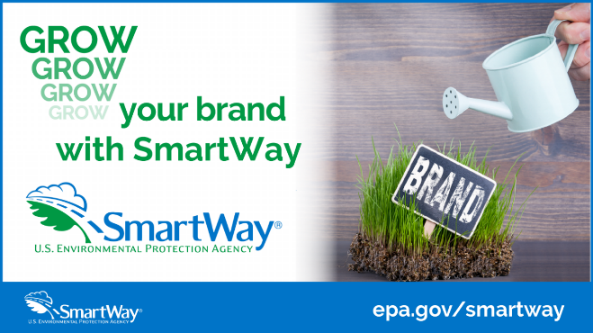

Post 2:

Just use it! Did you know that you can put the #EPASmartWay logo on your tractor or trailer if it meets EPA’s specs? Move your goods efficiently with SmartWay. Learn more: epa.gov/smartway

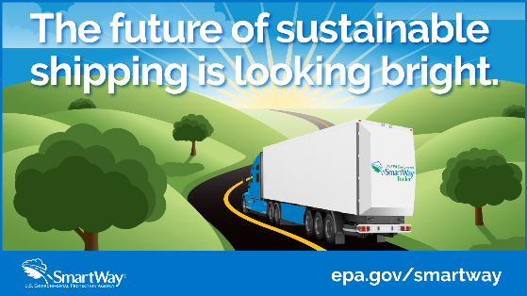

Post 3:

Be part of the #EPASmartWay story! Use the SmartWay logo to brag about your accomplishments & let the world know that your company is committed to being part of a cleaner supply chain. Any way you ship it, move it the SmartWay. Learn more: epa.gov/smartway

