Thank you for your commitment to green initiatives at the University of Illinois. One of the ongoing requirements listed in the terms of the funding agreement for your project is the submission of semesterly reports with key information about your project. In addition to this form, please provide additional financial documentation and/or progress photos if available.

Please be as accurate as possible in describing the project (including possible setbacks or challenges in meeting the initial goals of the project). Not fully meeting your project's goals will not disqualify you from making future funding requests as long as your reports are as complete and accurate as possible. If you have any questions, please contact the Student Sustainability Committee, at sustainability-committee@illinois.edu.
Project Name: Clean Meat at Illinois

Date of Report Submission: 9/13/2021

Project Purpose:
Food insecurity is a major public health issue in the United States, affecting over 1 million Illinoisans in 2018 and over 13 million Americans in 2019 (Feeding America, 2019; USDA, 2019). Furthermore, nearly 20% of greenhouse emissions come from livestock and around 70% of all land used for agricultural production is used for breeding and maintaining livestock (UN Report, 2006; FAO Report, 2012). With the onset of climate change, the Covid-19 pandemic, and forecasted global population increases, food insecurity is a pressing issue that exists at the intersection of troubling socio-economic, public health, and environmental trends. Clean meat technology is a necessary and effective solution to our current and future food insecurity crisis because it offers better food security and resource equity, significant environmental and sustainability benefits, and reduced public health risks compared to present practices in industry. Clean meat, or laboratory meat, is a food product that is produced from growing animal cells of interest (cow, pig, chicken, etc.) at scale in a laboratory setting to achieve a biomass of suitable size for consumption. It is commonly referred to as clean meat because it is produced in a cruelty free setting and has a reduced environmental impact compared to standard meat products. The goal of this project is to implement a robust clean meat initiative on campus to provide more sustainable food products for students, and so that the University of Illinois can be a model toother universities and organizations in how to champion sustainable, environmentally friendly movements that effectively address real-world issues. Specifically, this project intends to capitalize on the remarkable enthusiasm our campus population has for sustainability and the world-class expertise our graduate students and faculty have in tissue engineering, agricultural and biological engineering, and food science by bringing these two groups together to form a robust, campus-wide clean meat movement.

Detailed Accounting of Expenditures to Date:
Please see table below detailing expenses.

Item | Cost
PPAR gamma/NR1C3 Antibody | $ 299.00
Oil Red O solution | $ 40.30
Pax7 Antibody w/ shipping | $ 174.00
Cd29 Antibody w/ shipping | $ 160.00
Desmin antibody | $ 150.12
CD44 antibody w/ shipping | $ 461.00
MyoD antibody | $ 349.00
Cultisphere-G microcarriers | $ 226.00
Magnetic stirrer (x2 @ $301 each) | $ 602.00
Synthemax II microarriers | $ 203.00
100 mL Spinner Flask (x2 @ $211.18 each) | $ 422.36
Sigmacote solution | $ 47.00
Glutaraldehyde solution | $ 43.70
Gelatin solution | $ 44.82
Triaxial Extrusion Needle | $ 539.10
Equine Serum (x2 @ $40.22 each) | $ 80.44
Porcine Mesenchymal Stem Cells + Cell Media | $ 2,330.00
Sub-Total | $ 6,171.84
Labor | $ 2,368.25
Total | $ 8,540.09
Remaining (as of 09/10/2021) | $ 1,459.91

Project Progress to Date:
As described above, the goal of the Clean Meat at Illinois project is to create a campus-wide movement around raising awareness/investigating the feasibility of alternative sources of meat (i.e. clean meat), as well as alternative sources of proteins more broadly. Towards this goal, two initiatives are being actively pursued in parallel to meet the previously stated objectives. Specifically, one thrust has been a laboratory-based initiative consisting of cell culture training and experiments involving muscle cell expansion and scaffolding, and pig stem cell differentiation. The other thrust has been outside of the laboratory in the form of creating an RSO on campus, The Illinois Alt. Protein Project, specifically devoted to raising awareness about alternative proteins and providing students with the tools, knowledge, and resources to pursue careers or research opportunities in the alternative protein field.

Together, these twin initiatives have been pursued with the goal of improving student education and engagement related to the Clean Meat project and alternative proteins generally. Regarding the laboratory-based initiative, the biggest progress milestone to report is the successful establishment a functional bioreactor system, using which, in our preliminary experiments, we can achieve a 10-fold increase in muscle cell biomass using a model cell line in less than a week (C2C12 cells, 1.38e6 cells to 13.28e6 cells). Additionally, two undergraduates were trained in the necessary techniques to perform these experiments, and they lead future bioreactor experiments. The next steps for the bioreactor work are to confirm our cell expansion capabilities with experimental repeats, then perform cell expansion experiments with xeno-free cell media to compare cell growth rates between traditional media formulations and more sustainable, animal-free formulations. If time permits, we would ultimately like to perform final cell expansion experiments with the porcine mesenchymal stem cells (MSCs) to study animal stem cell expansion and identify opportunities to improve their expansion without loss of muscle differentiation capacity. Regarding the cell scaffolding experiments, we have been successful in repurposing apple slices into cell scaffolding materials that can retain and maintain muscle cells in culture for one week. Currently we are performing repeats to confirm the robustness of cell attachment, and in the future, we aim to optimize the density of cells can be maintained on these scaffolds to achieve the maximum amount possible. Finally, pig MSC differentiation experiments have proven to be more challenging given the amount of training required to handle them and the amount of time the cells need to grow. As such, these experiments are still ongoing, and we anticipate having results to report by the end of the semester. Please see the attached spreadsheets for raw data regarding bioreactor and cell scaffolding experiments.

Regarding student engagement outside the laboratory, The Illinois Alt Protein Project will be holding cooking events throughout the year aimed at raising awareness about alternative protein sources, how to incorporate them into everyday meals, and reducing the stigma associates with existing products on the market. Moreover, in an effort to connect students with more resources related to conducting alternative protein research in the laboratory or jobs in this field upon graduation, Illinois Alt Protein Project will be co-hosting an undergraduate research workshop in October with the Office of Undergraduate Research, and on September 22 we will begin our guest speaker series for which five experts from academia and the alternative protein industry will speak to students about their specific fields, how to get involved in the future, and answer any student questions. Furthermore, we are actively working to organize co-hosted events with other food and sustainability RSOs to engage more students with our group and mission throughout the academic year.

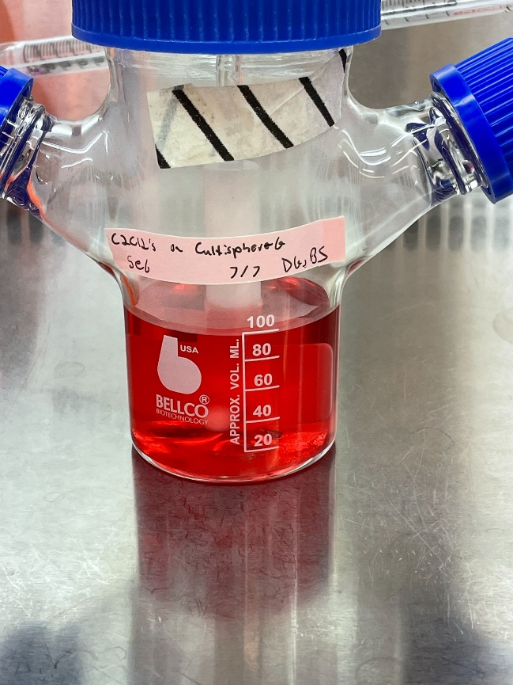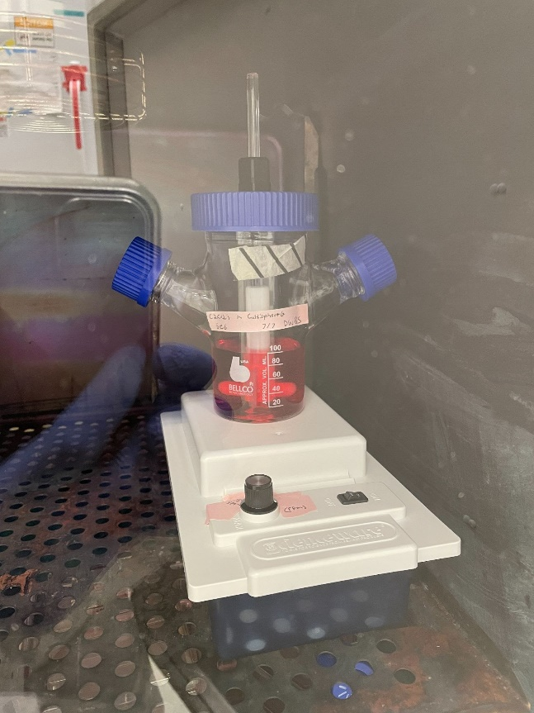

Small volume stirred tank bioreactor containing muscle cells attached to gelatin microcarriers (left). Complete bioreactor system (stirred tank bioreactor and magnetic stir plate) inside a cell culture incubator at 37 degrees Celsius (right).

Student Involvement and Outreach to Date:
Initially, the project team consisted of two PhD students and two undergraduate students, but since the time this proposal was submitted the number of students involved has expanded considerably. For the laboratory initiative, two additional undergraduates have joined the team and spent the summer receiving training and actively performing experiments. For the non-laboratory initiative (The Illinois Alt Protein Project), the team has expanded to include an executive board of four undergraduates and two graduate students (two new undergraduates and one new graduate student), and current total RSO membership (measured by the number of individuals who actively registered for and joined the RSO’s private Slack channel for member communications) is up to approximately 68 as of the writing of this report with students from half a dozen different majors. Additionally, two undergraduates are actively involved in both laboratory and non-laboratory initiatives. Taken together, that brings the total number of students involved, directly or indirectly, by the Clean Meat at Illinois project to around 70 students.

Additionally, we have actively been cultivating relationships with other RSOs on campus devoted to food science (e.g. Association of Food Technologists) and sustainability (e.g. Student Sustainability Committee) to increase awareness and collaborate with other groups with similar missions.

Marketing and Promotion Efforts to Date:
In Spring semester of last academic year, The Illinois Alt Protein Project actively advertised for interest meetings and general meetings, in addition to its first guest speaker (Amy Huang from The Good Food Institute). This semester, we attended Quad Day and had a booth devoted to engaging and attracting new members, and we will begin advertising for the guest speaker series during the week of September 13th. Regarding the laboratory initiative, no formal advertising has been done to date. We are currently planning to submit a request to give a presentation at the Undergraduate Research Expo in the coming Spring semester, and we are actively exploring other opportunities to give presentations about the Clean Meat at Illinois project and our current results on campus this semester.

Additional Comments:
Any additional comments/relevant information for the semesterly report

