Thank you for your commitment to green initiatives at the University of Illinois. One of the ongoing requirements listed in the terms of the funding agreement for your project is the submission of semesterly reports with key information about your project. In addition to this form, please provide additional financial documentation and/or progress photos if available.

Please be as accurate as possible in describing the project (including possible setbacks or challenges in meeting the initial goals of the project). Not fully meeting your project's goals will not disqualify you from making future funding requests as long as your reports are as complete and accurate as possible. If you have any questions, please contact the Student Sustainability Committee, at sustainability-committee@illinois.edu.
Project Name: Joint Pollinator Garden and Composting Systems to Offset Environmental Impact and Reinforce Responsible Stewardship in Research

Date of Report Submission: 9/13/2021

Project Purpose:
This project aims to foster environmental stewardship among UIUC students, decrease wasteful practices through behavior changes and increase landscape resiliency through the installation of pollinator gardens that support small scale composting on campus. Students from three departments, and recent UIUC alumni installed and maintaindc these garden-composting systems, reducing food waste greenhouse gas emissions and supporting endangered pollinators/microfauna. The gardens also reinforce responsible stewardship increasing inclusivity of indigenous students with similar values. These garden plots, planted with native flowering plants and grasses, watered from rain barrels and trench composted with personal food scraps support local endangered pollinators and microfauna (salamanders), serve as a small scale composting initiative, reduce food waste greenhouse gas emissions and promote behavior change in participants/observers. This project is an expansion of the pollinator garden-composting system (“carbon garden”) funded by the SSC in 2019. Funds were awarded to add three additional student-managed gardens to the UIUC campus.
Detailed Accounting of Expenditures to Date:
Plants: $2879.69
Greenhouse space and soil: $875.06
Student labour: $857.2
Total: $4611.95

Please see spreadsheet for details

Project Progress to Date:
In 2020, our project team put in place the two garden installations on time: Eastern Davenport Hall, and The Vivarium plot fall plantings. This amounted to approximately 500 plants.

In 2021, we completed early mid-Spring plantings in the Northern and Southern plots at the Vivarium, and repaired/removed failed plantings from the previous Fall.

The Davenport Hall plots have become overgrown as invasive plant species were able to grow extensively in the plot during the shut down. Considerable time was spent over May, June, and July trying to eliminate these species, cull the native plant species so that they were not overcrowded.

Again, Rain barrel, composting, website/signage and outreach to 4H and the Language lab in particular, have been delayed by the pandemic. We are hoping to have the signage in place at all developed sites this Fall.

The timing of the planting of the IGB plot remains unclear as pandemic-induced delays have interfered with the water drainage project that was to precede the planting. We are in touch with the responsible people at F&S.

Student Involvement and Outreach to Date:
An additional 8 students have been involved in the design, installation of the gardens bringing the total number of students engaged in the development of the plots to 20. These same students have been involved in the development of SOPs for removing noxious plants, and to help ensure the safe transfer for food waste for the composting system.

The composting system relies on involved labs and departments to be open so that generated food waste can be put into the compost bins. The pandemic has considerably slowed progress in student involvement and practice adoption. This Summer, however, our own lab slowly reopened. The involved labs in the Vivarium have remained closed. Lastly, the Anthropology department and involved Chemistry labs are partially opened. These reopening/ partial reopening are really intensive efforts to restart work practices and team, often from scratch. PI and student band width for additional tasks has been low. As we acclimate to our new work circumstances, the composting portion of the system is being re-initiated. We anticipate that the Brinkworth lab, Anthropology department and involved Chemistry labs will be back in practice over the course of this semester.

There is a surge of the undergraduate presence on campus. A great many sophomores are on campus for the first time and eager to be involved in lab activities. My own lab is anticipated to double in size this year. It’s an excellent time to leverage new-reality excitement to engage students in stewardship practices. Maintenance of the existing installations will recruit and involve dozens of students in the practice of composting and native plant garden care.

Marketing and Promotion Efforts to Date:
Traditional promotion and outreach efforts have been difficult. Gardens are something one works with their hands. In the context of a highly contagious pathogen that can maim even those that are vaccinated, it is difficult to scale promotion and outreach. However, in the Spring of 2021 I gave a public facing talk via Facebook Live a Champaign County Sustainability Network. The speakers and audience included UIUC students and Champaign County community members. The talk was well received and helped the “Carbon Garden” project connect with individuals engaging in other small scale composting efforts in the area, and generated email enquiries from the community.

We are currently in talks with Brent Lewis, Morgan White and the founder of the Red Oak rain garden to find ways to safely promote the project further and develop long term stewardship strategies.

Additional Comments:
Some of the microfauna visiting these spaces

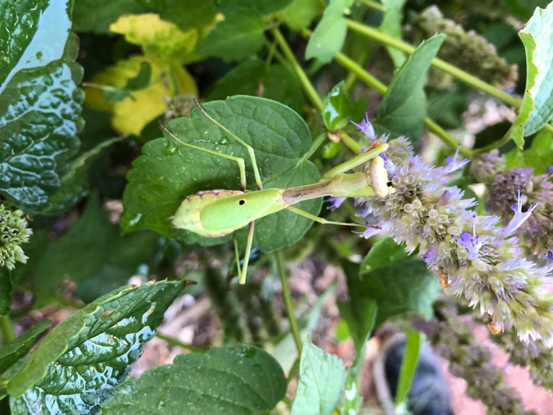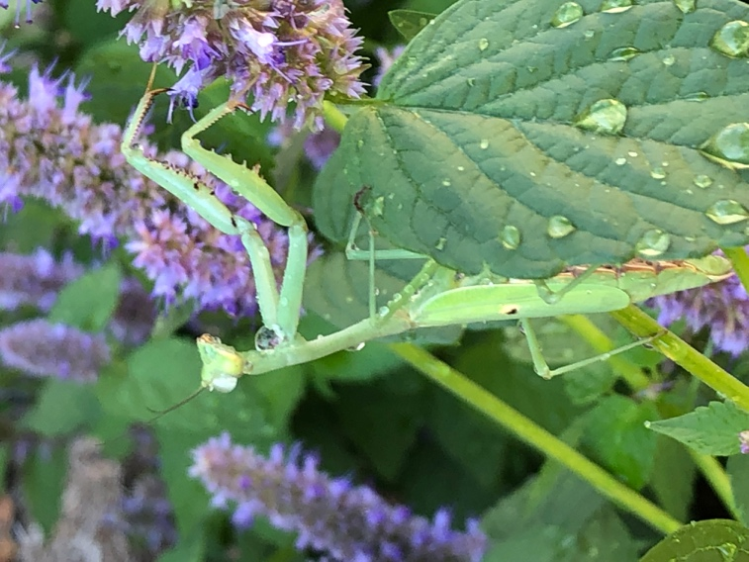
Figure 1 Carolina mantis (Stagmomantis carolina) on Anise Hyssop (Agastache foeniculum).
S. carolina is the only mantis native to Illinois. Vivarium planting.

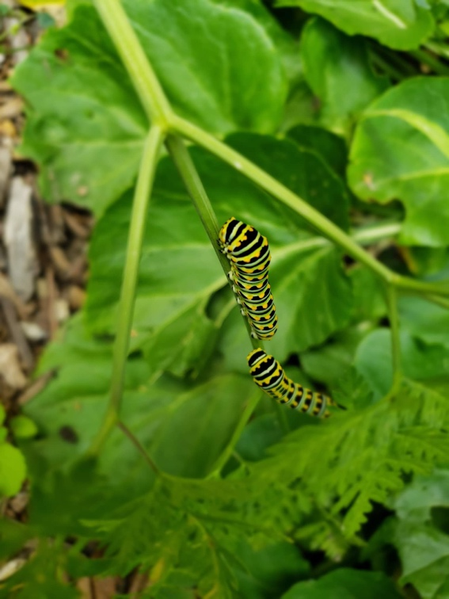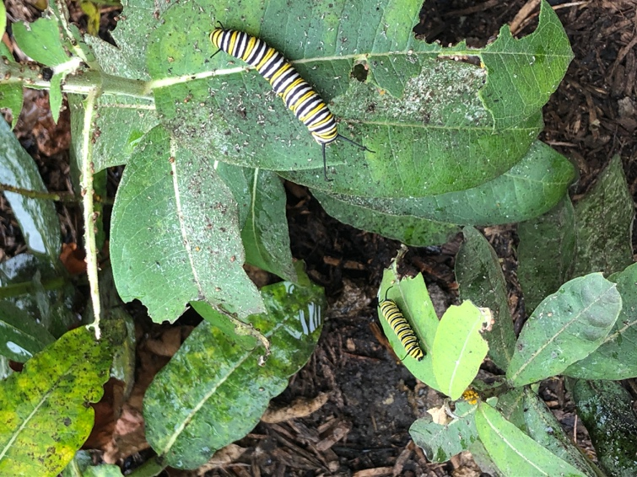
Figure 2. Left - Black Swallowtail caterpillars (Papilio polyxenes) on Cow Parsley/ Queen Anne’s Lace
(Anthriscus sylvestris). Right – Monarch caterpillars (Danaus plexippus) on Common Milkweed (Asclepias syriaca). Davenport
Hall planting
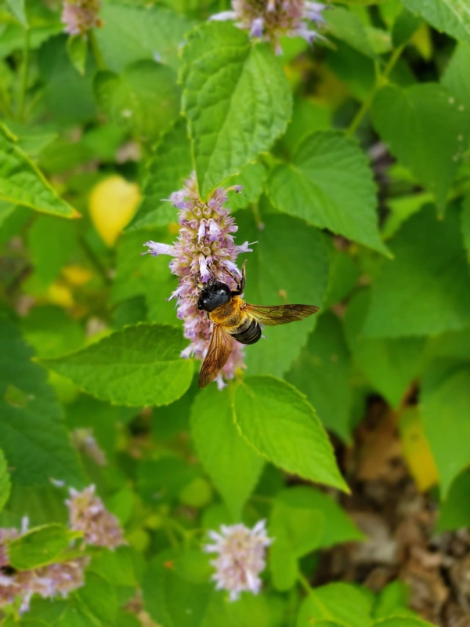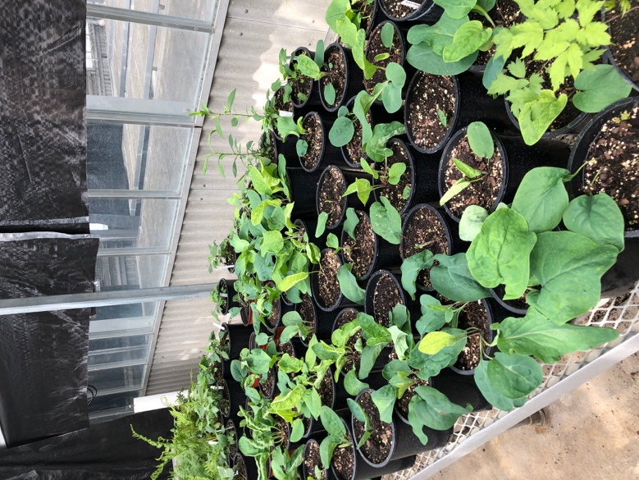
Figure 3. Left - A bee-like fly participating in Batesian mimcry on Anise Hyssop(Agastache foeniculum) (Davenport Hall).
Right – 2021’s Virginia blue bells (Mertsenia virginica), Black Cohosh (Actaea racemosa) and Heart Leaved Asters (Aster cordifolius) for Vivarium planting

