Thank you for your commitment to green initiatives at the University of Illinois. One of the ongoing requirements listed in the terms of the funding agreement for your project is the submission of semesterly reports with key information about your project. In addition to this form, please provide additional financial documentation and/or progress photos if available.

Please be as accurate as possible in describing the project (including possible setbacks or challenges in meeting the initial goals of the project). Not fully meeting your project's goals will not disqualify you from making future funding requests as long as your reports are as complete and accurate as possible. If you have any questions, please contact the Student Sustainability Committee, at sustainability-committee@illinois.edu.
Project Name: Illini Formula Electric

Date of Report Submission: 9/15/2021

Project Purpose:
Illini Formula Electric is a Formula SAE racecar team on campus that builds and all-electric, open wheel, formula style racecar each year. We focus on adapting the latest innovation and technology in the Electric Vehicle industry onto our vehicles and providing our members with the opportunity to do hands-on engineering. Our current project is a new All-Wheel-Drive vehicle that incorporates four motors independently at each wheel. This setup is the most advanced form of all-wheel drive as it allows each corner of the vehicle to be distributed the precise amount of torque for optimal grip. Due to this major redesign in powertrain, the entire vehicle is affected, and all systems are undergoing redesign.

Detailed Accounting of Expenditures to Date:
Currently, we’ve spent $12,714 in the FY 21 Fiscal Year. A detailed statement provided by our MechSe business department will be provided

Project Progress to Date:
Since fall 2020, we’ve created our first overall design of the AWD competition vehicle and finished building the mechanical aspects of our AWD prototype Go-Kart. Our design for the AWD competition vehicle was started in June 2020 and all work had to be done remotely due to COVID. Unfortunately, around November we realized that it was unrealistic to build the design we made given the number of members we had on campus and limited shop access. We decided to take our previous year’s vehicle to competition under the special circumstances. This year we are fully committed to finish designing and building our AWD vehicle for competition. So far, we have finished the design for our custom motor controller and built one physical prototype. We have created a design for a 600V pouch cell battery pack which is higher in system voltage and capacity but requires less cooling. We have developed a torque vectoring algorithm that we are currently implementing onto our AWD go-kart for testing. We have also made a design for a single-stage planetary gearbox but are now re-designing it to become a compound planetary gearbox to save space for suspension mounting points.

Student Involvement and Outreach to Date:
We had the best recruiting season this year out of the four years that our most senior members have participated in the team. Across Quad Day, E-Night, and our spectacular outdoor Recruiting General Meetings we had more than 600 sign-ups. After an expected drop in interest after the initial weeks we currently have more than 100 active members across 10 subsystems. Our new members are already taking on design projects and contributing to various subsystems.

Marketing and Promotion Efforts to Date:
To prepare for the new year, we’ve made new merchandise to give out during recruitment events. These include our custom PCB ruler that serves also as drill/bolt sizing tool and laser cut/etched acrylic keychains with the outline of our vehicle. We placed a greater emphasis on the public image of our team by having very well-presented booths during Quad-Day and E-night. We also had a demo day on the first weekend of school where we invited all interested students to come to our shop where we did an outdoor grill and demonstrated our vehicle.

Additional Comments:
We’ve had a rather rough year during 2020-2021 due to COVID-19. With a new leadership structure on the team and improved membership we are ready to fully achieve what we had planned before in the current year.

Please also change primary contact to:
David Lam
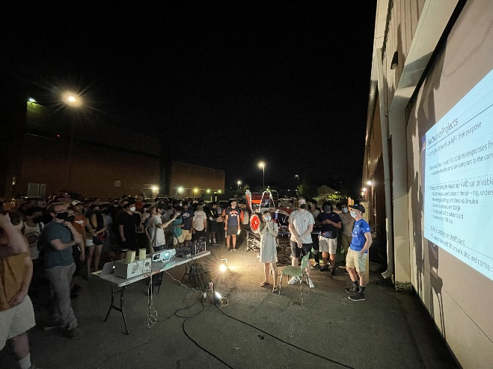
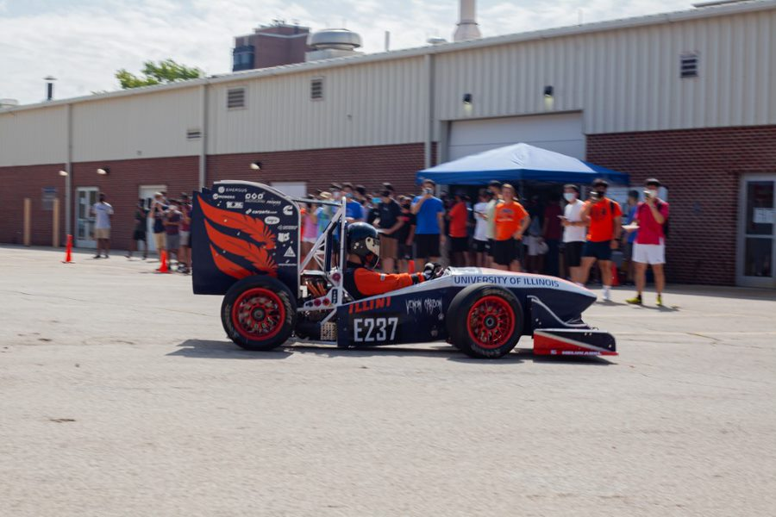
wj6@illinois.edu

