Thank you for your commitment to green initiatives at the University of Illinois. One of the final steps in completing the terms of the funding agreement for your project is the submission of a Final Report with key information about your project. You will also need to submit a detailed report of expenses (if you don't list it within this document) as well as supporting photos to showcase your project.

Please be as accurate as possible in describing the project (including possible setbacks or challenges in meeting the initial goals of the project). Not fully meeting your project's goals will not disqualify you from making future funding requests as long as your reports are as complete and accurate as possible. If you have any questions, please contact the Student Sustainability Committee, at sustainability-committee@illinois.edu.

Project Name: Re_Home wall rehab and siding

Date of Report Submission: 9/9/2021

Project Purpose:
The Re_Home was designed and built by students for the 2011 US DOE Solar Decathlon Competition. Following the competition, the house was set up at the Agricultural and Biological Engineering Farm Research and Training Center (ABE FRTC) and has been used by Illinois Solar Decathlon team and various departments. It serves as a valuable educational facility for students from different colleges and schools on campus to learn sustainable living with net-zero energy. The original wall sheathing under the siding had extensive damage from water intrusion.

This project’s goal is to stabilize the structure for the long term by creating a more watertight building envelope. Going forward, we will continue to open the Re_Home to students and the community for teaching and other educational outreach opportunities.

Project Summary:
This project removed the damaged exterior wall surface, creating a water resistant drainage plane and replacing the old siding with new more water resistant system.

Summary of Project Expenditures:
The total expenditures were $ 65,271.13. We will seek departmental or other funding sources to cover the amount exceeding the $ 60,000.00 funds provided by the SSC.

Problems/Challenges Encountered
The project went smoothly and the end product should serve the house well for many years. Costs to remove and reinstall the solar inverters and other electrical components came in higher than expected. Difficulty obtaining aluminum flashing due to pandemic related supply chain issues slowed the completion date until the end of July. However, the scale of these issues weren’t overly burdensome and the project was completed successfully.

Student Involvement and Outreach to Date:
Planned Re_Home use this upcoming semester includes simulated home visits by classes in the UIUC School of Social Work. Currently, graduate and undergraduate students involved with the Center for Digital Agriculture are using the Re_Home as a base for their nearby field research activities.

Marketing and Promotion Efforts to Date:
This project will be highlighted on the ABEIllinois facebook page and the ABE @ Illinois Connections newsletter going out to alumni, faculty and staff.

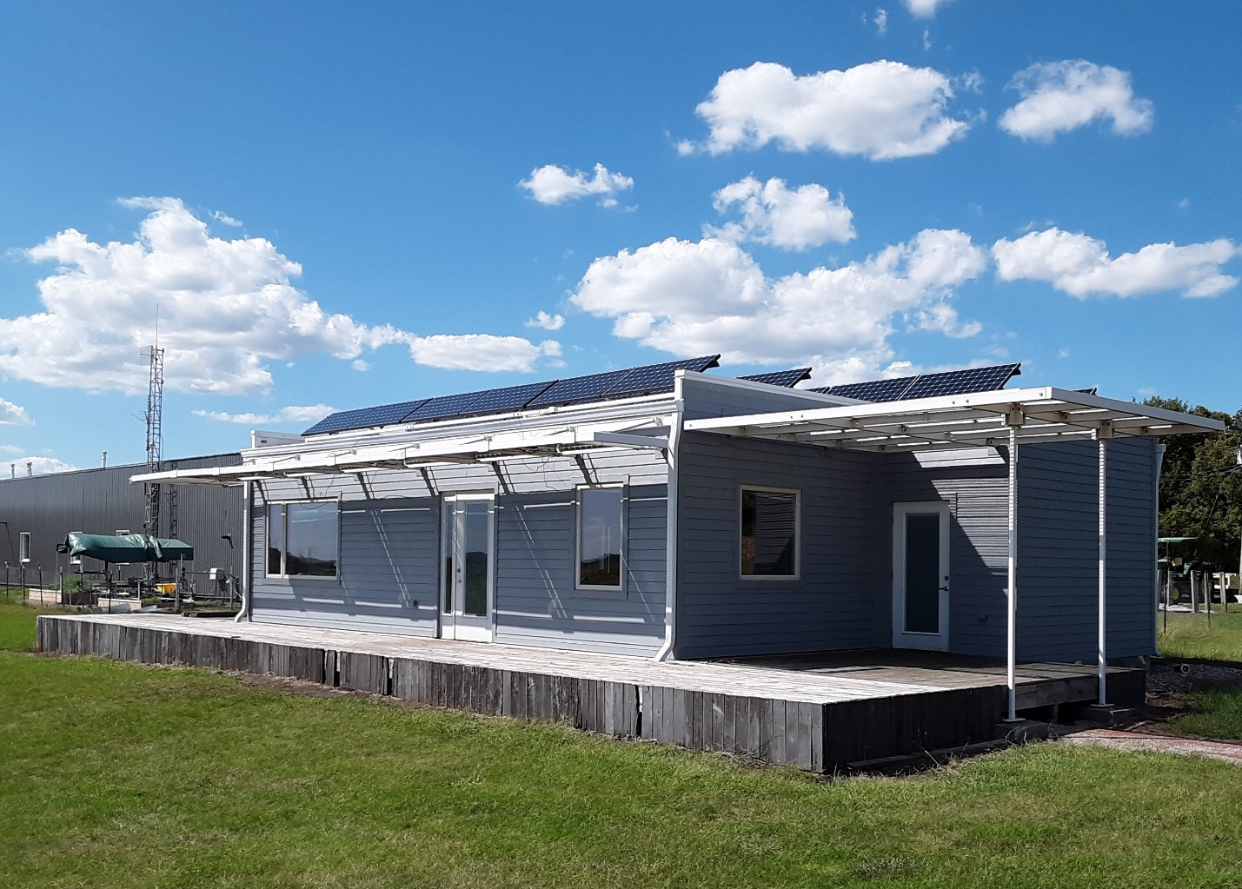

Re_Home solar house with new drainage plane siding system installed – se corner

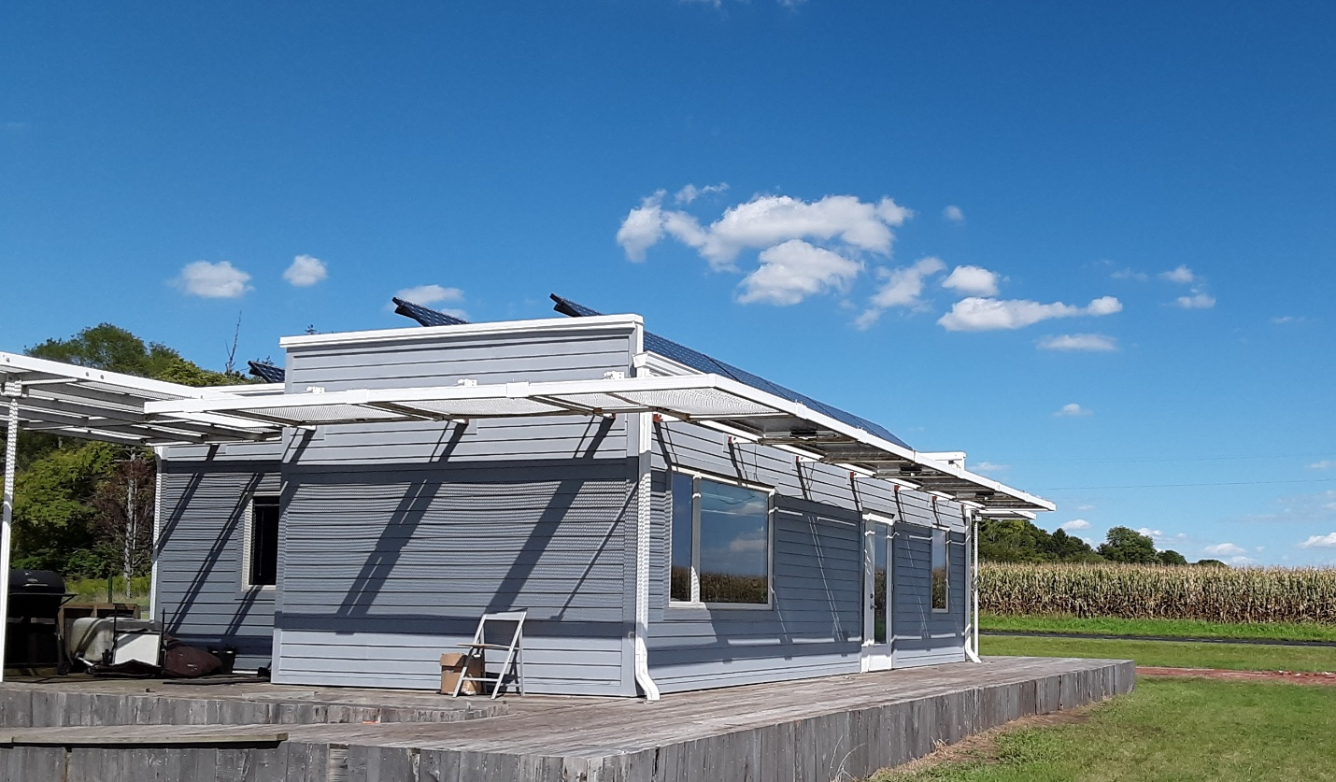

Re_Home solar house with new drainage plane siding system installed – sw corner

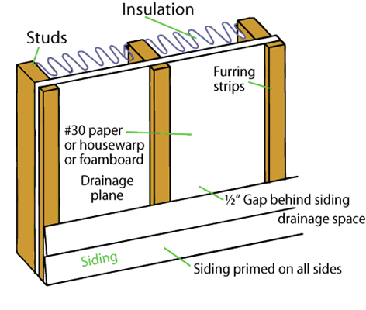
Drainage plane siding detail of Re_Home

In addition to the above fields, please provide a detailed accounting of how the funding was spent as well as pictures of the final project in an email to sustainability-committee@illinois.edu. Thank you again for your commitment to sustainability.

