iCAP Energy Team
Winter Meeting Agenda
Friday, December 3rd 9:00 A.M.
Zoom
- Introduction
- Review of Meeting Objectives
  - Focus: Determining Recommendation Priorities
- Idea 1: Use of Building Integrated Photovoltaics
  - Objectives
    - 2.1: Energy Planning Document
    - 2.2: Increases Energy Efficiency
    - 2.3 Clean Energy Sources
  - Responsible Entity
    - Capital Planning & Projects
  - Timeline
    - Multiple Years
  - Expected Cost
    - Low Cost
  - Description
    - In future building construction projects, implement photovoltaic glass for the windows of buildings to generate solar energy. The increased cost is small compared to overall project budget and careful planning must be required with landscaping and shading.
    - Onyxsolar.com is an example of this technology.
- Idea 2: Energy Conscious Culture & Engagement
  - Objectives
    - 2.2: Increase Energy Efficiency
    - 2.2.2: Reduce Building Level Efficiency
  - Responsible Entity
    - Human Resources
    - Communication
    - Engineering
  - Timeline
    - Multiple years
  - Expected Cost
    - Unknown
  - Description
    - Hire a change consultant to help us determine successful and proven methods to engage everyone in an energy conscious culture via branding, communications, nudging, and other suggested approaches.
- Idea 3: Geothermal System for National Petascale Computing Facility
  - Objectives
    - 2.2: Increase Energy Efficiency
    - 2.2.2. Reduce Building Level Energy
    - 2.3: Clean Energy Sources
  - Responsible Entity
    - F&S
  - Timeline
    - Multiple Years
  - Expected Cost
    - High Cost
  - Description
    - The NPCF Building accounts for a large margin of the UIUC Campus' electricity consumption due to its demands for controlled temperatures within the building. Often, this building is not even considered when looking into campus energy consumption because of its high use of power. By implementing a Geothermal system to help reduce energy usage while keeping the temperatures within the building at the correct level, it will save long term costs and overall electricity and energy consumption for the UIUC campus.
- Idea 4: Pilot Studies for Renewable Energy Technologies at the Building Level
  - Objectives
    - 2.3- Clean Energy Sources
  - Responsible Entity
    - F&S, Faculty, Staff
  - Timeline
    - Multiple years
  - Expected Cost
    - Unsure
  - Description
    - To determine the suitability of emerging renewable energy technologies, pilot studies should be undertaken at selected buildings or within groups of buildings to evaluate operational and energy efficiencies. Working with F&S, U of I researchers and staff would deploy and monitor these installations. The projects would be funded by the SSC and external funding organizations.
Possible technologies include:
      - Thermal energy storage
      - Hybrid energy systems (e.g., solar/geothermal; biogas/thermal storage; air+ground heat pump systems)
      - Steam to hot water conversion systems
      - CO2 refrigerants with high-temperature heat pumps
      - Thermal energy exchange from delivered water and wastewater
      - Groundwater heat exchangers (e.g., Darcy Solutions)
      - Waste heat recovery (e.g., capture thermal energy from steam tunnels/building spaces)
      - Ductless HVAC systems
      - Building-scale vertical axis wind turbines
      - Emerging technologies (solar roofs, solar glass, passive cooling)
- Idea 5: Feasibility Study of CO2 District Heating and Cooling
  - Objectives
    - 2.1- Energy Planning Document, 2.2- Increase Energy Efficiency, 2.2.2- Reduce Building-level energy, 2.3.2- Clean Thermal Energy
  - Responsible Entity
    - F&S
  - Timeline
    - Multiple years
  - Expected Cost
    - Unsure
  - Description
    - Emerging technologies using compressed carbon dioxide (a widespread commercial and industrial refrigeration) have been developed to provide district heating and cooling with a two-pipe compact network (one pipe carrying saturated CO2 as a vapor and one saturated CO2 liquid pipe). The proposed technology turns low temperature waste heat into hot water and electricity and captures waste energy locally with heat pumps and heat exchangers. Studies show that up to 80 % of the final energy can be saved in urban areas, at a cost that is lower than the conventional technologies.
A feasibility study should be conducted to evaluate replacing the campus steam and water energy distributions systems with an integrated smart thermal CO2 network that will utilize the existing Abbott Power Plant, electricity from solar voltaics and wind, and potential for capturing waste heat from campus buildings.
  - Sources
    - 1 ExerGo CO2 district heating and cooling. https://exergo.ch/portfolio-item/co2network/.
    - 2 District heating and cooling energy network using CO2 as a heat and mass transfer fluid. HPT Magazine, https://etkhpcorderapi.extweb.sp.se/api/file/1945.
    - 3 Energy integration of CO2 networks and power to gas for emerging energy autonomous cities in Europe. https://doi.org/10.1016/j.energy.2018.05.083.
- Idea 6: Building Level Energy Dashboard
  - Description
A building level “energy dashboard” has been available on the iCAP portal. I can no longer access it. Unsure why. The proposed dashboard here may be built upon the earlier dashboard.
We recommend providing a Building Energy Dashboard available through the iCAP portal. The primary purpose of the dashboard will be to provide and maintain necessary information on individual building energy use to the contractor for the Comprehensive Energy Plan. The dashboard should provide comprehensive energy information on the critical campus buildings. Over time the list should include all 319 energy-consuming buildings in the University District.

The dashboard should provide information (or placeholders for information) on the following, for each building:
    - Building description including age, square footage, primary uses, significant additions, etc. (already available)
    - Monthly utility consumption data (already available)
    - Anticipated deferred maintenance work (already available)
    - Unused and underused space
    - Energy model and calibrated energy model on readily available platform
    - Blower door test results
    - Comment space for building users
    - Anticipated equipment upgrades and cost
    - Anticipated envelope upgrades and cost
- Idea 7: Building Envelope Commissioning
  - Description:
    - The building envelope, together with ventilation, lighting and plug loads, determine the energy load for the building. Reducing heat loss through the building envelope should be a priority for the university. The design and construction industries have recognized thee building envelope as a weak spot in the delivery of high quality and energy conserving buildings. Just as ASHRAE has recognized the Commissioning Process for building mechanical equipment as needing its own guideline (ASHRAE Guideline 0), the National Institute of Building Science has recognized the importance of commissioning for the building envelope NIBS Guideline 3 Building Enclosure Commissioning Process BECx.
    - We recommend that the campus, through Facilities and Services:
      - Adopt NIBS Guideline 3 in its Facilities Standards,
      - engage and empower Building Envelope Commissioning as part of its design and construction for new buildings and for buildings undergoing major renovation, and
      - develop a budget line, separate from Deferred Maintenance, to address the energy conservation needs addressed through the commissioning process.
- Idea 8: Decommissioning
  - Description:
    - Many buildings on campus are at least partially unused or underused. The Petascale building (so I understand) is no longer funded through NSF and it is to be decommissioned. Under the new Budget Plan, units are encouraged to minimize the footprint of space that they use.
    - We recommend, with regard to unused and underused space on campus:
      - F&S present a policy statement on how best to ensure energy conservation in such space, and
      - F&S track unused and underused space, and coordinate with equipment operators on campus to ensure that zoning, controls and other elements of space conditioning contribute to maximum energy savings for these spaces.
- Idea 9: MMR Safety and Security
  - Description:
    - The Micro Modular (nuclear) Reactor is likely to be included as an element in the Comprehensive Energy Plan (CEP). The contractor for the CEP is expected to be qualified to assess the engineering aspects of MMR and the cost. But that contractor is not expected to be qualified to address nuclear reactor safety and security. Safety and security will be important issues for an upcoming campus and community debate on the possible plan for MMR.
    - We recommend to the Chancellor that the campus commission a report on safety and security surrounding MMR. We recognize that laying the groundwork for this report is a matter of great sensitivity, and we trust the office of the chancellor to establish the groundwork in a way that the report has the greatest likelihood of acceptance by the campus and the community.
- Idea 10: Late COVID Ventilation
  - Description:
    - Mechanical ventilation is provided for campus buildings at a level consistent with ASHRAE Standard 62.1, which sets a minimum level. When COVID-19 appeared, increased rates of ventilation were widely recognized as desirable. Most campus buildings (and commercial buildings worldwide) were typically adjusted to provide the maximum amount of ventilation, even when these same buildings went largely unused and underused. This ventilation came at significant cost.
    - The community should be considered as being at a stage where tradeoffs between anticipated virus exposure and energy costs of ventilation must be considered together. While maximizing ventilation was considered as a necessary emergency measure, the time has come, or will come, when a balanced approach must be adopted.
    - We recommend that F&S develop a plan for providing ventilation that considers an eventual climb-down from emergency measures.
- Idea 11: Stretch 55
  - Description:
    - The comfort zone for commercial buildings (maximum and minimum temperatures and humidities, seasonally) is established by ASHRAE Standard 55. The F&S Facilities Standards have adopted ASHRAE 55. This serves as a starting point for all conditioning equipment design, and it sets expectation levels for building users.
    - As the world moves to a future with scarcer space conditioning energy, it is reasonable to expect that comfort levels may not be maintainable at pre-climate crisis levels. We may expect adjustments in the comfort zone, which place part of the burden of meeting energy needs on building users. Building users presently have, as incentive to save energy and invest in energy savings, only their own financial wherewithal and their predisposition toward sustainability. Their own comfort and productivity are not seen as being at risk. We may imagine a change in their incentive structure if their own comfort and productivity is seen as subject to change, however small or incremental.
    - “Stretch 55” is imagined as a revised ASHRAE 55, which includes incremental changes to the defined comfort zone. These changes may be adopted on a schedule, or they may be adopted in response to failures to meet energy-use milestones. They may be presented to the campus community as a way of persuading increased concern and action toward energy-use reduction.
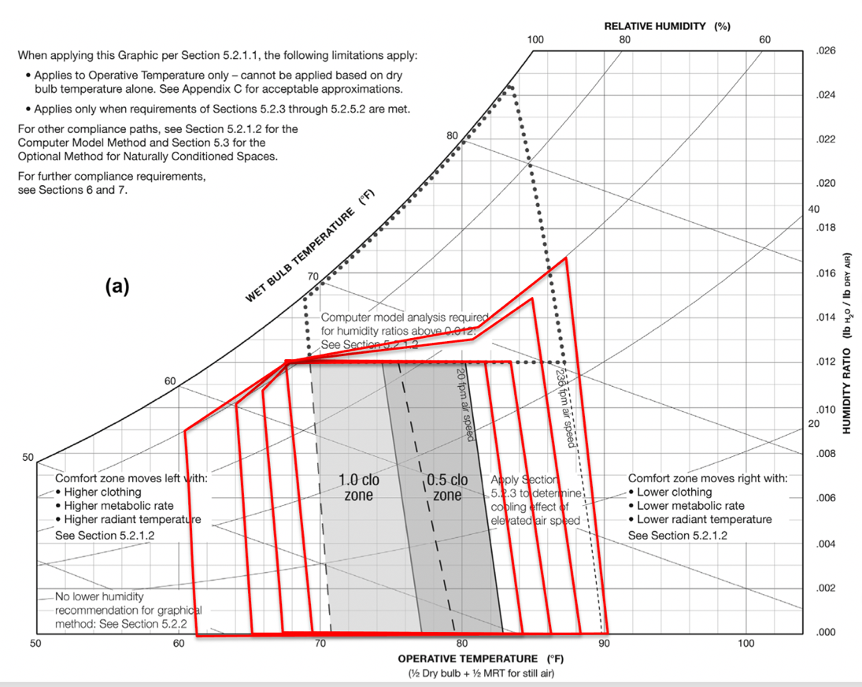
- Idea x: Encourage University Administration to begin budgeting to meet iCAP Energy Target
  - Objectives
    - 2.1: Energy Planning Document
    - 2.2: Increases Energy Efficiency
    - 2.3: Clean Energy Sources
  - Responsible Entity
    - University Administration, Board of Trustees
  - Timeline
    - 2021-2050
  - Expected Cost
    - $100sM
  - Description
    - The University of Illinois is committed to meeting the iCAP goal of zero GHG emissions by 2050 or earlier. The Master Plan for the university at present contains no planning to meet this goal, nor has there been budgeting to meet the goal.
    - The Energy Team has recommended preparation and adoption of a Comprehensive Energy Master Plan for the Campus, to replace the Utilities Production and Distribution Master Plan which shows no reduction in GHG emissions under any of their scenarios.
    - The Energy Team recommends that the university administration and Board of Trustees begin budgeting to meet the Energy Target. The cost is expected to be several hundreds of millions of dollars. The actual cost will not be known until completion of the Comprehensive Energy Master Plan.
    - The work under this recommendation will be completed primarily by F&S but they must engage multiple perspectives, including its consultants, faculty, staff and students. F&S currently works with a Deferred Maintenance budget. The new Energy Plan budget must be in addition to the Deferred Maintenance budget, though operations will likely occur where the two budgets must dovetail.
- New Business
  - Discussion of a note objecting to the renaming of the “Comprehensive Energy Master Plan” to “Clean Energy Plan”
- Adjournment
Hello Morgan,

You mentioned to Bill Rose that the Comprehensive Energy Master Plan has been renamed to something with “Clean Energy” in the title. We do not accept this change. The term “clean energy” is used almost exclusively in the field of energy production and energy sourcing to contrast that energy with fossil fuels. The Master Plan we recommended is largely focused on energy conservation and use reduction, with production needed to provide the remainder. Please do not allow this change to go forward. If alternatives are necessary, we would accept “Energy Master Plan” or “Campus Energy Master Plan”.

Thanks for your consideration.

