Southern Arboretum Woodland Plantings 2021
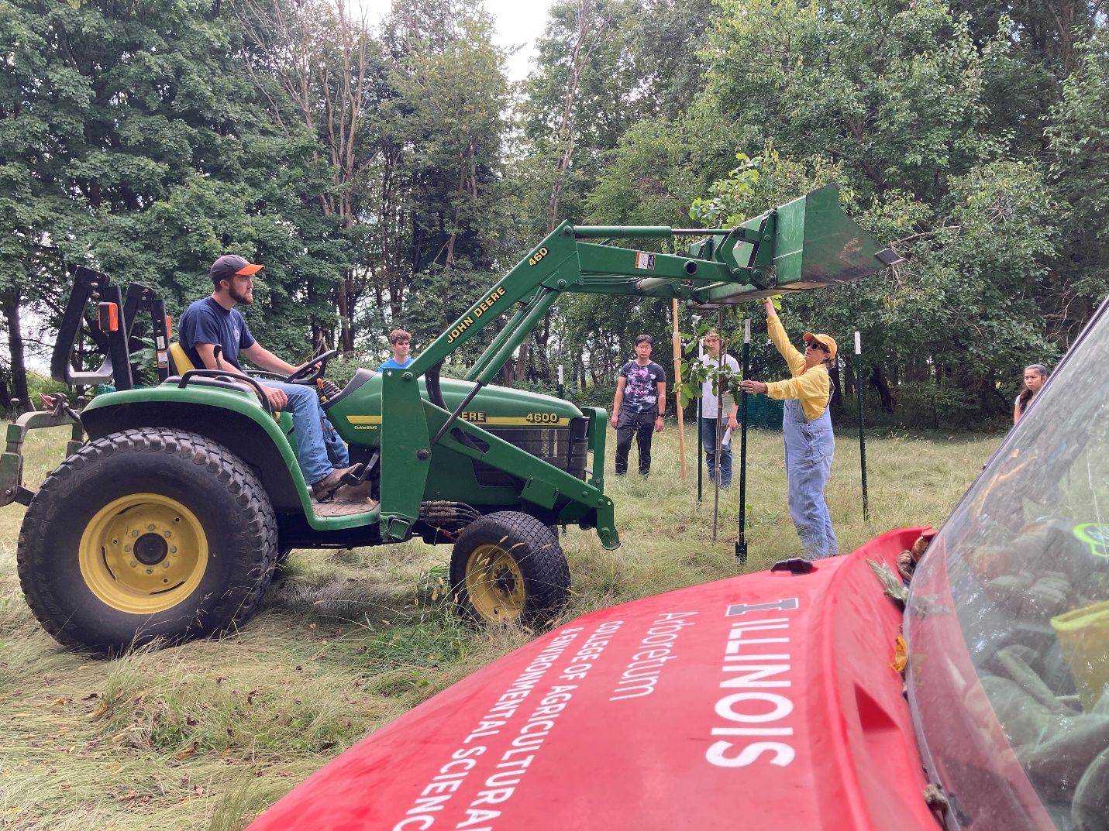

Historically, the area of the Southern Arboretum Woods (SAW) was presumably grassland or prairie, used as agricultural fields, then managed by the University as a tree plantation/research plots for entomology and forestry research. Eventually, the research ceased, and the unmanaged area grew wild with weedy and invasive species, such as bush honeysuckle and garlic mustard. For the past several years, the arboretum staff and student organizations have gone through tremendous efforts to clear the understory of undesirable species to the point where more valuable species may be installed. The arboretum has compiled a list of canopy trees, understory trees, shrubs, and herbaceous species selected to provide wildlife resources, such as food, shelter, and host plants.
In the spring of 2021, the restoration ecology course under Dr. Miller (NRES 420) along with arboretum staff began the first phase of the unconventional “restoration” of the SAW. During these sessions with Dr. Miller’s students, 13 understory shrubs were planted, 5 of each species, for a total of 65 shrubs planted.
SAW Shrub and Small Trees FA2021 | Common Name | Quantity
Amelanchier laevis | Allegheny serviceberry | 5
Amorpha fruticosa | false indigo bush | 5
Aronia melanocarpa | black chokecherry | 5
Cercis canadensis | redbud | 5
Cornus obliqua / amomum | silky dogwood | 5
Corylus americana | American hazelnut | 5
Hamamelis virginiana | fall-blooming witch hazel | 5
Physocarpus opulifolius | ninebark | 5
Prunus americana | wild plum | 5
Rhus copallina | winged sumac | 5
Rhus glabra | smooth sumac | 5
Rhus typhina | staghorn sumac | 5
Sambucus canadensis | elderberry | 5

The students learned the proper techniques for tree planting, including pruning of branches and encircling roots, proper depth and width for planting, mulching, fertilizing, and fencing off the young shrubs for protection from deer browsing.
In the fall of 2021, the introduction to environmental science course (NRES 100) with Lauren Lynch also had a similar session of planting with the arboretum staff. During this session, some oaks were planted as well as additional shrubs lost from the first planting and several new shrubs, for a total of 30 shrubs.
SAW Shrub and Small Trees SP2021 | Common Name | Quantity
Quercus bicolor | Swamp white oak | 10
Carya illinoinensis | Pecan | 5
Quercus muehlenbergii | Chinkapin oak | 5
Nyssa sylvatica | Black tupelo | 5
Amelanchier laevis | Allegheny serviceberry | 5

The next steps for the plan include thinning unhealthy and exotic trees to clear more area for more shrubs and canopy trees, weed management, and monitoring the performance of the plantings. The arboretum hopes to continue collaboration with ACES faculty and student organizations for this project to hopefully turn the SAW into a resource for learning, research, and wildlife habitat.

