Thank you for your commitment to green initiatives at the University of Illinois. One of the ongoing requirements listed in the terms of the funding agreement for your project is the submission of semesterly reports with key information about your project. In addition to this form, please provide additional financial documentation and/or progress photos if available.

Please be as accurate as possible in describing the project (including possible setbacks or challenges in meeting the initial goals of the project). Not fully meeting your project's goals will not disqualify you from making future funding requests as long as your reports are as complete and accurate as possible. If you have any questions, please contact the Student Sustainability Committee, at sustainability-committee@illinois.edu.
Project Name: South Farm Nitrate Monitoring Station

Date of Report Submission: 3/2/2022

Project Purpose:
Nitrate monitoring data to develop a baseline nitrate loss from the UIUC south farm area. This aligns with the previous iCAP goal of reducing nitrate losses by 50% from the UIUC south farm.

Detailed Accounting of Expenditures to Date:
There were no expenditures on this project in 2021. There is a large encumbrance due to previous vendor payment issues. These are still being resolved.

Project Progress to Date:
Student participation from CEE 458 – Water Resources Field Methods, installed one sensor in the fall of 2019. It was such a good experience for this class in the fall of 2019, the second sensor was reserved for installation this class in the fall of 2020; however, despite having this on their agenda, limited contact due to COVID-19 prevented installation. Installation was in the que for CEE 458 for the fall of 2021 with a class of 20 in-person students with an additional 14 students participating online from China. There were some issues with the installation due to timing and weather, so this sensor will likely be installed the spring of 2022.
A security breach with our data management provider and COVID have brough our data migration and dashboard development to a halt. We have also had connectivity issues since the data service update and phase-out of our 3g cellular network so manual downloads have been required since May of 2020.
The initial SSC funding was quintessential to securing a $1.1 million USEPA grant, allowing additional monitoring as well as installation of conservation practices to reduce nitrate in the Embarras. This was a convenient addition, as this will allow us to directly move towards the iCAP nitrate reduction goals while monitoring the change. The initial SSC grant efforts will be carried forward with this grant, including personnel to collect water quality samples. Partner institutions include University of Arkansas, Mississippi State University, University of Wisconsin, and University of Kentucky.
This initial funding has also lead to a $2.2 million grant from the USDA NRCS, to use these sensors for a large multi-state project. In addition, a matching grant of $340,000 was secured from the Illinois Nutrient Research and Education Council (NREC) for purchasing four of the sensors used in this project.
The average nitrate-nitrogen concentration to-date at our first site is 9.6 mg/L nitrate-nitrogen, which is higher than the 8.6 mg/L nitrate-nitrogen measured through grab samples in the mid 1990s. This increase may be due to sampling location differences or differences in in-channel processes. For example, a beaver dam failed in early 2020 and the nitrate-nitrogen concentration for the period when the beaver dam was in place was 7.0 mg/L, which was a 19% decrease from the mid 1990s. Further, efforts to plant cover crops in the watershed draining to the monitoring location have been fruitful with nearly a four-fold increase in acreage between 2020 and 2021. Despite this large increase, preliminary evaluation of nitrate concentrations have not shown decreases.
Ultimately, this project has been a huge success, though there have been unexpected and uncontrollable challenges.

Student Involvement and Outreach to Date:
The primary involvement by students is the installation and maintenance of the monitoring stations through CEE 458, Water Resources Field Methods. In addition, this class has reviewed water quality data to anomalies and issues with instrumentation. Apart from this, students in Crop Sciences 113 were exposed to collected data through an extra credit assignment.

Marketing and Promotion Efforts to Date:
As noted above, a security breach on the third-party data collection service, connectivity issues due to phase-out of the 3g cell network, and COVID have halted progress on data summary and promotion. The plan was to have all of these aspects automated. Before COVID, our IT department was working on a simple dashboard display to automatically post to Twitter on a weekly basis (see example below). Aside from Twitter, we have promoted the Student Sustainability Committee in two large grant applications as well as through a college of ACES project where we would like to upgrade infrastructure. We also referenced this project in $10 million and $20 million proposals to the National Science Foundation, though these were unsuccessful.

This project was presented at the 2020 Healthy Soils for Healthy Waters Workshop in March of 2020.
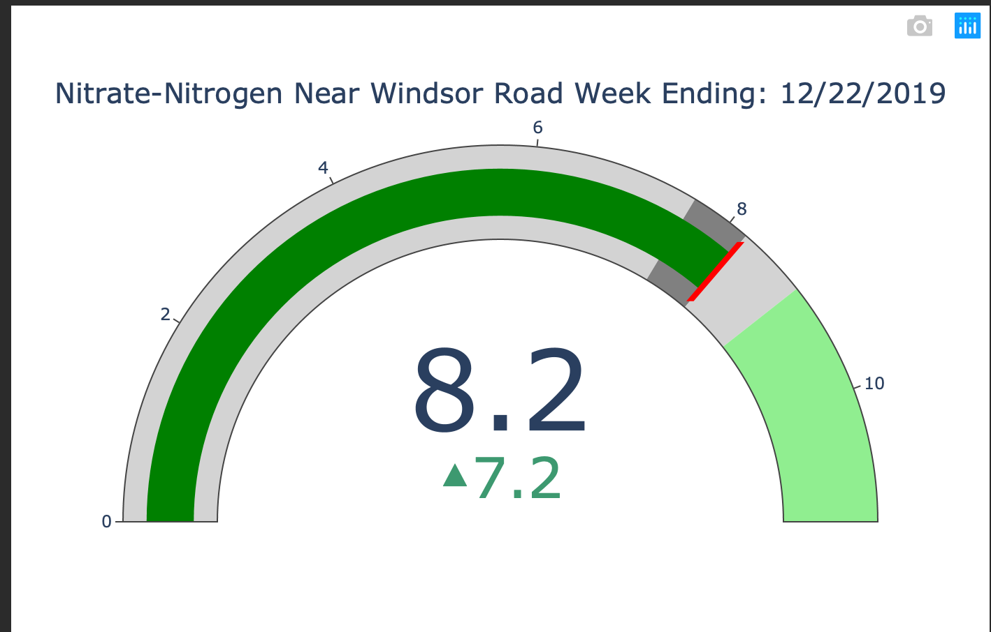

Additional Comments:
Any additional comments/relevant information for the semesterly report

