Donation Sites -- Frequently Asked Questions
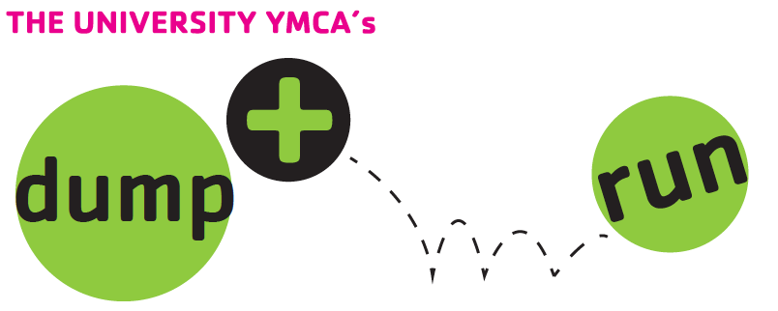
THANK YOU for participating in this year’s Dump & Run community recycling event! This program would not exist without the help of our collection host sites. With your contributions, we are going to keep thousands of items out of the local landfills.

What should we expect?
During May collections, YMCA staff and volunteers check on the donation boxes at each location. These boxes get full very quickly, especially towards the end of the week as students move out. We do our best to check every box every day. Volunteers will be wearing lime green Dump and Run shirts. Volunteers are instructed to bag up items in trash bags and empty the boxes as completely as possible at each stop. The collected items are then taken to the Stock Pavilion to be sorted.

When will the boxes be delivered?
We try to get all of the boxes delivered on Monday, May 6.

When will the boxes be removed?
Boxes will be picked up between Friday, May 10 and Tuesday, May 14 depending on the preference of the site and availability of volunteers. We will pick up all boxes at the latest by the site’s preferred stated deadline but may have to remove boxes earlier in some cases to make deadlines.

Our donation box is overflowing with donations! Help!
Please call us! We do our best to check every collection box daily if not more than once but it isn’t always possible. If the box at your location is overflowing and it is a problem, contact us at (217) 337-1500 so we can prioritize your location in our collection schedule.

What kinds of items do you accept?
We collect dishes, glassware, pots & pans, small household appliances, computers, electronics, lamps, bicycles, office & school supplies, nearly-new clothing, books, toiletries, lawn & garden, artwork, musical instruments, sporting equipment, furniture & other household goods.

We do NOT collect televisions, paint, child/infant car seats, stoves, washers, dryers, cassette and VHS tapes, non-working electronics & computer parts, sleeper sofas, mattresses, or large exercise equipment. PLEASE DO NOT PUT TRASH IN THE COLLECTIONS BOX.

How can we help things go smoothly?
Thanks for asking! Help us educate donors about what they should and should not put in boxes or about bagging items before placing them in the box to make collections go faster. We can also provide signs for your building.

Additional questions? Call us at 217-337-1500 or email us at dumpandrun@universityymca.org.

Thank you again for your participation and patience. We look forward to another year of reuse and recycling!

