Funding
The iCAP Portal has a robust tracking mechanism of funding. This is not a substitute for financial accounting, which is handled through the University accounting system, Banner. The Funding section for projects is for recognizing the contributors for iCAP projects. There are only a handful of funding sources for iCAP projects, even though there are hundreds of projects. The highly detailed accounting is kept in the Banner system of record, and the iCAP Portal provides a summary by year and by funding source for the related project.

Creating Funding Sources
A funding source can be an organization, committee, or official group that provides funds for the completion of one or more projects. The following steps should be taken to add a funding source.
- One can add funding sources from the ‘Administration’ option, using the ‘Funding Source’ option under ‘Add Content.’
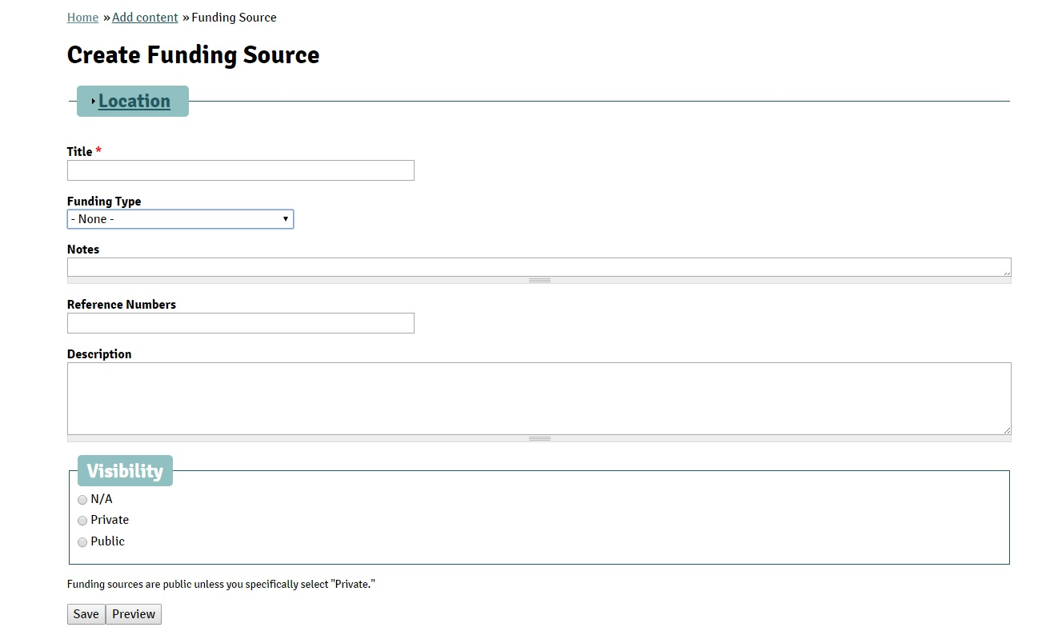
- In the ‘Title’ field, type the name of the funding source, for example “Illinois Clean Energy Community Foundation (ICECF).”
- There are various kinds of funding sources:
  - Student Fees
  - Grant Funds
  - Institutional Funds
  - iCAP Funding Program
  - External Funds
  - Donor Funds
  - Other
- ICECF is a granting agency; therefore, select ‘Grant Funds’ from the scroll down menu in the ‘Funding Type’ field.
- Any details typed in the ‘Notes’ field will not be visible to the Public. One can only see this detail when logged in to the iCAP Portal.
- Reference Numbers – This field is for general references for the Funding Source. For example, the University may have a customer number. It is not for a grant number from that Funding Source because those would be specific to the project that was funded.
- Describe the Funding Source and type in the ‘Description’ field. For ICECF, the description was pulled from their own website. “Providing financial support for clean energy projects in Illinois for over 15 years. The Illinois Clean Energy Community Foundation was established in December 1999 as an independent foundation with a $225 million endowment provided by Commonwealth Edison. Our mission is to improve energy efficiency, advance the development and use of renewable energy resources, and protect natural areas and wildlife habitat in communities all across Illinois.”

- Similar to other items described in the iCAP Portal User Guide, ‘Visibility’ of the Funding Sources are set by default to ‘Public.’ You can, however, change the visibility by clicking ‘Private’ to restrict the general public (people without login access to the iCAP Portal) from viewing the details of the funding source.
- Click on ‘Save’.
Following this you can go to specific projects and add the Funding Source for that project, using ‘Add Existing Funding Source’ on the ‘Edit Project Funding Information’ page and fill out all the details. Add this funding source to all the projects benefitting from it.
When you click on the Funding Source on a specific project’s ‘Edit Project Funding Information’ page, another page with all the projects benefiting from the funds provided by this organization will open. For example, if you click on ‘Illinois Clean Energy Community Foundation (ICECF),’ you will see all the iCAP Projects that have been funded by ICECF. This list will contain the name of the project as the main heading. The fiscal year will be in the first column. The second column will contain the ‘Approved amount’ for the fiscal year, third column will have ‘Spent amount’, and the fourth column will show the ‘Relinquished amount.’ The bottom row will have the total for all FY’s amount approved, spent, and relinquished. Along the rows, at the end, will have the ‘View details’ which will contain all the information regarding the project funding from this source sorted by the FY. The information will include the date funding was approved, contact person, any description or note, and date entered. This page will also have the other operation option – Edit/Delete.

Adding Funding Information to the Project
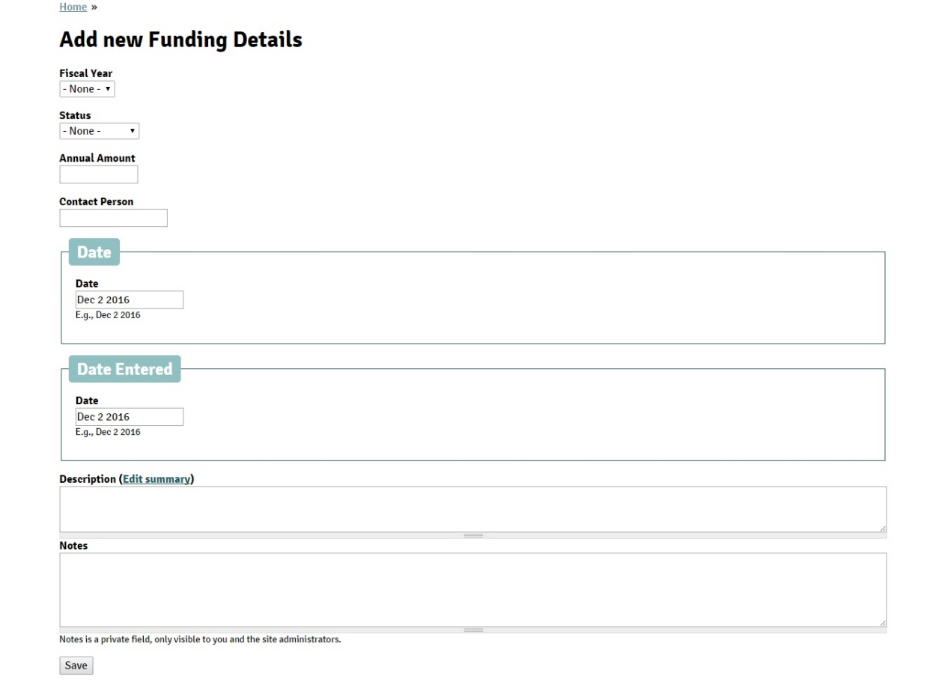
- To add funding details for a project, you have to click on the ‘Edit Project Funding Information’ option in the Administration box on the right hand corner of the project page. This will take you to the project funding page for the specific project. For example, if you click on the ‘Edit Project Funding Information’ on the ‘Campus Bike Center’ project, you will see this page: (Add the new snapshot of the project funding page)
- Under the Funding source, click on “Add”.
  - Select the Fiscal Year from the drop down menu.
  - Select the status of the funding – Approved, Spent, or Relinquished.
  - The annual amount that will be provided.
  - Who is the Contact Person?
  - When was the funding approved, or spent, or relinquished?
  - When was the funding details entered in the iCAP Portal?
  - Write a short description about the funding detail, if necessary.
  - Write any notes, if required. The notes will not be visible to the public, and only authorized users will be able to view the notes.
- This will add the funding detail not only in the project’s page, but also to the funding source’s page.

