11-14-22 – Final Report: Zero Waste Basketball Game

On November 14, 2022 the University of Illinois at Urbana-Champaign held its inaugural Fighting Illini, Fighting Waste event at State Farm Center – a game day recycling event to capture bottles and cans at the Illini vs Monmouth Men’s Basketball game. America Recycles Day, also referred to as National Recycling Day, is the signature recycling program of the national nonprofit organization Keep America Beautiful. It is observed each year nationally on November 15. In honor of this national observation, the Division of Intercollegiate Athletics; the Institute for Sustainability, Energy, and Environment; Facilities & Services; and Coca-Cola are partnered for the November 14 game.

Additionally, in partnership with Coca-Cola, the University of Illinois is pursuing a “Don’t Waste” campaign to holistically advance the effort to increase recycling and decrease waste across campus. The Fighting Illini, Fighting Waste is the first high-visibility zero waste event that was formed at the weekly “Don’t Waste” meetings with Coca-Cola.

47 student volunteers with the help of 4 volunteer leaders came together to achieve three priority objectives:
- Directly impact Illinois Climate Action Plan (iCAP) objective 5.2, “reduce the total campus waste going to landfills.”
- Increase public awareness for campus recycling and the iCAP.
- Encourage behavior change among basketball game attendees when they are presented with the opportunity to recycle.

To achieve these objectives, a four-fold approach was executed:
- Established recycling infrastructure within the upper concourse of the facility via the temporary placement of 14 Coca-Cola recycling bins. Student volunteers were stationed near the vomitories on the upper concourse holding blue recycling bags to capture bottles and cans.
- Instigated public education and engagement initiatives during the game via volunteer-attendee interaction. Student volunteers, sporting bright green shirts, were available for questions regarding what was and was not recyclable. Student volunteers also gave away reusable tote bags and orange Block I t-shirts to attendees “caught” recycling. Recycling signage was posted near the 14 bins and in the 13 upper concourse bathrooms to passively educate attendees where student volunteers could not be present.
- Integrated student involvement into the core event operations: students executed the event and directly engaged with attendees.
- Pursued community outreach and publicity ahead of the event.

During this event, student volunteers helped divert 280 pounds of recyclable material away from the landfill (cardboard, bottles, and cans). In total, the event achieved a 10.6% diversion rate. (Note: Municipal Solid Waste (MSW) Diversion rate is defined as “Total Recyclables Solid” divided by the sum “Total Recyclables Solid” and “Total Landfilled.”).

Student Volunteer Feedback
- Blue bags supplied by F&S were too thin for handling; it was common for liquid to leak from the beverage cans into the bags and onto the floor. Thicker bags are needed for future events.
- Expectations for the length of the event need to be made clear prior to the event. Some student organizations had differing understandings of how long they were expected to be present for volunteering.
- Attendees loved the t-shirt and tote bag giveaways! Volunteers ran out of giveaway materials before the end of the game.
- When attendees are presented with the infrastructure to recycle, they do it and do it well!
- Signage posted above the recycling bins (which indicated what was and was not recyclable) seemed to help with contamination.
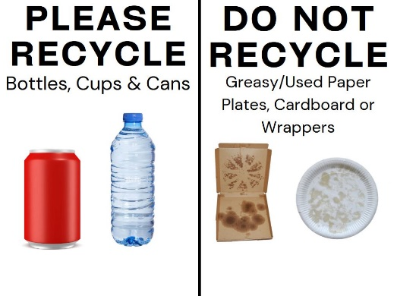
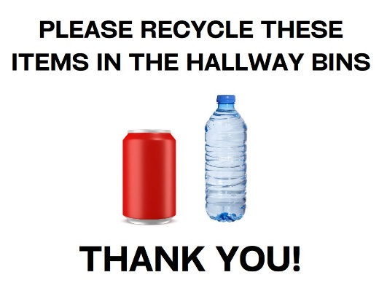
- Provide signage to volunteers that simply and effectively communicates to attendees what is going on. This could look like a sign that says “Recycle at this game!” or a picture of the recycling logo. The “Fighting Illini, Fighting Waste” sign was good, but didn’t necessarily clearly indicate what was going on.
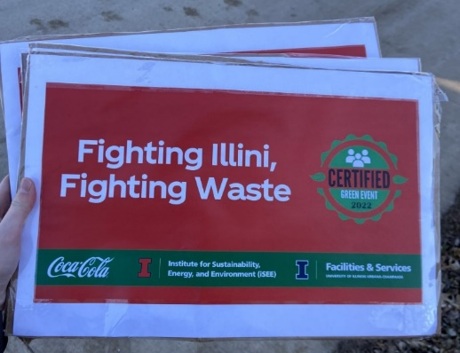

Attendee Feedback
300+ responses to the post-game survey
  - “Did you notice that this game was a recycling-focused event?” YES / NO
    - 51% indicated that they were aware.
  - “Did you recycle your bottles and/or cans at the game?” YES / NO
    - 55% indicated that they did recycle their bottles and cans.
  - “Do you support having more emphasis on recycling in future games?” YES / NO
    - 83% indicated that they are supportive of future recycling efforts.
General comments: good to see volunteers, would like to see permanent recycling containers
Successes
- Dedicated student volunteers: made the event a success, executed a great diversion rate for the first event, easy to work with, nearly all that signed up showed up.
- Orange Krush Club area worked very well as a “home base” for our giveaway items and as a place for student volunteers to store their belongings.
- T-shirt designs: attendees positively commented on both the green and orange shirts and were interested in receiving both as giveaway items.
- Anecdotally, there was only positive feedback from attendees: positive comments, positive engagement with the “caught green handed” initiative.
- Student volunteers arriving 45 minutes before the doors open gave the team leads plenty of time to organize the space and prepare for the pre-game training.
- It was wise to start small: starting with a weeknight, pre-season basketball game allowed us to get a feel for the flow of State Farm Center events without having to take on the level of waste we would see at a popular Big Ten game.
- Blue recycling bags were placed in grey bins on the upper concourse when full, which worked very well.

Areas for Improvement
- Volunteering
  - Student volunteers stayed from 6:15pm – 10:30pm (~4 hours). This is long, especially for an event where volunteers are on their feet and talking consistently.
  - Student volunteers at this event specialized across four different roles:
- Greeting attendees on the lower concourse and then moving to the upper concourse for visibility after the game started.
- Guarding recycling bins on the upper concourse to draw attention to recycling and help attendees understand what is and is not recyclable.
- Holding blue bags near trash bins outside the vomitories to actively collect bottles and cans as attendees entered and exited the arena.
- Giving away giveaway items (tote bags and orange t-shirts) when attendees were “caught” recycling.
  - For future events, it would be wise to split up volunteering into 2 or 3 “shifts” (ex: pre-game 6:30pm-8:00pm, game 8:00pm-9:30pm, post-game 9:30-10:30pm). This shortens the length of volunteering time per student and lessens the need for multiple role specializations (ex: post-game volunteers would only focus on bottle and can collection in the stands). This would also make the process of training student volunteers easier to organize.
  - Idea: student volunteers working the pre-game and post-game shifts could be incentivized with access to free tickets. Attend the game, then head into your shift, or vice versa.
  - Blue bags could be saved back closer to half-time when things pick up. It was a slow start, so we could have these volunteers in other roles (engagement, education) before half-time and bring the bags out at half-time.
- Bin placement
  - Establish permanent recycling bins and blue bag use on the upper and lower concourses.
  - Consistent use of the blue recycling bags.
  - How can we separate black landfill bags from the blue recycling bags in the pickup process? Currently everything is added to the compactor, so the Waste Transfer Station had to separate the bags.
- Engagement
  - Trivia, by the nature of operations, is not a high-visibility engagement point. Note this for the future!
  - Provide large posters to volunteers that simply and effectively communicates to attendees that we are recycling at the event (ex: picture of the recycling logo).
- Concessionaire
  - Reach out to concessionaire to determine how many Coca-Cola products are sold versus recycled.
    - We could weigh an empty bottle, estimate how many Coca-Cola products we see enter the recycling stream, and then take the empty bottle weight and compare it to the weight gathered at the Waste Transfer Station (would give us upper and lower bound estimate).
  - Aluminum cans and plastic bottles were really the only concessions able to be recycled. Working with the concessionaire in the future to choose materials that campus can recycle (plastic 1, 2, and aluminum) would improve the diversion rate. It’s largely the food containers that are an issue, with the contamination. Composting infrastructure would also greatly improve the diversion rate.

