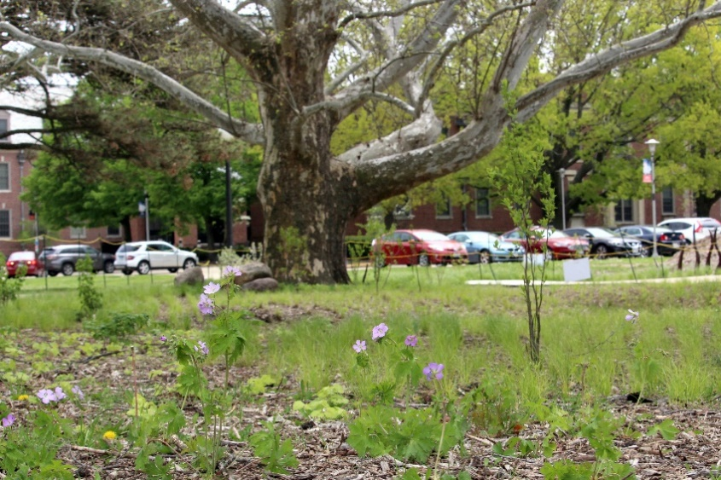

**Photo Point 1: Before  
April 28, 2020** – This “before” photo shows RORG before native spring ephemerals and tulips were installed throughout the garden. The Sycamore trunk in the background provides a permanent marker.

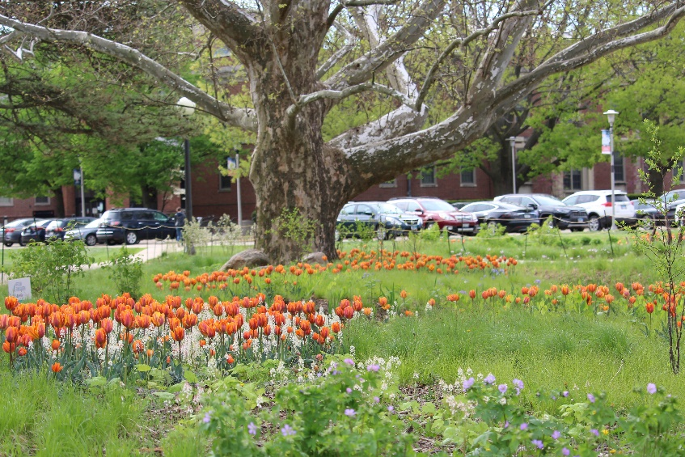

**Photo Point 1: After  
April 28, 2021** – This “after” photo shows RORG in the first spring after native ephemerals and tulips were installed. Photo shows a display of foamflower (*Tiarella cordifolia*) and tulips. Hundreds of native bluebells (*Mertensia virginica*) had just passed their bloom. The photographer took the photo exactly one year from the “before” image using the Sycamore trunk as a permanent marker.

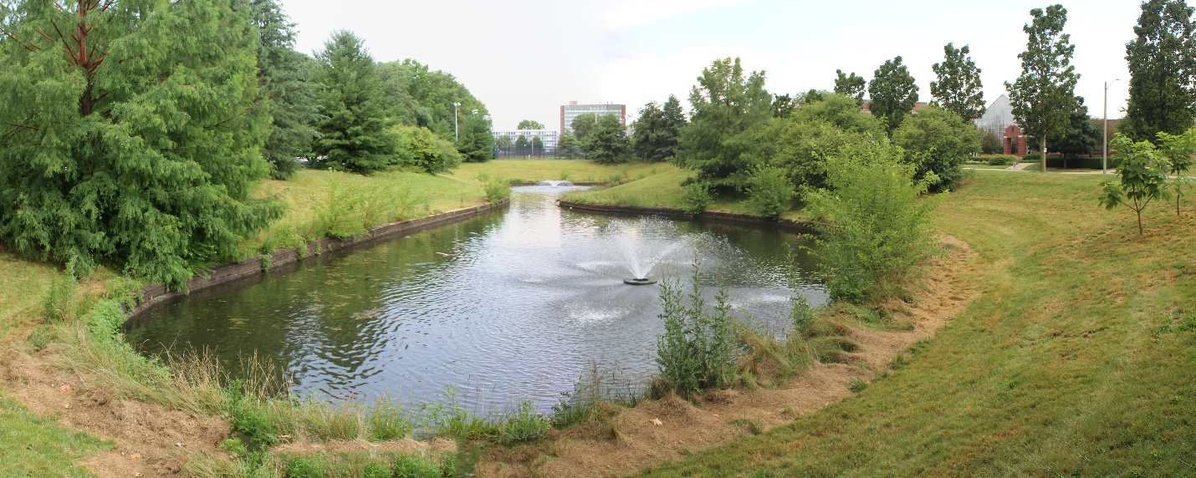

**Photo Point 2: Before  
July 2020** – This “before” photo shows Dorner Drive Retention Pond just before work began on treating and removing the variety of invasive species that existed within the low-mow conditions throughout the site. The dormitory building in the background acts as a permanent marker.

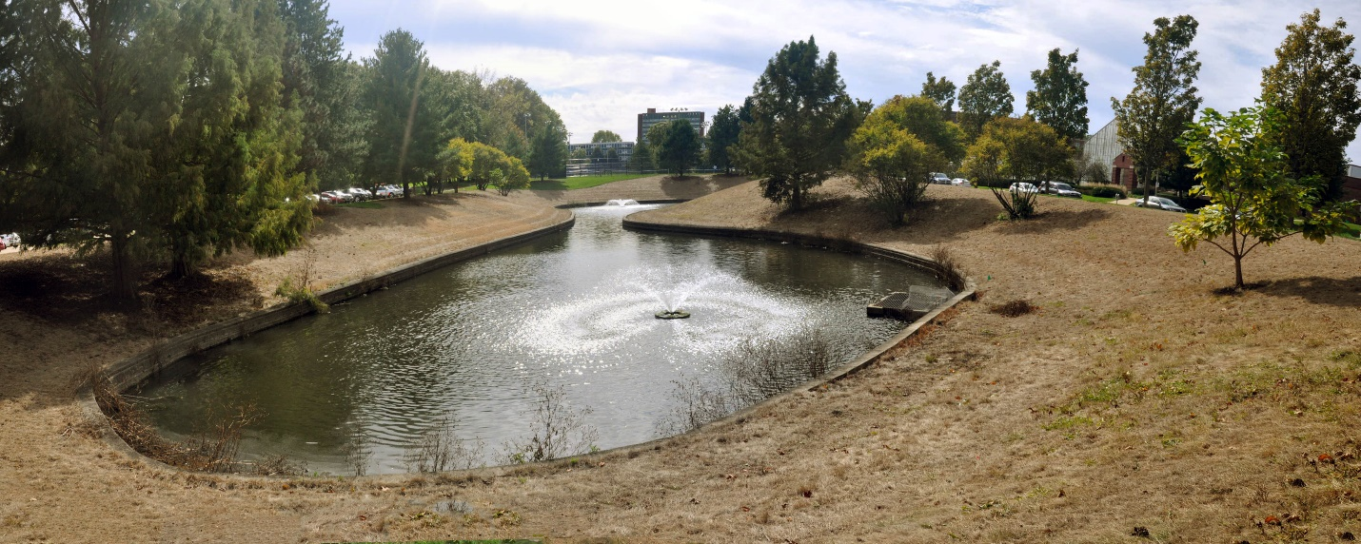

**Photo Point 2: After  
October 2021** – This “after” photo shows Dorner Drive Retention Pond after invasive woody species like Honeysuckle, Buckthorn, and White Mulberry were removed from along the pond edges and from underneath the tree canopies. The site has been treated in preparation for native seed to be installed in late fall 2021. The photographer took this image from the same location using the dormitory building in the background as a permanent marker.