Land and Water meeting, March 22nd, 2022
Attendees: Jennifer Fraterrigo, Betsy Liggett, Morgan White, Carmen Ugarte, Maria Librada Chu, Arthur Schmidt, James Ellis, Brent Lewis

- First meeting of the spring semester
  - Introductions
    - Attendees talking about their roles on campus, previous projects/involvement
- Flowchart of the Illinois Climate Action Plan (iCAP) Progress explained by MW
  - 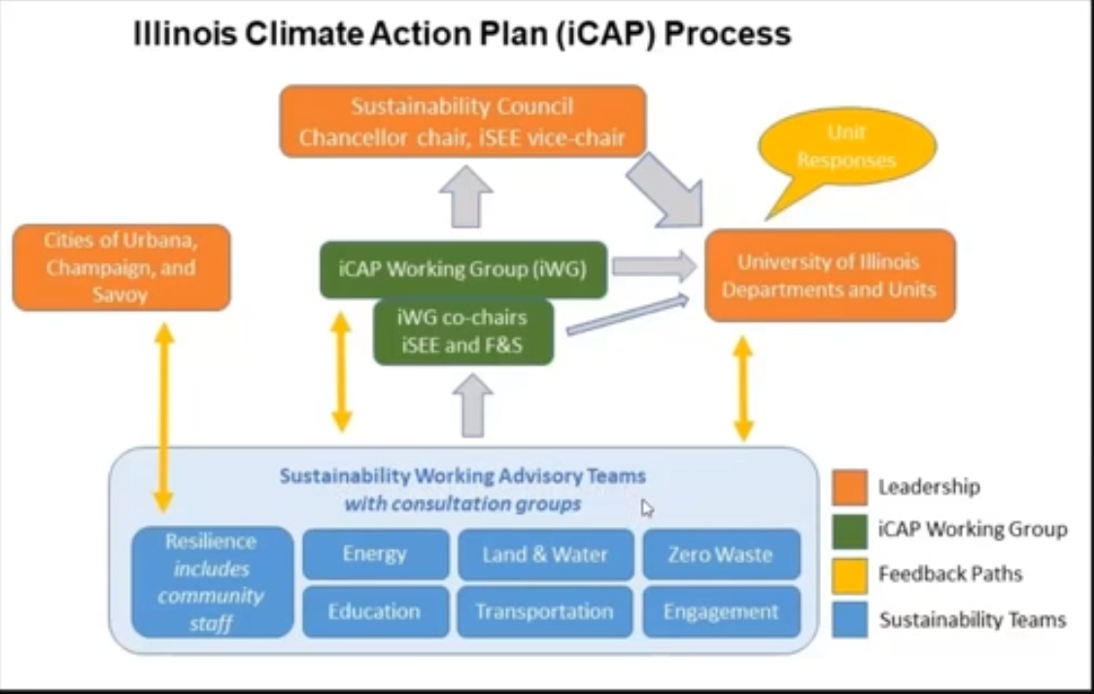
  - Note: review the iCAP website for current recommendations
    - https://icap.sustainability.illinois.edu/project/icap-working-group-iwg
- Review from November meeting “brainstorming”
  - Main topics
    - Compiling storm water data
    - Increasing green infrastructure
    - Increase # of trees
    - Monitoring soil health**
      - Could iSEE coordinate a shared pool of instruments that could be used by classes for teaching purposes but lead to crowd-sourced data for land/water conditions
  - For monitoring soil health (iv), discussion:
    - Lots of classes on campus have the ability to provide this data, in the event that data will be collected and added to iCAP
    - Actual locations would need to be identified, actual soil health metrics would need to be decided
      - Need to be very specific in what is being measured to then reach out for help
    - If funding is a problem, could this be resolved by pooling resources around campus? ACES, ENG, ect.

