**Tree Inventory Project Proposal**

January 12, 2016

**Project purpose**

This project would document existing trees on campus, using a GPS device and collecting tree details into the ArcGIS data layer. The existing Tree Inventory was last updated in 2006, so it includes trees that have subsequently been removed and it is missing new trees that have been planted. Through this project, the Tree Inventory would be updated to include all and only existing trees on campus. This project funding does not address the long term data upkeep as future trees are added or removed.

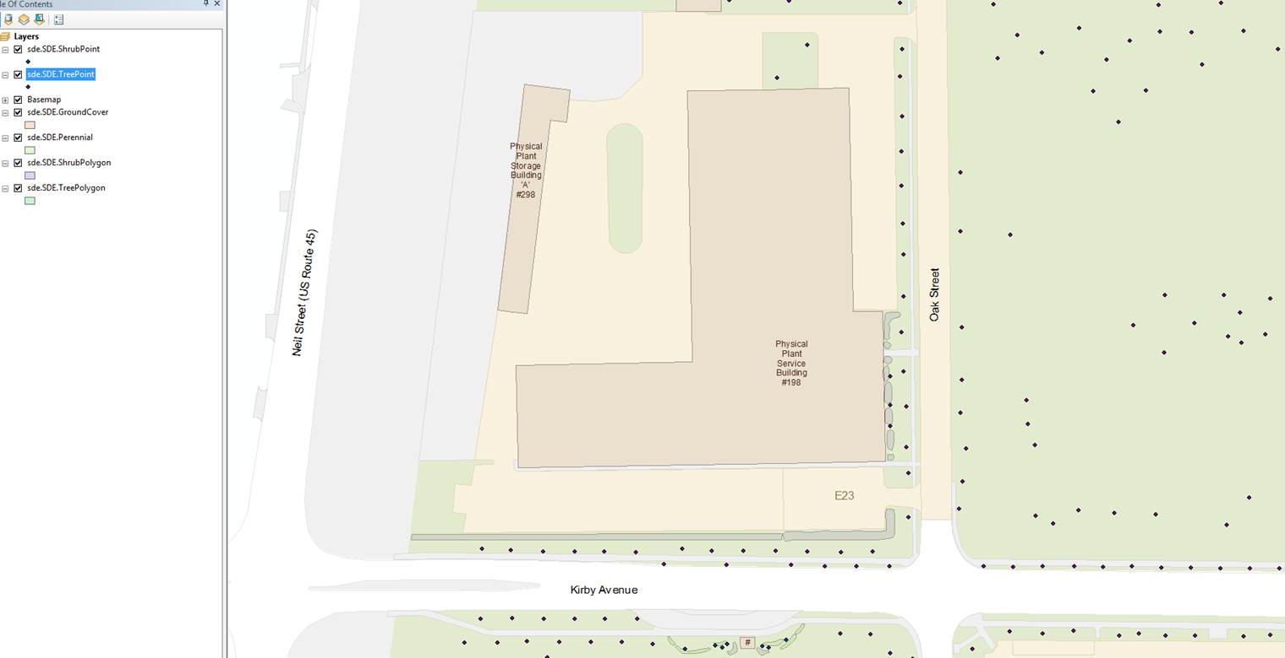

Figure 1: screen shot of existing grounds data near PPSB

**Project budget**

The proposed project scope includes the purchase of equipment and temporary staff hires. The proposed equipment is a Trimble Geo 7x handheld with rangefinder and associated software, for $15,819. The proposed staff is a 900-hour extra help employee reporting to Ryan Welch for $19,000, and one student employee reporting to Chad Kupferschmid for $5,600. The total project implementation cost is $40,419.



This would provide a handheld GPS locator device, with horizontal mapping-scale accuracy. There are two options still under consideration: 1) upgrade the device to provide vertical mapping details as well as horizontal, and 2) purchase a full back-up device for the existing Utilites & Energy Services GPS survey-scale accuracy. These two options are being investigated by Chad. They may cost more at first, but provide better reliability for continuing the U&ES data collection process.

**Student options**

The proposed extra help employee for Grounds has expertise in specific tree identification. This person could be supported / accompanied by student volunteers or interns.

The student employee for FIR would work on incorporating the data from the GPS device into the tree layer in the ArcGIS program. Alternatively, the student could be given course credit for the work, under the direction of an appropriate faculty member.

The data from the tree inventory could be used in class projects, and it could be incorporated into the iCAP emissions inventory, related to sequestration.