SmartWay Social Media Posts – June 2023

Post 1:

Using the #EPASmartWay logo helps differentiate your company from the competition. Be sure to let your customers and stakeholders know that you’re leading the way on clean, sustainable supply chain management. Learn more: epa.gov/smartway

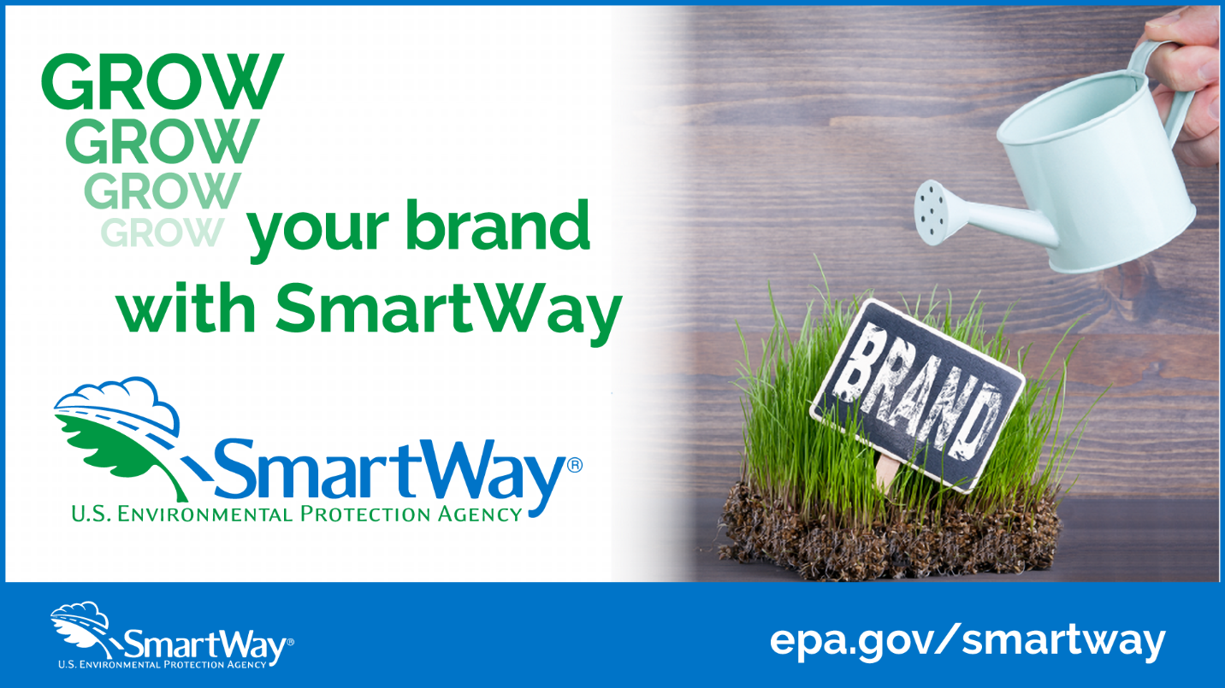

Post 2:

Just use it! Did you know that you can put the #EPASmartWay logo on your tractor or trailer if it meets EPA’s specs? Move your goods efficiently with SmartWay. Learn more: epa.gov/smartway

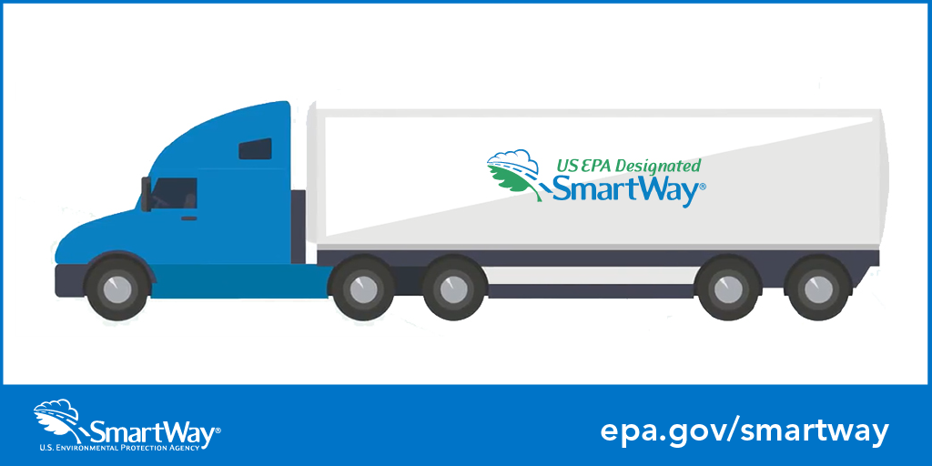

Post 3:

Using the #EPASmartWay logo and brand signifies top performance & corporate leadership in freight efficiency. It helps highlight companies that are helping the country move to a cleaner, more sustainable supply chain. Learn more: epa.gov/smartway

