Thank you for your commitment to green initiatives at the University of Illinois. One of the final steps in completing the terms of the funding agreement for your project is the submission of a Final Report with key information about your project. You will also need to submit a detailed report of expenses (if you don't list it within this document) as well as supporting photos to showcase your project.

Please be as accurate as possible in describing the project (including possible setbacks or challenges in meeting the initial goals of the project). Not fully meeting your project's goals will not disqualify you from making future funding requests as long as your reports are as complete and accurate as possible. If you have any questions, please contact the Student Sustainability Committee, at sustainability-committee@illinois.edu.

Project Name: Pollinator Signage

Date of Report Submission: 12/5/2022

Project Purpose:
The goal of this project is to provide awareness about pollinators around the University of Illinois (UC) campus. Signage of varying sizes were posted inside and outside of campus buildings, providing facts about native plants and pollinators. Before publishing, each signage and its contents were approved by the University Board.

Project Summary:
In October 2017, several students of the Sustainability Living-Learning Community (SLLC) went to the AASHE Student Summit and attended a Bee Campus USA workshop. During this time, these students were inspired by the progress of other universities and decided to obtain the Bee Campus USA Certification for the University of Illinois Urbana-Champaign. In order to accomplish and maintain the certification, one of many requirements is to "display signage focused on pollinator conservation.” Since the initial funding request from SSC, four (4) small signs were installed at the following locations:
- Lincoln Avenue Residence Hall (LAR)
- Wassaja Residence Hall
- Natural Resources Building
- Burrill Hall

In doing so, the University is now considered part of Bee Campus USA.

In January 2021, a scope change was submitted to install a larger sign outlining the Bee Campus Student Organization, progress the campus has made, and changes the University implemented to become more pollinator friendly. In addition, this signage aimed in acknowledge the SSC for its funding of the signs, and for several of the pollinator friendly plantings around campus. This scope change did not request any changes in funding. However, the request was made to extend the funding deadline by one (1) year, through May 2021. The original proposed timeline for this scope change accounted for at least one (1) month for the design, ordering the sign, and waiting until spring thaw to install the signage. The designing process would include collaboration with students for its content development. This scope change was approved.

A larger sign, with a dimension of 24“ by 36”, was installed at the corner of Florida Avenue and Orchard Street, near the Florida-Orchard Prairie. See the images below to review the location and design. This sign met its project timeline goal of installation by the end of 2021. The sign was officially installed at the location on _____.
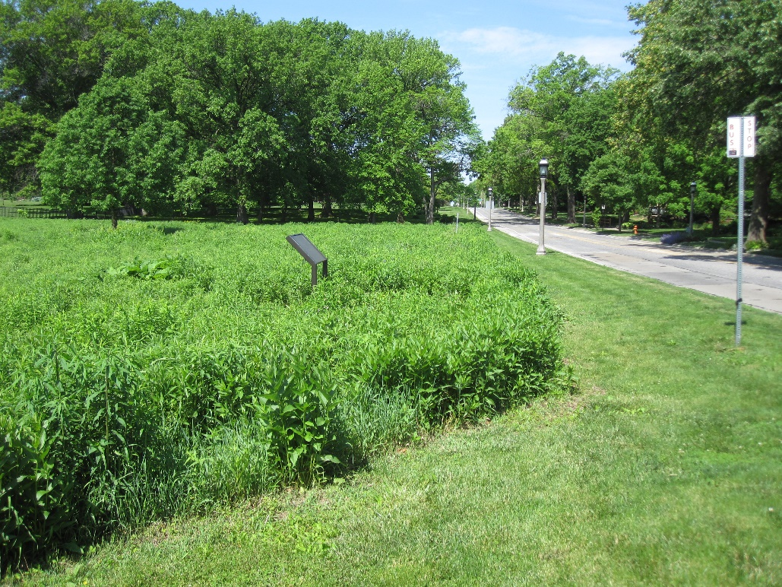
Figure 1: Location of large sign installation.
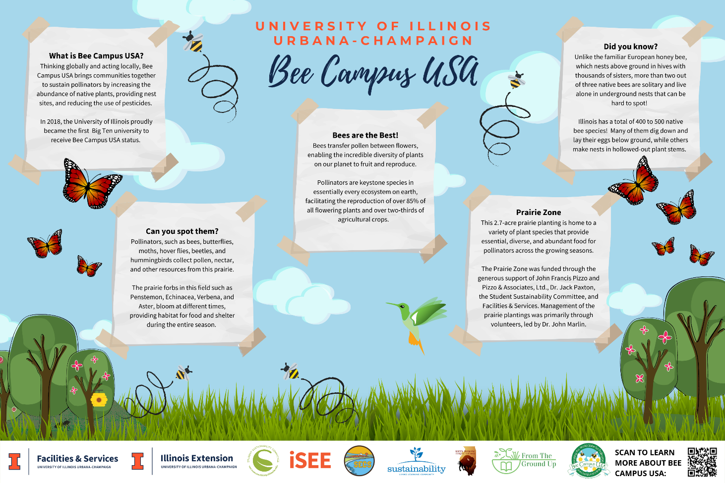Figure 2: Large Sign Design & Contents

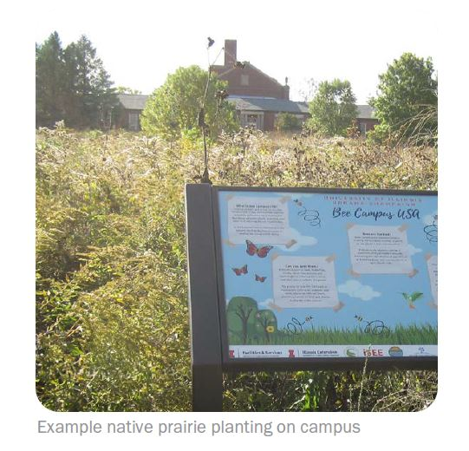
Figure 3: Installation of the Large Sign

Summary of Project Expenditures:
Awarded Amount: $3,000
Installation of four (4) small signages: $618.30

Project Timeline:
- October 08, 2019: Drafted signage for the small Bee Campus USA signs and proposed placements were reviewed at the Bee Campus USE committee meeting.
- November 18, 2019: Content for the Florida-Orchard signage was brainstormed by Blake Cedergren. The suggested information included facts about native plants, pollinators, and animals related to the prairie.
- March 18, 2021: The 24" by 36” sign frame was ordered and delivered to campus. The sign was ordered from vendor @03979410 DRM INDUSTRIES CORPORATION, with the Workorder 10845244-001.
- June 14, 2021: A 24” by 36” blank sign was installed at the Corner of Florida Avenue and Orchard Street, by the Florida-Orchard prairie, near Orchard Downs and the Presidents’ House.
- September 20, 2021: The 24” by 36” sign design was printed.
- October 2021: The designed sign was officially installed in the blank sign at the Corner of Florida Avenue and Orchard Street, by the Florida-Orchard prairie, near Orchard Downs and the Presidents’ House.

Problems/Challenges Encountered:
- Sign installation was put on hold throughout the colder months of the year, as the ground was frozen and too difficult to dig into. As a result, installation had to be pushed back to a later time in order for the ground to thaw in the spring.
- Due to having limited time and availability to work on this project by F&S staff members, this project spanned the course of two (2) years. The majority of the work completed occurred in stages, with each succeeding action taking place when the overall workload was less.

Student Involvement and Outreach to Date:
By January 2021, around six (6) student members from the Bee Campus Committee were assisting the completion of the project. These individuals helped with the placement and designing of the signage.

The small signs were designed by F&S with student review, and the large sign was initially drafted by F&S Student Sustainability Intern, Chantelle Hicks. After Chantelle’s leave, Avery Maloto continued the design until its completion. The content developed included information from Bee Campus students and F&S.

Additional outreach was conducted to contact student leaders from various RSOs involved with the creation of the prairie and their contributions to Bee Campus USA. Leaders from SECS, Red Bison, and From the Ground Up were asked to provide RSO logos to include on the display.

Marketing and Promotion Efforts to Date:
Not applicable.

Diversity, Equity, and Inclusion:
Chantelle Hicks and Avery Maloto, student sustainability interns representing the F&S Diversity team, contributed to the design of the sign.

Additional Comments:
Any additional comments/relevant information for this report:

In addition to the above fields, please provide a detailed accounting of how the funding was spent as well as pictures of the final project in an email to sustainability-committee@illinois.edu. Thank you again for your commitment to sustainability!

