September Affiliate Social Media Posts
September 2023

Post 1

#EPASmartWay designated trucks & verified technologies help drivers squeeze more miles out of every tank. These technologies can help your carriers with fuel and time efficiency. #thankatrucker www.epa.gov/smartway

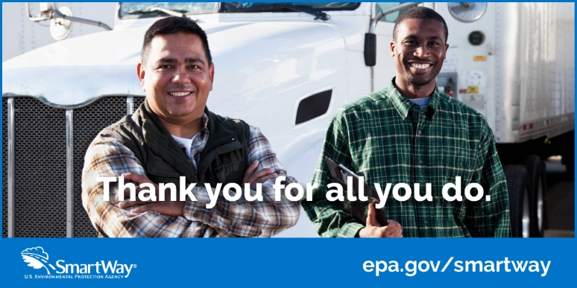

Post 2:

This National Truck Driver Appreciation Week join us & #EPASmartWay to #thankatrucker. Truck drivers are trained, highly skilled professionals—more than 3.5 million in 2023—who make it their mission to deliver your goods in a safe, efficient manner. #TruckDriverAppreciation

Post 3:
This National Truck Driver Appreciation Week join us & #EPASmartWay to #thankatrucker. Professional truck drivers help keep supply chains moving.

