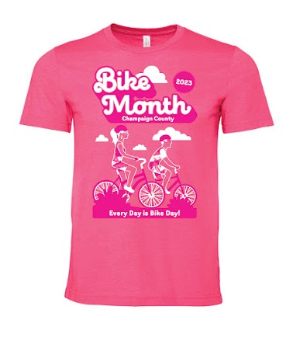
Champaign County Bike Month Media Release
For Immediate Release: 11 September 2023

Contact:
Gabe Lewis, Champaign County Regional Planning Commission
glewis@ccrpc.org
217.819.4102 (call) or 217.493.8800 (text)
or
Jeff Yockey, Champaign County Bikes
jeff@champaigncountybikes.org
217.565.1785 (call or text)

Champaign County Bike Month returns in September
Free events include Bike to Work Day and Light the Night

Thursday, September 14th is Champaign County Bike to Work Day! Thursday morning from 7-10 am will be the 13th annual Champaign County Bike to Work Day presented by MTD and Bike at Illinois, and Tuesday night, September 19th from 4-7 pm will be the 15th annual Light the Night free bike light giveaway.
Cyclists can visit one of 16 Bike to Work Day Welcome Stations across Champaign, Urbana, the University of Illinois campus, Savoy, Mahomet, St. Joseph, and Rantoul from 7-10 am. The stations will offer free snacks, coffee, bicycling information, and Bike Month 2022 t-shirts to cyclists while supplies last. This year’s shirt may remind people of a popular summer blockbuster movie, and reminds people to “Ride Bikes to Gather.” Whether you are a new or regular bicycle commuter, you travel to work or work from home, or if you are a student of any age, bicyclists of all ages and abilities are invited to participate in this friendly event. Cyclists are encouraged to join the hundreds of people already registered for this event by pre-registering online at cubikemonth.org and to check in at one of the Welcome Stations on September 14. The University of Illinois Veterinary Medicine Welcome Station returns this year after a hiatus last year, creating eight Welcome Stations on campus. All Welcome Station locations are viewable on this map: https://tinyurl.com/sjbm4s5h.
There are three Light the Night locations on the University of Illinois campus where people can get free lights installed on their bike: Alma Mater, Hallene Gateway (Lincoln Avenue at Illinois Street), and a new location at the Ikenberry Commons quad (southeast of Gregory Drive at First Street). People must bring their bike to receive lights. Illinois state law requires a bicycle to have a front light and either a back light or reflector when riding in the dark.
Rain dates are scheduled for Bike to Work Day on September 15th, and for Light the Night on September 21st. All changes will be posted on the “C-U Bike Month” Facebook page and website. Other free bike events happening this fall are the Bike to Market Saturday on September 16th and 23rd, Park(ing) Day on September 22nd, Bike to the Barbie Movie nights on September 22nd-23rd on the University of Illinois Quad, Bike Your Park Day on September 23rd, the Full Moon Ice Cream Bike Ride on September 29th, Walk ‘n’ Roll to School Day on October 4th, and Bike the Park Day at Crystal Lake Park on October 7th. More details are available at http://CUbikemonth.org/calendar.html.
Champaign County Bike Month activities are organized by Champaign County Bikes (CCB), the Champaign County Regional Planning Commission (CCRPC), University of Illinois at Urbana-Champaign, Champaign-Urbana Mass Transit District (MTD), City of Champaign, Champaign Center Partnership, City of Urbana, Village of Savoy, Village of Mahomet, Village of Rantoul, the Champaign County Forest Preserve District, and The Bike Project. Bike to Work Day is also sponsored by local bike shops, groups, and clubs; along with area businesses and organizations. These groups seek to encourage safe active transportation through this event and encourage people to adopt bicycling and walking into their everyday lives.
Bike to Work Day participants are once again invited to contribute to advance biking in Champaign County by donating funds to the Friends of the Kickapoo Rail Trail (KRT). Donations will allow the Friends of the KRT to purchase a Gator-type trail vehicle, a trailer, and many hand tools for their work with volunteers to maintain the KRT.

###

