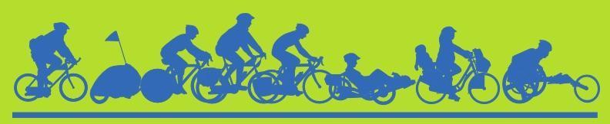

Annual Bike to Work Day 2023 and Bike Month 2024
Sponsorship Opportunities
July 2023
Biking & Walking should be safe and accessible for everyone!

Dear Community Service Organization, Not for Profit, or Business Partner:

Since 2021, Champaign County hosts a split format of bicycle celebrations, hosting Bike to Work Day and Light the Night in September, as well as celebrating the traditional National Bike Month in May. This split format once again set new records in 2022-2023 for participation and outreach in promoting sustainable and active transportation and recreation in our community. Building on the past two years of success, we want to keep the momentum going with the fall/spring split of our signature events again in 2023-2024.

Sponsorship support now works throughout the year in developing safer cyclists thanks to these collective “Bike Month” events like: 16 Bike to Work Day Welcoming Stations across the County with over 900 registrants; the distribution of 750 Light the Night bike light sets; bicycle safety education at summer camps; Bike to School and Walk and Roll to School Days; Earn-a-Bike at Don Moyer Boys and Girls Club; Urbana Market at the Square in September and May; outreach at Earth Day events; Project Ignition (Driver’s Ed) at Urbana High School; and several community Bicycle Rides such as the Full Moon Ride.

We gave away over 1,200 T-shirts at our events this past year and over 13,000 in the past decade. The shirts are popular and seen regularly about town. Past support has allowed this success. As a business, a non-profit, or an agency, your mission achieves ongoing recognition through the educational marketing of community-building Bike Month events. Importantly, this year, your support will be leveraged to help Safe Routes to School programming as new sources of funding are sought to replace the loss of Illinois Department of Transportation (IDOT) funding which was directed only to infrastructure proposals for the past cycle.

Bicycling is universally recognized for promoting both physical and mental health, sustainability, equity, independence, and fun. Your continued support is needed and reflects your commitment to these values. “Bike Month” events are collaborative efforts of local governments, agencies, and nonprofits (*listed below). Champaign County Bikes (CCB), a registered 501(c)(3) organization, serves as the fundraising arm and will handle the Bike Month Fund sponsorships and donations. All sponsors and donors to Bike Month will receive acknowledgement and a receipt from CCB. Event reports will be posted to their website.

The “Sponsorship levels and Recognition” chart on the next page shows how you can support these events over the next year. If you have a preferred benefit level, you can complete the quick survey located at https://forms.gle/sMRd2HQLAhoUADNv6 or read on for contact information. Because many are currently financially strained, we hope that new agencies and groups will contribute what they can.

Sponsorship funds are leveraged with contributions from event participants that support various activities related to bicycling such as the westward extension of the Kickapoo Rail Trail, youth participation and educational outreach, and local bicycle training and training facilities. We thank you for your ongoing support in making Champaign County the most bike-friendly county in the state. More information on various events, anticipated attendance, project goals of the 2023-24 Bike Month participant fundraising, and planning team members are listed below. With your help, we are looking forward to continued growth of active transportation in a thriving community.
Bike Month 2023-24 Suggested Sponsorship Levels and Recognition

Level | Donation | Back of T-shirt Logo Placement | Website  Recognition
Diamond* | $5,000 | Contributors will be listed vertically, with the largest sponsors on top. The names/logos are largest at the top and decrease in size for each donation level. We ask for some grace as logos are challenging to evenly size, and the T-shirt designer seeks to make the back of the shirt be as aesthetically pleasing as the front.  * Diamond and Platinum level sponsors will be recognized by name early and often during announcements, presentations, and where appropriate during media events and interviews. | X
Platinum* | $2,500 |  | X
Gold | $1,250 |  | X
Silver | $750 |  | X
Bronze | $300 |  | X
Friend of Bike Month | $100 |  | X
Gifts-in-Kind |  | If the value exceeds $300, we will add you to the shirt. | X
Bike Month Partner Agencies |  | Appear together at the bottom. | X

For questions or to be a sponsor of Bike Month 2023-2024 events you may contact CCB directly or complete the survey at https://forms.gle/sMRd2HQLAhoUADNv6.

Sponsors are asked to please provide or send in the following information:

● The contact person for your organization, and their contact info.
● The dollar amount your organization will provide for Bike to Work Day 2023/Bike Month 2024.
● A check for this amount, made out to: Champaign County Bikes. EIN# 02-0810177**
● A vector file (.ai or .jpeg) of your current logo.

Social media, calendars, news releases, and other means are used to raise awareness of Bike Month and point people to our website/registration site: www.CUBikeMonth.org
On behalf of the Bike Month Planning Group, we thank you for your past support and hope you can help out once again.

Jeff Yockey
Champaign County Bikes
Jeff@ChampaignCountyBikes.org
217-565-1785
Planned Events
Updates: www.CUBikeMonth.org

Bike to Work Day, Bike Week, and related Fall 2023 Events (#BikeThere)

September 14 – 2023 Bike to Work Day* (7:00-10:00am) (Rain Date Sept. 15)
September 19 – Light the Night bike light giveaway (4:00-7:00pm) (Rain Date Sept. 21)
September 22 – Car-Free Day
September 22 – PARKing Day, Sixth Street between Green & Healey
September 23 – Bike Your Park Day (Adventure Cycling)
October 4 – Walk ‘n’ Roll to School Day
Monthly from April to October – Full Moon Rides (community-oriented rides to Sidney—weather permitting); approximately 20 - 100 participants
September Saturdays – Presence at Urbana’s Market at the Square; other partner venues as requested
Bike Month 2024
May 8 – K-12 Bike to School Day - 7:30am-9am
May Saturdays – Bike to Market – Urbana’s Market at the Square - 7am-12pm; about 50 interactions per week
May 15 – Ride of Silence - 7pm-9pm; 20-45 participants
Events not yet determined, but usually scheduled:
May – Community Used Bicycle Sale
May 12 – Mother’s Day Ride
May or June – Traffic Skills 101 Bike Safety Class

*Bike to Work Day has been our signature event involving an estimated 1,000 cyclists and volunteers annually. In past years, 20% of all cyclists visiting our Welcome Stations were first-time bike commuters. Throughout the year and particularly the months of September 2023 and May 2024 (National Bike Month) we will encourage Champaign County citizens to get out and ride their bikes for fun and experience some of the other side benefits bicycling offers as well. See www.CUBikeMonth.org for our calendar listing the many bike events planned for September 2023 and May 2024 as they are added, along with additional information. You are welcome to send us any bike related events that you would like the public to be aware of by emailing Gabe Lewis at glewis@ccrpc.org.

**Sponsorship/Donations can also be made via Paypal/Credit card Donate button on our website:
www.ChampaignCountyBikes.org
Champaign County Bikes, PO Box 2373, Champaign, IL 61825
CCB is a 501(c)(3) organization and will send your organization an invoice and receipt.
2023-24 Funding Projects: Safe Routes to School, Facilities, & Education

We will ask our Bike Month event participants to give generously to these projects, with a $25 gift being the target amount, and larger gifts being encouraged. Kids participating in our Bike to School Day event next May will be given a free Bike Month 2023-24 T-shirt. Our aim is that for every $1.00 you contribute to Bike Month 2023-24 as a sponsor, $2.00 will be raised for our Student Safety and Education Fund from the cyclists you are helping to encourage. Your encouragement will build capacity that encourages others! Of particular concern is the loss of IDOT funding for the C-U Safe Routes to School Project. To help maintain the program while new sources of funding are being sought, fundraising will focus on general bicycle education and student safety programs.

2023-24 Bike Month participants are supporting these key causes:

Safe Routes to School |  |  | Youth and Family
Student Safety |  | + | Education
Awareness | Advocacy |  | Bike Fleet  & Related Equipment | Classes  Events
Promote the benefits of walking and cycling to school to K-12 students, while also advocating for safer active transportation infrastructure at and near schools. Instill habits of lifelong bicycling and walking at a young age. |  |  | Teach kids and adults how to safely ride a bike. Education creates a culture of bicycling and driving safety. Develop a facility where bicyclists can go to learn and practice skills.
Encouragement events, like the ones planned, play a huge role in getting more people out on bikes. We continue to believe that it is appropriate to ask cyclists who are benefitting from the work and encouragement of city officials, advocates, and our CU Bike Month sponsors to join us in investing in the future of bicycling in our community. In years past, participant donations have helped to:
- Kickstart the Kickapoo Rail Trail;
- Obtain an educational bike fleet for youth;
- Financed development of 2 donated trailers to make our bike safety courses more accessible.
Since 2016 we have used our bike fleet to teach hundreds of children basic bike safety and handling skills, and some even to ride a bike! Your help in promoting our bike events through items like T-shirts and programming publicity gets more people out on bikes safely and encourages further generosity among our area cyclists.
CCB will strive to have a trailer present at many of the events during Bike to Work Day or Bike Month events. If you are interested in being a trailer sponsor, contact CCB Board Member Jeff Yockey. Major trailer sponsors will be recognized on the graphics used on the trailer for the typical three-year life of these.
The Bike Month budget for 2023-24 is $17,500 with a goal of reaching over 2,000 cyclists through the year. The Bike Month budget covers promotion and education materials, design and purchase of the Bike Month T-shirts, and other event expenses.

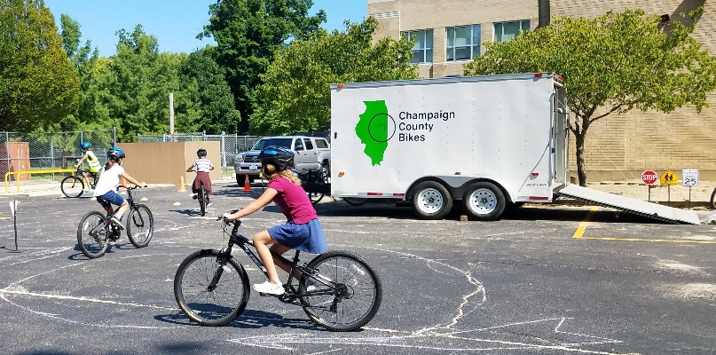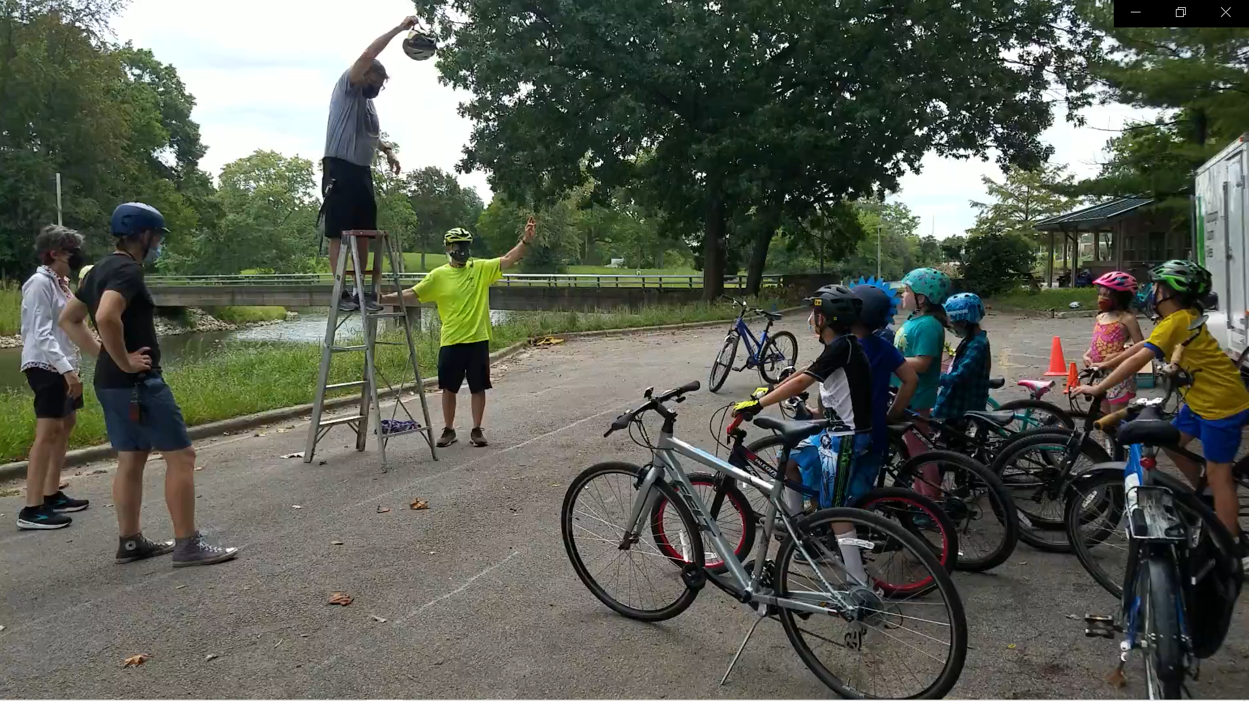
Bike trailer with youth (above) and new drivers (below). Helmet safety demo (above); Earth Day (below).
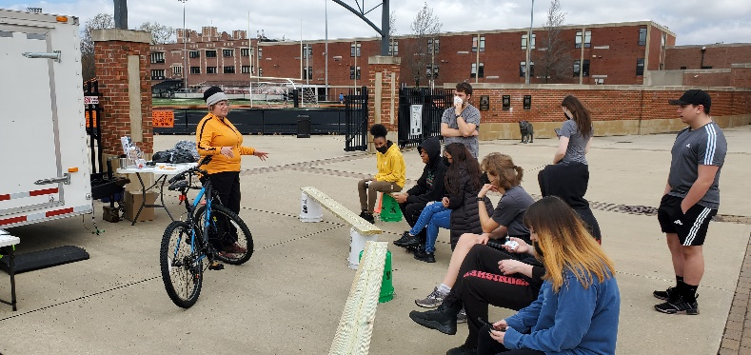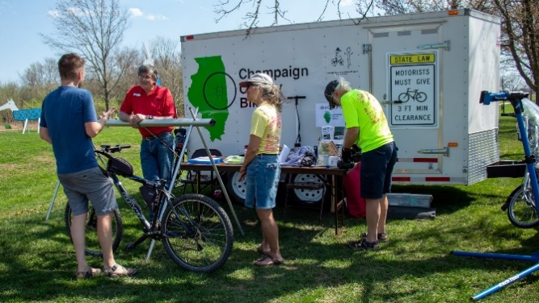
*The Bike Month 2023-24 Planning Team (listed below) thanks you for making Bike to Work Day/Bike Week in September 2023 and Bike Month in May 2024 possible.
Jeff Yockey | Champaign County Bikes
Cynthia Hoyle/Thomas Valencia | CU Safe Routes to School Project
Jay Rank | Champaign Urbana Mass Transit District
Gabe Lewis/Thomas Valencia | CC Regional Planning Commission
Sarthak Prasad | University of Illinois
Lily Wilcock | City of Champaign
Marcus Ricci | City of Urbana
Nick McDuffee/Ireland Hieb | Village of Savoy
Sam Ihm | CC Forest Preserve District/Kickapoo Rail Trail
Jake Benjamin/Barry Israelwitz | The Bike Project
Xander Hazel | Champaign Center Partnership
Ellen Hedrick | Village of Mahomet
Jake McCoy | Village of Rantoul

