Resilience iCAP Team Meeting | Location: | Microsoft Teams
 | Date: | 10/20/23
 | Time: | 9:00 a.m.
 | Facilitator: | Claire Keating

Meeting Start Time: 9:06pm
Attendees: Morgan White, Warren Lavey, Miriam Keep, Linda Derhak, Carena Van Riper, Cheryl Bicknell, Scott Tess, Jennifer Fraterrigo
- Welcome from Chair, Morgan White
- Introductions of team members
- Charge Letter Tasks: Resilience Team Charge Letter
- Chair shared the iCAP Resilience list of tasks from the charge letter.
- Charge letter contains objectives and a priority list.
- Chair recommends all team members to read iCAP Resilience Chapter.
- Not only does the team push for recommendations, but also facilitate these recommendations.
- Think about the next iCAP 2025 for Resilience.
- Meeting notes and recordings will be attached, and team members can invite guests to speak at our meeting.

  - Read the Resilience Chapter: https://icap.sustainability.illinois.edu/files/project/5293/iCAP-2020-FINAL-WEB.pdf
  - View Resilience objectives:
8.1 Develop a coordinated urban biodiversity master plan by FY24 to make the Champaign, Urbana, Savoy, and campus metro area a model for biodiversity.
8.2 Coordinate rainwater management plans for the entire urbanized areas of Champaign, Urbana, Savoy, and the university. Starting in FY21, share the total number of green infrastructure locations on the iCAP Portal on an annual basis.
- Both cities have a stormwater management plan and campus is beginning to plan their own stormwater management plan.
- Warren Lavey mentions that we should encourage each entity (Champaign, Urbana Savoy, Campus) to work together to make sure that our plans are aligned.
- Morgan White mentions that there is some contention between each municipality about how to manage rainwater.
8.3 Develop a collaborative plan for environmental justice that will assess metro area resilience and actively address related issues. The plan will be written and publicized by FY24.
- Campus has to be careful when we reach out to community, as campus is limited in what we can and can’t do.
- Warren mentions something about an email but I will have to go back and look.
- The intentions of this team is to share ideas and knowledge about the university and the surrounding community.
8.4 Take leadership in addressing the most pressing sustainability challenges in our local communities through collaboration with local governments and related community groups, by forming an advisory panel for coordinating efforts across jurisdictional boundaries. By FY24, select at least three major local sustainability issues to address and identify lead agency and key stakeholders.
8.5 By FY23, collaborate with colleges and community groups to inventory existing certification opportunities for green jobs and identify gaps.
8.6 Support Vision Zero as a county-wide goal for safe and sustainable transportation.
8.7 Establish a local offsets program by FY24.
- How could carbon offsets happen locally? What would be that mechanism?

  - Priority Areas/Needs:
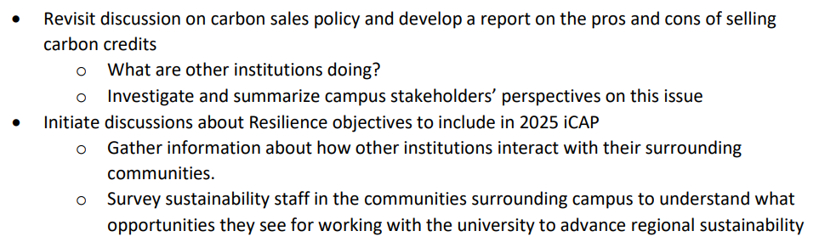

  - iCAP Portal project updates:
        - Urban Biodiversity Plan
        - Vision Zero
        - Air Quality Monitoring Station
- Discuss Resiliency Commitment and develop a mission statement for this year.
- Action Items
  - Read iCAP Resilience Chapter (all team members)
  - Reach out to project leaders and update status of iCAP Portal (all team members)
  - Upload EOY Report to iCAP Portal (Claire)

- Adjournment
Minutes submitted by:

