SmartWay Social Media Posts
April 2024

Post 1:
This Earth Day make planet-smart choices & become an #EPASmartWay partner. Get access to free tools, information, recognition & technical assistance. Gain insight into freight operations & invest in our planet through smarter, more fuel-efficient choices. www.epa.gov/smartway
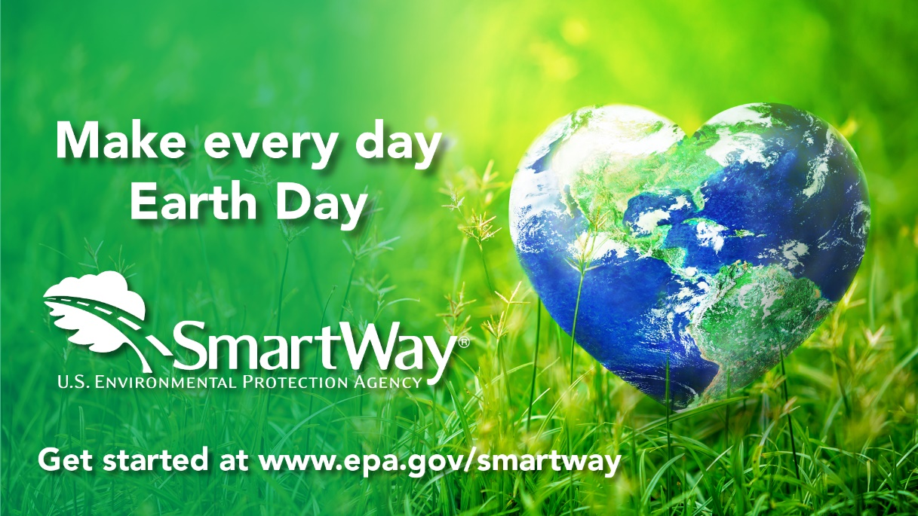
Post 2:
This Earth Day, take stock of and consider investing in your supply chain for a smart and sustainable future. #EPASmartWay suite of free tools can help you learn how to invest in our planet through smarter, more fuel-efficient choices. www.epa.gov/smartway
