Solar Farm 3.0 Report
Per request in leadership meeting 12-9-22, updated mbwhite 1-22-23
Climate Leadership Commitments: All three universities in the University of Illinois system are signatory to the Climate Leadership Commitment to be carbon neutral as soon as possible and no later than 2050. The UIUC campus is also a signatory to the Resilience Commitment to help communities to adapt to climate change.
The UIUC strategy to reach carbon neutrality is primarily through energy conservation and renewable energy. Currently, UIUC has approximately 2 million square feet that is LEED certified, and UIUC’s construction standards exceed the minimum state energy performance requirements. The Facilities & Services (F&S) team at UIUC undertook numerous retro-commissioning projects to maximize energy savings. UIUC completed several Energy Performance Contracting to design and implement projects that pay for themselves through energy savings. All these efforts have succeeded to reduce energy consumption per square foot by approximately 40% since the 2008 baseline.
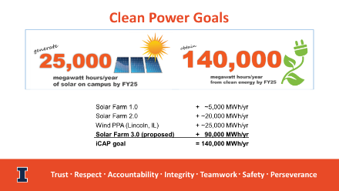
The other strategy to meet UIUC commitment is to generate and utilize renewable energy. UIUC built Solar Farms 1 & 2 and rooftop solar projects that generate approximately 25,000 MWh and purchased 25,000 MWh wind power through Prairieland Energy Inc (PEI). To meet the UIUC’s carbon neutrality goals, there is an important milestone to achieve, which is adding another 90,000 MWh to bring the total energy from renewable sources to 140,000 MWh by 2025. Furthermore, our sister campus UIC needs 80,000 MWh per year to meet their next renewable energy milestone. The F&S team collaborated with UIC and PEI to engage COHO, a reputable market energy consultant to develop this comprehensive study to identify and evaluate options to meet the university goals.
- UIUC Goals: UIUC’s Illinois Climate Action Plan (iCAP 2020) Objective #2.3.1 is to use 140,000 megawatt-hours per year (MWh/yr) of clean power by FY25. There are existing clean energy contracts and installations for 50,000 MWh/year, so UIUC is seeking 90,000 MWh/year.
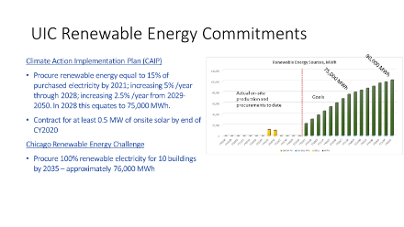
- UIC Goals: UIC’s Climate Action Implementation Plan (CAIP) Procure renewable energy equal to 15% of purchased electricity by 2021; increasing 5%/year through 2028; increasing 2.5%/year from 2029-2050. In 2028 this equates to 75,000 MWh. UIC is seeking 80,000 MWh/year.

Definitions: The following are some useful terms:
- REC stands for Renewable Energy Certificates and sometimes it is called Renewable Energy Credits. Each REC represents the production of one megawatt-hour of renewable power added to the electric grid, so each Mega What hour equals one REC. This is an accounting methodology that provides the institution the legal right to claim the usage of Renewable Energy.
- PPA stands for Power Purchase Agreement and it is a contract to buy electricity and receive RECs. In this type of agreements, an institution guarantees fixed price for electricity generated from new-built Renewable Energy project, then consume or sell some of this electricity back to the grid, and receive RECs as a result of this investment.
- NPV stands for Net Present Value which is the todays value of the estimated cost over the 15-year period which is the term of the agreement, with a discount rate of 5%.
- BAU stand for Business as Usual which represents power production using the current co-generation power plants, on-site two solar farms we currently have, the wind Power Purchase Agreement, and what we purchase from the grid on the floating market price.
- MISO stands for Midcontinent Independent System Operator. MISO Manages the generation and transmission of high-voltage electricity across 15 states, mostly in the Midwest region, and the Canadian province of Manitoba for more than 42 million people including central Illinois region.
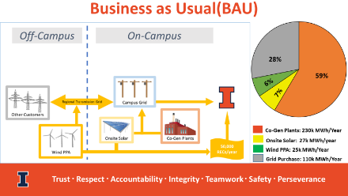
Business As Usual (BAU): To conduct this study, it is essential first to see the University’s current energy profile. UIUC currently produce electricity from three main sources, Abbott Power Plant where we mainly use natural gas to produce electricity, Solar Farms 1.0 & 2.0, and a Wind Power Purchase Agreement. The balance between what we produce annually, which is approximately 282k MWh, and what we consume, which is approximately 392k MWh is purchased from the grid. About 60% of UIUC electrical demand is produced at Abbott Power Plant, 7% of UIUC electrical demand is provided from the onsite solar farms, and 6% from the wind PPA. The remaining 28% is purchased from the regional grid, MISO. For the purpose of this report, this is called Business As Usual because all the options considered, to achieve the university clean energy goals, are compared to this baseline.
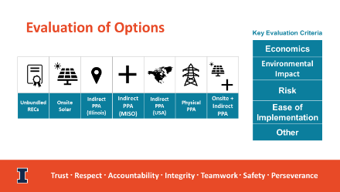
Options Considered: To meet the next clean energy milestone on our path to carbon-neutrality—which is adding 90,000 MWh/year for UIUC and 80,000 MWh/year for UIC from renewable sources—COHO identified and evaluated several options. These options were evaluated based on economics, whether they would achieve savings or incur cost premiums, environmental impacts to maximize avoided grid emissions, risks associated with each option, and the ease of implementation during contract execution and post contract execution management.

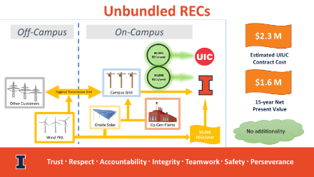
Unbundled RECs: The first option evaluated is unbundled RECs, where U of I pays a fixed dollar amount per MWh for each REC on the national market, to legally claim the use of renewable energy. In this case, UIUC and UIC are just acquiring the RECs but no electricity from renewable sources is purchased by U of I and no additional renewable electricity will be produced or added to the regional or national power grid. The estimated total cost to UIUC over 15 years is about $2.3M and $2M for UIC. The Net Present Value for this contract is $1.6M for UIUC and $1.4M for UIC. This is the easiest option to implement both in procurement and negotiation, and in the post contract management. In terms of risks, the price of RECs is highly volatile. For example, the current REC price is $3 while it was $7 last year. The university can mitigate this risk by locking in REC pricing for up to 5 years, but this comes with significant premium.
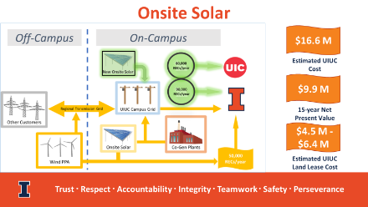
Onsite Solar: The second option is to build an onsite solar farm, like solar farms 1 and 2. UIUC and UIC pay fixed price per MWh for electricity generated from new-built solar project on UIUC campus. The University receives power and RECs, 90k for UIUC, and 80k for UIC. Some of this electricity will be consumed on UIUC campus and the remaining will be sold to the grid at floating wholesale market rate. The estimated premium cost to UIUC is about $16.6M and $14.8M for UIC. The NPV for this amount is $9.9M for UIUC and $8.8M for UIC.
In addition, building such a massive 170,000 MWh/year solar farm will need 350 to 500 acres of land and the estimated leasing cost is $4.5M to $6.4M over a 15 year term. This option requires UIUC to acquire the land, a competitive RFP process, and 4-6 month of negotiation. The selected developer will be responsible for the development and the operation of the solar farm throughout the 15 years term. Because the University commits a fixed price per MWh to a developer for 15 years, potential price fluctuations constitutes a downside risk if the wholesale market price at the time the electricity is generated is less than the fixed price in the PPA.
Indirect PPA: The third option is Indirect PPA. In this method, U of I guarantee fixed price for electricity generated from new-built Renewable Energy project. The generated electricity will not be delivered to the campus and will be sold directly to the local grid at floating wholesale market price. Similar to onsite solar farm, the Downside Risk exists The new solar farm can be located anywhere in US, each potential location has different cost implication, and therefore, this option has three sub-options:
- If the farm is located in Illinois, over the 15 year term, this will cost $11.1M for UIUC and $9.8M for UIC, with a NPV of $6.6M for UIUC and $5.9M for UIC.
- If the farm is located in the MISO region but in another state, this option would actually save over the 15 year term. Savings are projected to be about $5M for UIUC and $4.4M for UIC, with NPV of approximate savings of $2.9M for UIUC and $2.6M for UIC.
- If the farm is located elsewhere in the US, for example, in Texas, the savings will be even slightly bigger. The projected savings over a 15 year term are about $6M for UIUC and $5.4M for UIC, with NPV of $3.4M for UIUC and $3.0M for UIC.
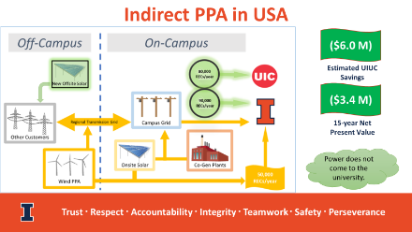
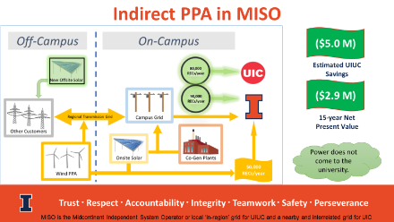
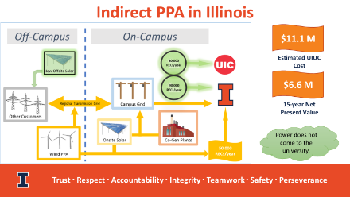
This option also requires a competitive RFP with 4-6 month of negotiation. The developer would be responsible for developing and operating the solar farm.

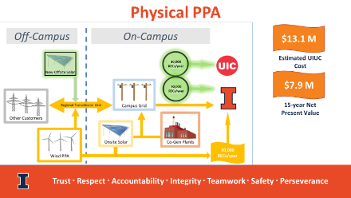
Physical PPA: The fourth option is a Physical PPA. In this option, U of I guarantees a fixed price for electricity generated from a new construction renewable energy project off-campus. Electricity is transmitted to the campus and the university is charged for the power and the delivery costs. Excess electricity is sold back to the grid at floating market rate. Similar to the Indirect PPA, potential downside risk exists. This option requires a competitive RFP with 4-6 month of negotiation, and a complicated contractual arrangement. The developer would be responsible for developing and operating the solar farm. Over a 15 year term, this option is estimated to cost UIUC $13.1M and $10.1M for UIC, with a NPV of $7.9M for UIUC and $6.0M for UIC.
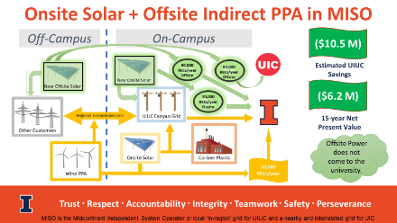
Combination option: The final option is a hybrid approach combining an onsite solar farm and an indirect PPA, for a total of 170,000 MWh/year. In this option, we build a 30,000 MWh/year solar farm at UIUC. This energy will be consumed on the UIUC campus and their RECs will be attributed to UIUC. For the remaining 60,000 MWh/year for UIUC and the entire 80,000 MWh/year needed for UIC, the University will enter into an Indirect Power Purchase Agreement for a solar farm to be built somewhere within the MISO region. This estimate is based on a location in Kentucky. The estimated savings for this option over the 15 year term is about $10.5M for UIUC and 4.4M for UIC, with a NPV of about $6.2M for UIUC and 2.5M for UIC.
The reason the savings for this option is even bigger for UIUC is that we will be able to consume the entire 30,000 MWh/year produced on campus and this will result in significant savings from avoided transmission and delivery costs. UIC and UIUC will still partner in procuring and executing the Indirect Power Purchase Agreement and UIC will still be able to achieve the same savings as if the entire 170,000 MWh were obtained through Indirect Power Purchase Agreement.
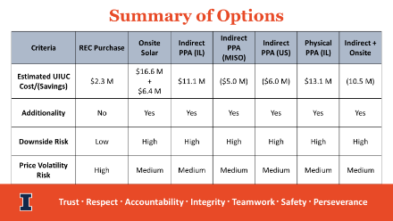
In Summary: The best option economically is the hybrid onsite solar farm generating 30,000 MWh/year plus an indirect PPA for 140,000 MWh/year which will enable U of I to achieve significant savings of about $10.5M. For all of the options considered, with the exception of unbundled RECs, the U of I investment will create new renewable energy generating facilities and reduce our carbon footprint. In terms of financial risks, with the exception of purchasing unbundled RECs, all the other options have some downside risks when the wholesale market price of selling the surplus electricity at the time it is produced, is lower than the fixed price the University is paying the developer.

We feel that the hybrid option meets several goals as it has great savings potential, adds renewable energy to the regional MISO network, which supports our local provider Ameren, and directly increases the capacity of the network we use to purchase the balance between what we consume and what we produce at UIUC. In addition, building another solar farm on campus will demonstrate U of I commitment and leadership on this crucial front.

https://fs.illinois.edu/projects/leed-certifications
https://fs.illinois.edu/docs/default-source/utilities-energy/energy-reporting-documents/energy_usage_trend_chart.pdf?sfvrsn=11a0dbea_2

