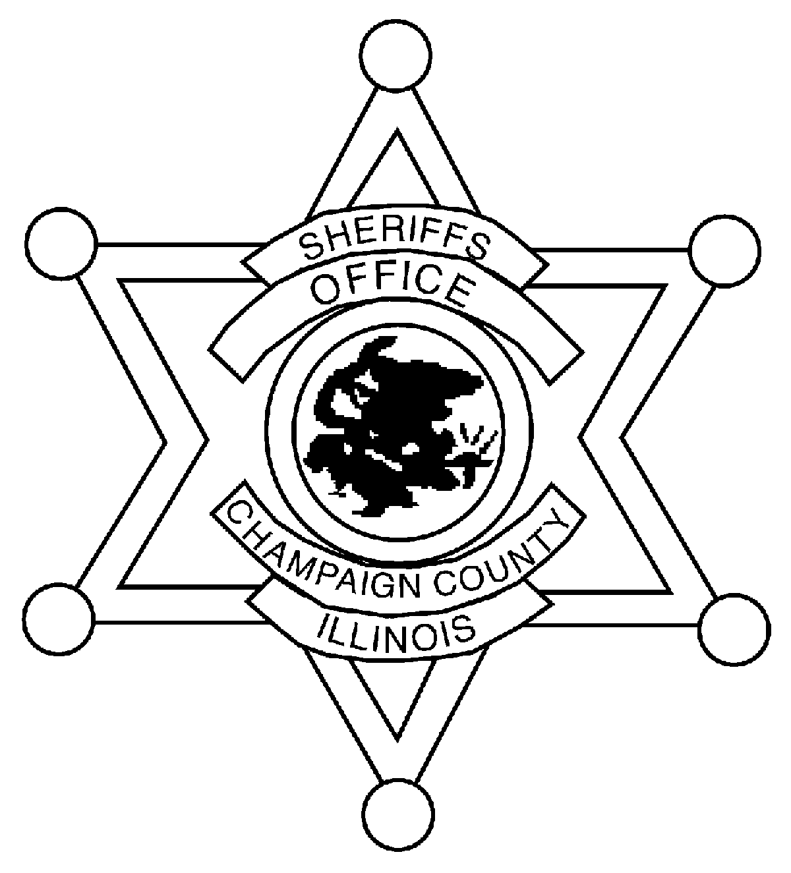
SHERIFF DUSTIN D. HEUERMAN
CHAMPAIGN COUNTY SHERIFF’S OFFICE

204 E. Main Street
Urbana, Illinois 61801-2702
(217) 384-1204

Coordinator John Dwyer
Champaign Co EMA
1905 E. Main St.
Urbana, Illinois 61802
(217)-384-3826

East Central Illinois Community Organizations Active in Disasters (COAD)
Meeting Agenda

December 7, 2023

Time: 2:30 pm

Location: ILEAS Boardroom
1701 E. Main St.
Urbana, IL 61802
Time: 2:30 PM

- Welcome & Introductions
- Member Updates
- Real-events & future exercises/training
  - Red Cross Shelter Training—Jan 15th 0900 at ILEAS
  - Ambassador Training-TBD
  - Reunification Drill/Exercise—June 14th
- Expand membership
- Recruit other organizations to join
- Open Discussion
- Next Meeting—Jan 18th
- Adjournment

