U of I Environmentally Preferable Procurement (EPP) Guide

Through the Illinois Procurement Code, 30 ILCS 500/45-26, University of Illinois Urbana-Champaign (U of IU of I) is obligated to contract for supplies and services that are environmentally preferable, unless contracting for an environmentally preferable supply or service would impose an undue economic or practical hardship on the contracting State agency, or if an environmentally preferable supply or service cannot be used to meet the requirements of the department.

By establishing this EPP Guide, U of I will bring recycling full circuit through the purchasing of products that contain recycled content; it will stimulate markets for the recyclables it collects. With this guide, U of I and its departments are committed to purchasing products that are made of recycled materials when they are available at reasonable prices. Specifications for contracts, at the discretion of the requesting department, may include a price preference of up to 10% for environmentally preferable supplies and/or services.

Definitions:

- "Supplies" means all personal property, including but not limited to equipment, materials, printing, and insurance, and the financing of those supplies.

- "Services" means the furnishing of labor, time, or effort by a contractor, not involving the delivery of a specific end product other than reports or supplies that are incidental to the required performance.

- "Environmentally preferable supplies" means supplies that are less harmful to the natural environment and human health than substantially similar supplies for the same purpose. Attributes of environmentally preferable supplies include, but are not limited to, the following:

  - made of recycled materials, to the maximum extent feasible;
  - sustainably produced resources/materials which reduces our carbon footprint, or products that can produce sustainable products using renewable or waste resources
  - not containing, emitting, or producing toxic substances;
  - constituted so as to minimize the production of waste; and
  - constituted so as to conserve energy and water resources over the course of production, transport, intended use, and disposal.
- "Environmentally preferable services" means services that are less harmful to the natural environment and human health than substantially similar services for the same purpose. Attributes of "environmentally preferable services" include, but are not limited to, the following:
  - use of supplies made of recycled materials, to the maximum extent feasible;
  - use of supplies that do not contain, emit, or produce toxic substances;
  - employment of methods that minimize the production of waste; and
  - employment of methods that conserve energy and water resources or use energy and water resources more efficiently than substantially similar methods.
- “Recycled Content” means the total percentage of recovered material in a product, including pre-consumer and postconsumer materials.
- “Total Recycled Content Percent” means total percent of post-consumer and/or pre-consumer recycled content in a product.
- “Virgin materials” means materials that have no recycled content.

U of I departments shall, at a minimum, observe the following requirements.

Paper products
All paper products, including computer paper, copier paper, stationary, envelopes, folders, towels, napkins, toilet paper, etc. will contain total recycled content of no less than 30%.

Office supplies
Binders, calendars, folders, letter openers, pens and pencils, rulers, etc. should contain recycled content.

Office electronics
Computers of all types, servers, monitors, cellphones, imaging, printing and copying equipment and televisions shall have secured, at a minimum, an EPEAT bronze rating.

Clothing
Shirts, pants, uniforms, and safety vests when made from polyester or other synthetic fiber – should contain recycled content.

Furniture
Indoor and outdoor furniture that is metal or plastic should have recycled content, or be remanufactured.

Lumber
When appropriate, use plastic lumber with recycled content, such as for decking, fence posts, picnic tables, park benches, furniture, and piers

Plastic bags
Plastic bags for trash and recycling must have a minimum recycled content no less than 10%.

Trash & Recycling Containers
Trash and recycling roll-off containers, indoor collection containers and receptacles should have recycled content.

Vehicles
Use re-refined oil, recycled antifreeze, recycled and remanufactured auto parts, and retread tires

Building materials
Insulation, carpet, tiles, steel framing, plastic partitions, pallets, paint, roofing shingles, and counter tops should have recycled content.

Construction & Traffic Control
Drainage pipes – plastic containing recycled content certified to AASHTO M294 Standard.

Concrete, asphalt, traffic cones, parking stops, traffic signs, and anything made from plastic should have recycled content.

The EPA Guidelines list standards for 61 product categories.

Departments are also strongly advised to be mindful of other environmentally conscious practices. Some of these practices include:
- When using the “Shop” simple search in iBuy, consider filtering by product flag (green or recycled). See Exhibit 1 for example.
- When shopping a catalog vendor in iBuy, many of our vendors offer green, recycled, or other similar sustainability designation. See Exhibit 2 for example.
- Purchasing products that are environmentally preferable, such as products that come from sustainably managed forests.
- When possible, offices within the same building can collaborate on purchasing orders to minimize packaging and reduce energy consumption.
- Each department can implement paper reduction strategies through setting double sided printing as a default, sharing and circulating materials, the use of electronic mail and newsletters, and the reuse of discarded paper for drafts, scrap paper, or internal messages.
- When refurnishing an office, consider buying

Exhibit 1:
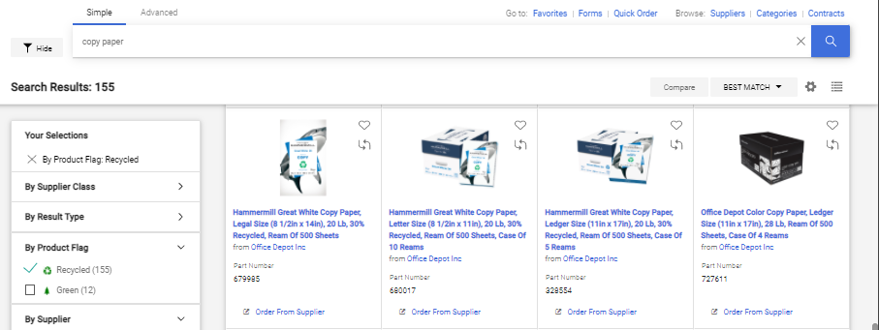

Exhibit 2:

