**FINAL SmartWay Affiliate Social Media Posts**

**November 2024**

**Theme: Thank You for Making a Difference**

**Post 1 (Facebook):**

Since 2004, #EPASmartWay partners have saved more than 396 million barrels of oil & over $55 billion in fuel costs – equivalent to eliminating the annual energy use of more than 25 million homes! Thank you, partners! #fuelsavings #freight #sustainability [www.epa.gov/smartway](http://www.epa.gov/smartway)

**Post 2 (Facebook):**

Thanks #EPASmartWay partners! As we celebrate our 20th anniversary, we thank you! You have helped avoid emitting more than 169 million tons of CO2—contributing to cleaner air and healthier citizens. #fuelsavings #cleanerair #freightefficiency – [www.epa.gov/smartway](http://www.epa.gov/smartway)

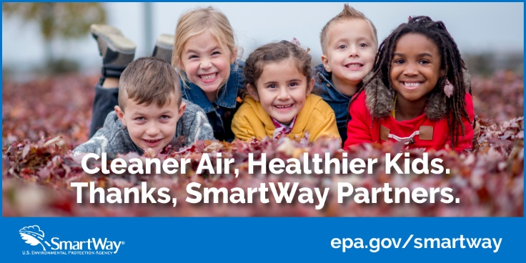

**Post 3 (Facebook; use either image from previous posts):**

#EPASmartWay partners are getting there with cleaner air. Collectively they have saved more than 396 million barrels of oil & over $55 billion in fuel costs – equivalent to eliminating the annual energy use of more than 25 million homes! #thankyou #fuelsavings